Week 2: Find Sequence of Interest

Learning Objectives for DNA Control Element Discovery

Skills
- Sign up for your user account (DNA Parts Registry for M Campbell Lab Page)
- Search published papers to find genetic regulatory element of interest

Cognitive
- Employ a scientific approach to answering biological questions and test hypotheses.
- Evaluate publications to find a suitable DNA sequence.
- Explain how DNA fragments are cloned.
- Review the information contained within promoters and RBSs.

Pre-Lab

Before you come to lab:

1) Create an account on the Campbell lab wiki page (http://igem.org/Lab.cgi?id=66) (top right "login", apply for new account)

2) Listen to this 6 minute information story about synthetic biology: http://www.npr.org/templates/story/story.php?storyId=90014997

3) Answer each of these four questions in two sentences or less.

A) What are the -10 and -35 regions of a promoter?

B) What is a plasmid? What parts are essential to its function?

C) What are oligonucleotides (often referred to as oligos)?

D) What is a ribosomal binding site (RBS)? To what does an RBS base pair?

Information: DNA Control Elements

In Lab:
1) Watch movie of restriction enzyme cutting DNA (http://www.dnalc.org/view/15476-Genetic-engineering-inserting-new-DNA-into-a-plasmid-vector-3D-animation-with-with-basic-narration.html)
See the structure of a restriction enzyme bound to DNA. (http://bioinformatics.org/firstglance/fgij/fg.htm?mol=1RVC)
Discuss sticky ends. How do we connect two segments of DNA with compatible sticky ends?

2) Each group will get a different part to work with:
- pClone Red – read pClone paper; find promoter with sequence
(view http://parts.igem.org/Part:BBa_J119137)
- rClone Red – read Campbell and Eckdahl, preprint 2018
(view http://parts.igem.org/Part:BBa_J119384)
- pClone mScarlet – read pClone paper; find promoter with sequence
(view http://parts.igem.org/Part:BBa_J100397)
- rClone mScarlet – read Campbell and Eckdahl, preprint 2018
(view http://parts.igem.org/Part:BBa_J100419)

Look at the maps that illustrate a portion of your receiving plasmid. You will need to read the assigned papers (see lab web schedule) to understand how you will modify the existing part to produce a predictable behavior.

3) Identify how a promoter or RBS could be designed and tested so that you can compare its actual function with your predicted function. For pragmatic reasons, avoid regulatory mechanisms such as “expose cells to X-rays” or “put cells in space where there is no gravity”, etc.

4) Working in your lab group, home in on a DNA sequence of interest. The pClone Red pClone mScarlet groups will want to find a promoter described in a published paper that can be located via PubMed. rClone Red and rClone mScarlet groups will want to design a new RBS that will work well with the 16S rRNAs in E. coli. You should consider the non-Watson/Crick base pairings shown on the next page when designing your new RBS. The only thing each group needs to do today is identify a sequence and make a prediction for its function. You will have more time to work on this next week when you specify the exact DNA sequence you want to test.

Non-Watson/Crick base-pairing rules for RNA
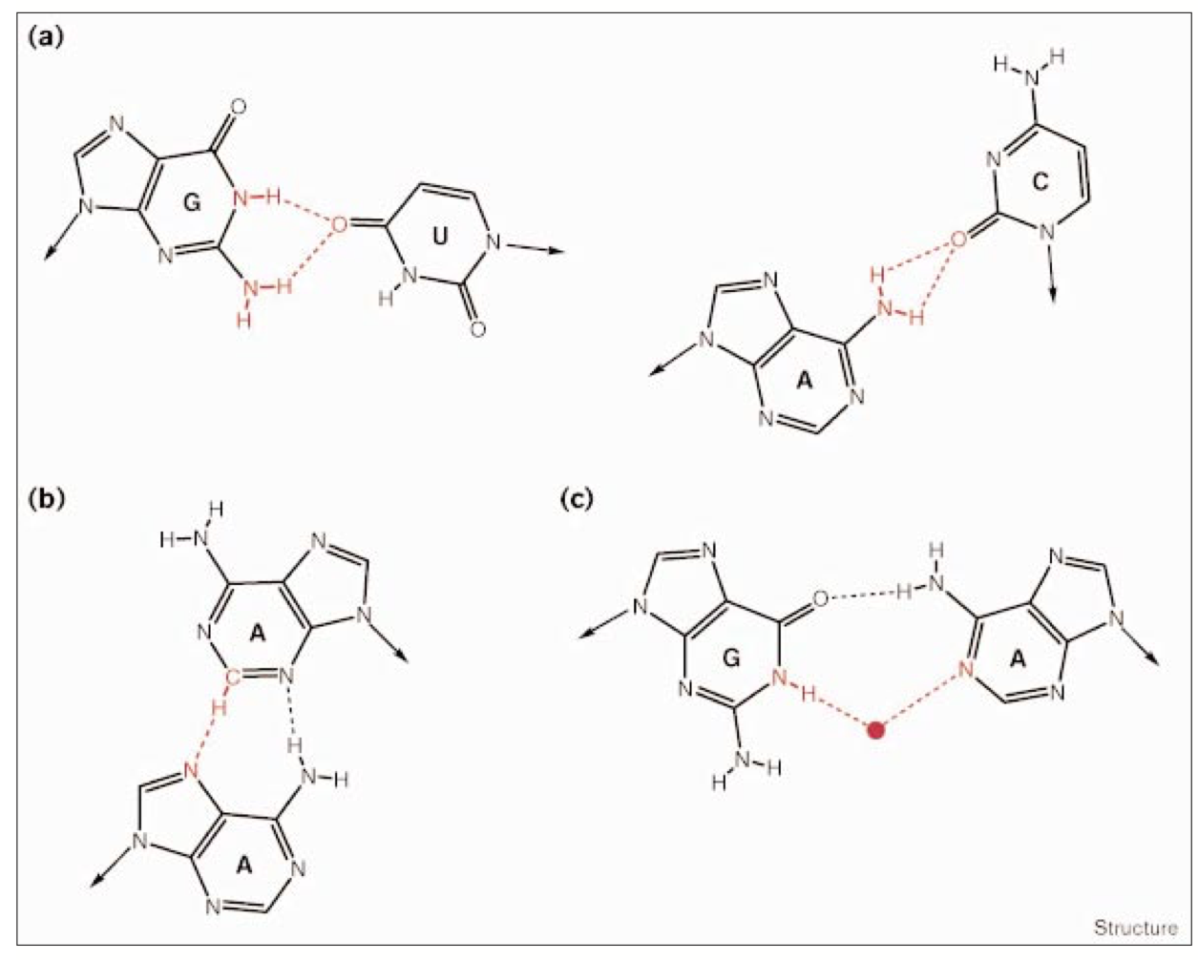
Non-Watson/Crick base pairs can form non-standard hydrogen bonds. a) Here one oxygen atom on a uracil can form two hydrogen bonds with guanine to form a U:G base pair. b) In this adenine-adenine base pair (A:A), there is a normal N-H hydrogen and an atypical CH-N hydrogen bond. c) G:A base pairing, or C:A base pairing can happen with two atypical hydrogen bonds. For C:A, one oxygen can bind with two hydrogens. For G:A, a water can participate in an atypical hydrogen bond combination. (Image from Westhof and Fritsch, RNA folding: beyond Watson-Crick pairs. Structure. Vol. 8(3): R55-R65, 2000, their figure 2.)

Try to invent a new RBS using the rules above and the consensus sequence for the anti-RBS
3' UUCCUCCACUA 5' = anti-RBS of 16S rRNA in ribosome

