Laura Voss

How to Use and Interpret the Pfam Database
http://pfam.sanger.ac.uk/

Pfam is a database for protein domain families, and can be used to identify the protein that an amino acid will probably form when it has matured and fully formed. Pfam identifies proteins based on their protein domains, or smaller building blocks which can exist independently of a completed protein, and generally perform one specific function. A protein’s main function is determined by which combination of domains it has, and what function they perform.

Within Pfam, domains are grouped into families; protein domains in a family are related by evolutionary descent. By using a statistical model called the Hidden Markov Model, Pfam can use the existing related domains to extrapolate what other domains in that family might be. Using these domain families, Pfam identifies the domains in a query amino acid sequence, and uses them to determine the probable function of the mature protein that is synthesized from this sequence.

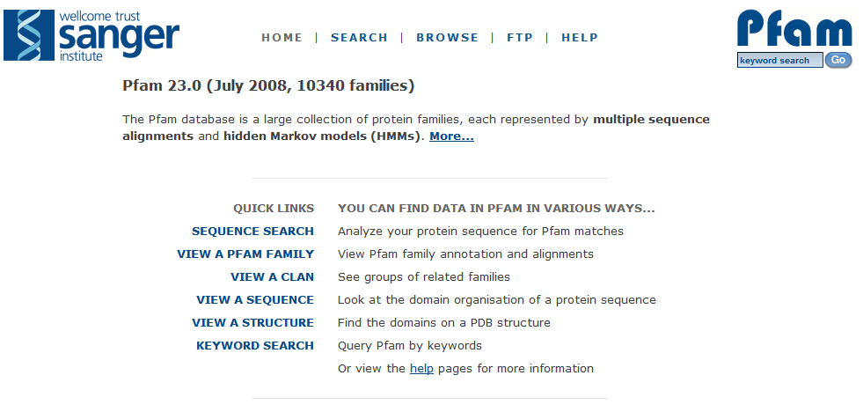To demonstrate searching and using Pfam, I’ll be using gene 2500587644, a methyl-accepting chemotaxis protein, as a sample gene. This protein can be found here on JGI.

This is the front page for Pfam, at the above URL. Pfam allows you to browse domain families, browse proteins by domain sequence, or search for proteins by keyword or structure, but you’ll usually end up searching for a protein via its amino acid sequence. Click “Sequence Search” to do this.

To find the amino acid sequence for your protein, go to the “Gene Details” page on JGI and scroll down to “Protein Information”. Click the link for “Amino Acid Sequence Length”; this will take you to the amino acid sequence.
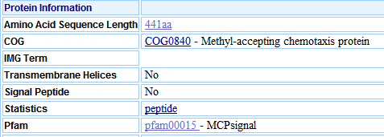

On Manatee, looking up the gene’s ORF or coordinates on the front page will direct you to the gene’s ORF page. Under “ORF ( )”, there’s a drop-down menu for “Select Display”; clicking “View Sequences” on this menu will take you to the amino acid sequence.

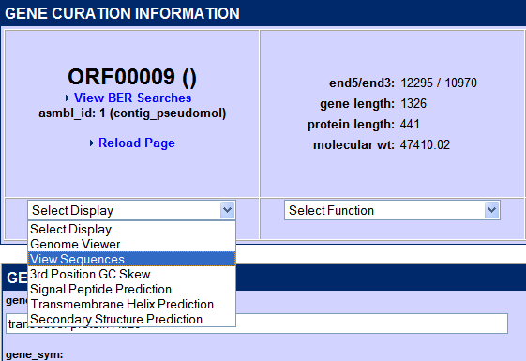

On SEED, click on the gene’s feature ID to access its page. Next to the Feature ID will be a link to the sequence page. Click on the far right radio button for the protein sequence.

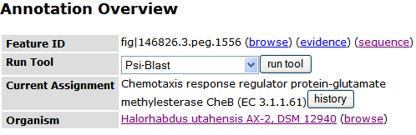

to

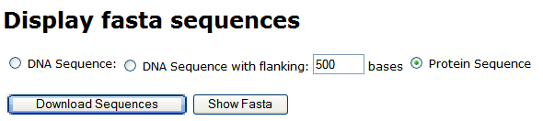

Once you have your sequence, go back to the Sequence Search page.
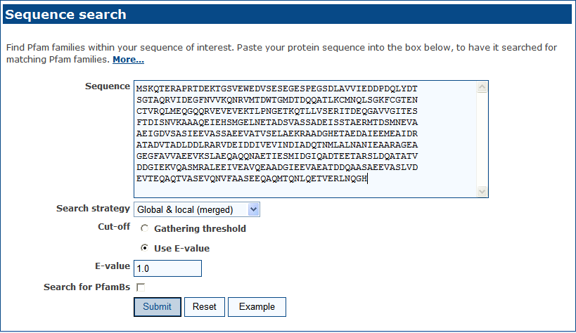

This is the sequence search page. Copy the amino acid sequence from the sequence viewer and paste it into the “Sequence” box and hit “Submit” to begin the search.

By default, Pfam will only search PfamAs, which are fully curated families and contain extrapolations about other possible domains in the family. PfamBs are uncurated and do not contain such extrapolations; searching PfamBs is not necessary for most proteins, but can be useful if a PfamA search shows no results, as it may show functionally conserved amino acid regions that will help you identify an unknown sequence.

Clicking “Submit” will bring up a menu like this:

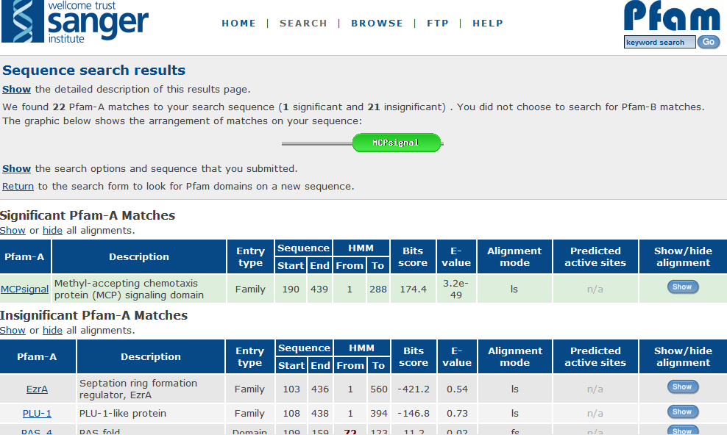
- The Alignment icon at the top (black circle) shows where the significant Pfam match lies in relation to the query sequence, with the colored shape being the matched Pfam and the grey line representing the query sequence. If more than one domain is identified on the sequence, multiple icons will show where each domain lies in relation to the others and the sequence. In this case, the amino acids corresponding to the Pfam lie near the 5’ end of the query sequence. Clicking on the Pfam icon will take you to the domain family’s page.
- Significant Pfam Matches are domain families whose members or potential members (because of the hypothetical domains projected by the HMM) match an amino acid sequence in your protein submission. For a Pfam match to be significant, its E-value must be very low, to the point where the number of matching amino acids is very unlikely to be coincidental. A significant Pfam match is your best guide to what a protein does.
- Insignificant Pfam Matches match the amino acid query sequence, but not to a significant degree; the match could feasibly be coincidental.
- Sequence Start and End describes the sequence alignment; “Start” lists the first amino acid in the query sequence that matches the HMM, while “Stop” lists where the match ends.

Clicking on the “Show Alignment” button on the far right (red circle) opens a diagram of the amino acid sequence of the HMM compared to the query sequence, with matching amino acids noted.

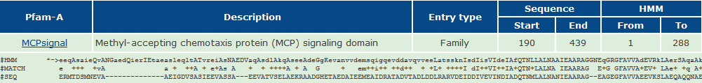
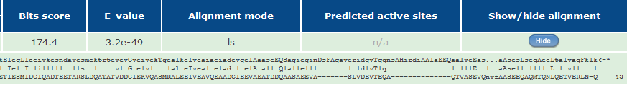

Clicking on the name of the Pfam brings up a page on the Pfam itself (note that clicking on the protein symbol in the Alignment icon will take you to the same page):

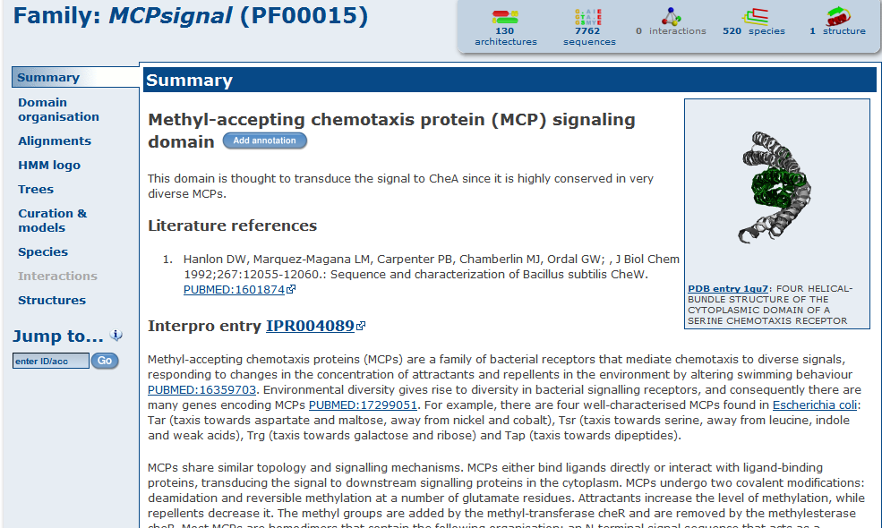
To the far left is a graphical representation of the protein domain. The text below “Interpro Entry” explains what the domain does. The Interpro link itself takes you to the EBI annotation of the protein, which describes what the domain does, lists proteins that contain it, and notes which species typically contains these proteins. This page also links to other databases’ record of this domain, at the bottom of the page.

From this page, you can navigate to many of Pfam’s other tools and features, listed on the sidebar (outlined).

From the sidebar, you can reach:

The Domain Organization page, which shows how the Pfam domain in question appears in other genes and proteins. The domain organization page lists other domains that the query domain appears with and the genes in which each of those structures appears. As with the main results page, clicking on the icon of one of the domains takes you to the domain’s main page.

The Domain Organizations page for our sample protein looks like this:

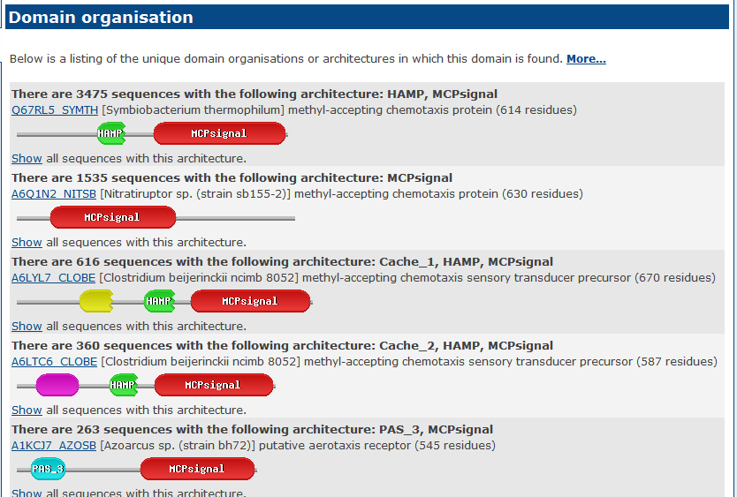

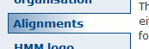The Alignments page, which gives various formats for downloading the alignment sequences.

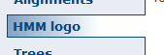The HMM Logo page, which displays a visual representation of the profile HMM. This page fully explains how to read the HMM logo, but a simpler explanation will be given here:

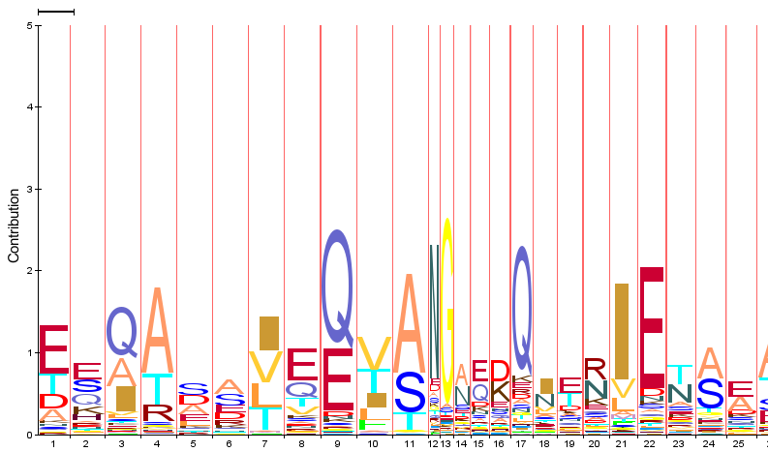
Figure 1: A selection of the HMM Logo for the sample gene.

Each slot represents one of the amino acids in the HMM. Because the HMM is designed to encompass entire families of domains and recognize potential members of the family based on conservation of sequences, several amino acids could potentially be in each slot. The height of each letter represents the probability that the amino acid it represents will be in that particular slot; a large letter is usually the one present in that slot, whereas one of the smaller letters won’t appear as often. The height of the column of letters itself represents how variable that amino acid ‘slot’ is; the taller the column, the more varied it is.

The width of the columns signals the contribution of an amino acid to the overall protein structure; an amino acid that is likely to be bypassed, cut out of the protein before maturation, or made redundant will have a small column width. Finally, the colors of the letters themselves represent the properties of the amino acids, as shown here:

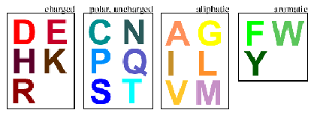

Aromatic amino acids contain benzene rings or other rings of atoms; aliphatic amino acids do not.

To demonstrate, we will try “reading” one of the columns (specifically Column 9) in the sample:

This column is of average width for the HMM logo, meaning that it is neither particularly important to the protein overall, nor is it redundant or unnecessary. Column 9 is one of the taller columns, meaning that it is among the more variable; the amino acid in Slot 9 has a greater tendency to change between the domains in the family. The most frequent amino acid in this slot is glutamine (Q), a polar, uncharged amino acid. Next most frequent in this slot is glutamic acid (E), a charged amino acid.

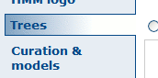The Trees page shows the evolutionary tree for all the domains in this particular domain family. The Curation and Models page gives more detail about the Pfam family itself, including the number of domains in each family, their average length, and the average amount of a hypothetical protein sequence that the domain covers.

The Species page, similar to the Trees page, shows the evolutionary linkage of the species in which the domains of this family appear. The Structures page provides a link to the Worldwide Protein Data Bank’s entry on this family’s domains, allowing you to view their 3-D structure.

Pfam is a large database, and can seem unwieldy at first, but it can also be one of your most valuable tools in determining what an amino acid sequence does, and is especially useful in identifying proteins with similarity but no function prediction.

