The use of multiple databases in the annotation and analysis of the Halorhabdus utahensis genome
L. Voss¹, P. Bakke¹, N. Carney¹, W. DeLoache¹, M.Gearing¹, M. Lotz¹, J. McNair¹, P. Penumetcha¹, S. Simpson¹, M. Win¹, Laurie Heyer² and A.Malcolm Campbell¹

¹Department of Biology, Davidson College, Davidson, North Carolina, U.S.
²Department of Mathematics, Davidson College, Davidson, North Carolina, U.S.

Abstract:
Our study had two goals: to study the genome of H. utahensis and how it functions in its environment, and to examine the strengths and weaknesses of three different gene annotation databases. We processed the H. utahensis genome with three different databases: JGI, Manatee (from JCVI), and RAST (from SEED). We began to examine specific genes by hand, using annotation templates provided by JGI and a series of tools to locate and identify genes, including BLAST, Pfam, THMHMM, and the Protein Database. Too much detail for an abstract. We found that several important differences existed between each databases’ annotation. We developed our own tools to automate the annotation of genes and to compare the three databases in order to more carefully examine their differences. We also examined genetic pathways in H. utahensis, including amino acid synthesis pathways; several pathways had gaps or missing genes that suggested that H. utahensis might have evolved novel methods of synthesizing some essential amino acids that compensated for their harsh environment. We concluded that processing a genome with multiple databases was more time-consuming, but resulted in fewer total errors, less of a bias toward a single method of reading, and a more thorough understanding of the genome in question. How do you know these two claims are correct?

Introduction:
Halophiles, or organisms that can tolerate an extremely high salt concentration in their environment, have been found passive to be potentially useful for biomedical and biotechnological purposes. Because they have adapted to live in extreme environments in which it was previously assumed nothing could live, they may be able to process previously pollutant or waste compounds, possibly opening new doors for fuel production or pollution control (need citations for these claims unless you made these discoveries.) Furthermore, the processes that halophiles have developed to survive in their forbidding environment may be made to serve a secondary purpose. The unique cell envelope of Halobacterium sp. NRC-1, for example, releases unique gas vesicles, which, if cultured in other organisms, could be used as a method of transmission for pathogens [2]. With such possibilities in mind, it is in our best interests to research and understand these organisms as carefully as possible, including processing their genome and understanding how genes correspond to cell function in such unusual organisms.
With genome annotation now in the hands of powerful computer processors, annotating genomes is no longer an arduous and painstaking task. Several databases (not a database as much as an annotation site) are available that perform automatic annotations, leaving allowing scientists to save their effort for a more careful examination of problematic genes that a computer cannot identify. However, no database is perfect. Each has its idiosyncrasies in how it processes and reads a genome; each will deliver a slightly different reading even for automatic annotation, necessitating human examination.
Halorhabdus utahensis, a halophile, was recently isolated from the Great Salt Lake, and can survive and grow in extremely high salinity, up to 27% NaCl [4]. This seems to be the highest salt concentration at which any organism can grow, making H. utahensis a promising subject for investigation. We decided, in examining H. utahensis, to also look more carefully at the possible databases available for genome annotation, comparing their strengths and weaknesses and hopefully achieving a more thorough understanding of both how H. utahensis survives and what the best approach is to processing genomes by computer.
Methods and Materials:
The H. utahensis genome was sequenced via whole-genome shotgun sequencing and annotated by the Joint Genome Institute (JGI), a subsection of the U.S. Department of Energy dedicated to “unit[ing] the expertise and resources in DNA sequencing, informatics, and technology development pioneered at the U.S. Department of Energy (DOE) genome centers” (JGI homepage (format wrong). The computer annotation is publicly available at http://imgweb.jgi-psf.org/cgi-bin/img_edu_v260/main.cgi?section=TaxonDetail&page=taxonDetail&taxon_oid=2500575004.
After reviewing the initial computer annotation, six team members selected six genes each for hand-annotation using JGI’s annotation template. Much of our information came from the taxon homepage itself, but we also used NCBI Protein BLAST to determine similarity of our genes to previously-identified genes. We also used tools such as Pfam, the Protein Database, TMHMM, and PSORT to identify nucleotide and amino acid sequences, protein domain matches, and possible protein locations. URLs
The remaining team members began developing programs with BioPerl, an open-source programming toolkit designed specifically for the data retrieval and integration necessary in bioinformatics [3]. The first tools they designed helped to retrieve annotation data from the sites listed on the template to speed up the process of annotating genes with known functions and saving time for more careful examination of unknown genes.
The Manatee and RAST servers also processed the genome. Manatee, developed by the J. Craig Venter Institute’s Institute for Genomics Research, includes a multitude of built-in tools, including BLAST data, data on paralogs, annotation suggestions, and multiple methods of gene search and identification. RAST, a service of the SEED project by the Fellowship for the Interpretation of Genomes (FIG), annotates genomes by curating subsystems across many genomes, and includes a genome browser as well as links to BLAST and KEGG.
After the genome was processed, the programming team compared the automatic annotations for the three databases and highlighted gaps, mismatches, and other inconsistencies between the three annotations. Programs they developed included a comparison of gene lengths between all three annotations, an analysis of the percentage of alternative start codons, a Venn diagram comparing genes that all three servers had read versus those that only two servers recognized or only one server recognized, and a search function that allowed us to perform a BLAST search of an E.C. number against incorrect all three annotations. Programs were also written to locate the consensus RBS Shine-Dalgarno sequence within our genome (vague wording). Too much detail in this area.
After initial computer analysis, we began examining the genetic pathways in RAST’s KEGG tool, which highlights genes that RAST has detected in each protein pathway. We looked for missing genes in pathways relevant to the metabolism of H. utahensis, searching the other annotations and using the same tools we had used to confirm gene annotations to fill gaps in the pathway. We also used a tool designed by the programming team, which ran a BLAST search for the gene described by an E.C. number against all three databases and against the genome itself. Duplication of M&M? If a gene was not found with the E.C. BLASTer, we looked it up in the EXPASY Enzyme Nomenclature Database to find the names and properties of proteins associated with the E.C. number in question.

Results:
Analysis of the three databases’ annotations revealed several differences in their findings. JGI, for example, tended not to use alternative start codons; JGI tagged ATG as a start codon in 84.1% of the genes it detected. Manatee and RAST more frequently used start codons besides ATG, with 40.5% of RAST’s genes beginning with an alternative start and 21.3% of Manatee’s genes beginning with an alternative start. However, all three databases seemed to agree on stop codons. ??!!!
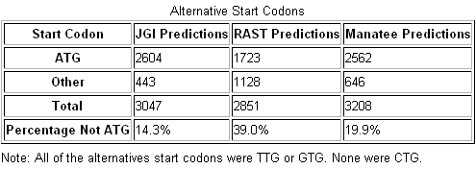
Table 1: Start Codons Used by JGI, Manatee, and RAST. This table shows the number of genes each database detected that began with an ATG start codon and the percentage of genes detected that did not use the ATG start codon. The differing percentages among the three databases probably accounts for many of the differences in the three readings, especially in total gene count and mismatched start and stop sites.

Interestingly, the more frequent ATG start codons did not seem to truncate gene length. When gene lengths were compared for the three annotations, most of JGI’s genes were in the 350-650 bp range, which was greater than the most frequent gene length for Manatee. The figure below illustrates the gene length trends for each database:
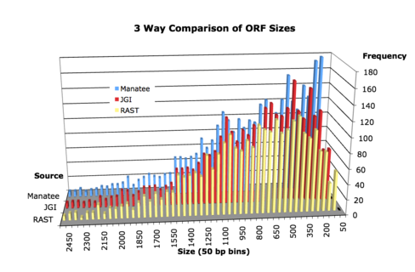
Figure 1: Three-Way Comparison of ORF Sizes. This graph shows the frequency of a given ORF size, in base pairs, for each of the three databases. The shortest ORFs appear most frequently in Manatee, while JGI and RAST’s ORFs are most frequently in the 17500 to 55000 (off 10X) base pair range. Longer genes appear most frequently in RAST.
The three databases also differed in the number of genes detected. RAST detected 1071 genes without the same start or codon as their correspondents in the other databases. Manatee and JGI, respectively, detected found 616 and 466 unique genes; they have 985 genes in common with one another but not with RAST, and 1471 genes common to all three databases.
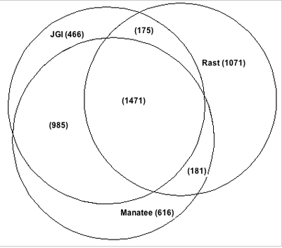
Figure 2: Venn Diagram comparing matching start and stop sites among three databases. Genes shared by two or more databases have the same start and stop site in those databases; genes only listed under one database do not appear with that start or stop site in any other databases’ annotation. The discrepancy in start codon use probably contributes to this difference; RAST uses the most alternative start codons, thus it has the most unique gene calls.
Of the three databases, RAST appears to have the most discrepancy in reading the H. utahensis genome, as it has the greatest number of unique gene calls and does not match up to gene length trends in either of the other databases. This is most likely attributable to its high percentage of alternative start codons.
The consensus RBS sequence for the H. utahensis genome, based on analysis of 25bp upstream from the start sites of genes in all three databases, is cgGAGGT. The conservation of each base pair differs depending on the database, but the guanines tend to be the most strongly conserved, as seen from the RBS Sequence Logo here:
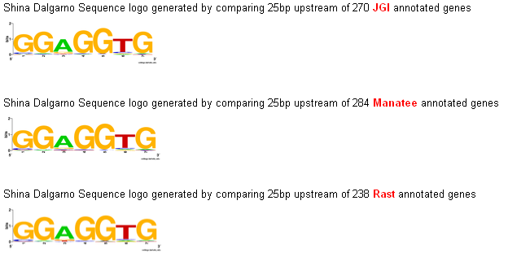
Figure 3: Shine-Dalgarno RBS Sequence Logo. This illustrates the consensusRBS sequence for H. Utahensis and how strongly that consensus sequence is preserved in each database reading. While the four guanines are strongly conserved in all three databases, the adenine and thymine in between them are more prone to variation, especially the adenine.
Looking closer at the 16S rRNA gene highlights the differences between RAST, JGI, and Manatee. The 16S rRNA gene encodes for the rRNA that will eventually become the small 16S subunit of the ribosome; it contains the Shine-Dalgarno sequence that allows genes to bind to the ribosome for transcription (this sentence has multiple errors in it). However, because it?? is not recorded in most protein databases, has no ORF, and is not recognized as a protein per se, it is more difficult to locate in other databases; JGI has it identified and annotated, but it appears to be missing in Manatee and RAST. BLASTing the nucleotide sequence from the JGI annotation against the RAST sequence, however, locates the rRNA sequence, labeled as ssu rRNA (small subunit rRNA). However, both sequences are exactly the same length and occupy the same gene coordinates (2397347..2398825). Manatee lists nothing at those gene coordinates, and a search either through the annotated Excel file or a name search for 16S subunit rRNA yields nothing. A term search turns up other rRNA and DNA synthases??, however, as well as a methyltransferase intended specifically for the 16S subunit rRNA. A general search for ribosomal proteins, however, turned up two separate 30S ribosomal proteins, of which the 16S protein is a part. Running these sequences through BLAST against the H. utahensis genome, however, yielded no significant hits. Since the second 30S protein encompasses the start and endpoints of the 16S annotation are this rRNA different length from the other two calls for 16S rRNA?, it seems reasonable to assume that Manatee does not recognize the 16S annotation within the 30S protein, even though JGI and RAST do. Shocking! They need to fix this.
An examination of amino acid synthesis pathways in H. utahensis revealed further differences in the annotations, as well as problems that can potentially be addressed by experimental testing of the bacteria itself. Out of all the amino acid pathways listed in KEGG, only three of them have separate synthesis pathways, rather than incorporating synthesis into the metabolism pathway, are lysine; valine, leucine, and isoleucine; and phenylalanine, tyrosine, and tryptophan. Of those three, all were missing genes in RAST’s pathway annotation; most importantly, genes were missing from the simplest pathways between the pathway start and the amino acid product (or pathway endpoint). Visuals here?
The only gene missing from the valine, leucine, and isoleucine pathway was 2.3.1.182, or (R)-citramalate synthase, which converts pyruvate and acetyl-CoA to the biochemical intermediary (R)-citramalate, which is involved in many aspects of bacterial metabolism [1]. A BLAST search of the H. utahensis genome found a match to the E.C. number with an E-value of 1x10⁻¹¹⁵, so it seems likely that this gene is present but was missed by RAST’s annotation. The lysine pathway, however, is missing a cluster of genes in between the pathway entrance and endpoint:
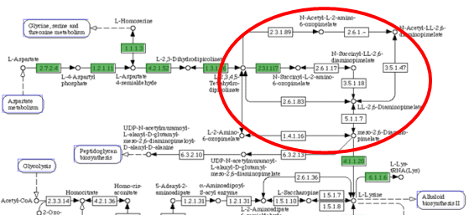
Figure 4: Cluster of missing genes from lysine biosynthesis pathway. The circled portion of the diagram indicates where genes are missing that are crucial to the completion of the lysine synthesis pathway. While other genes are also missing, they are not necessary for the pathway to be minimally functional, whereas the circled genes block the path from pathway entrance to end-product amino acid.
Upon closer examination of this gene cluster, I found that, of all genes highlighted here, one of two of them, at least, must be present for the pathway to be complete: 5.1.1.7. or 1.4.1.16. Any route through this section of the pathway would use one of those genes. BLASTing the E.C. number against the genome, however, yielded no results for either of the two genes. An EXPASY search for 5.1.1.7. yielded diaminopimelate epimerase, which catalyzes the stereochemical inversion of diaminopimelate. Running a text-based search for diaminopimelate epimerase against the three databases also yielded no results, but searching for epimerase yielded several nonspecific nucleoside-diphosphate-sugar epimerases, including a predicted nucleoside-diphosphate-sugar epimerase at 2002455...2003330 in JGI, RAST, and Manatee. There are ten nonspecific epimerases in JGI, one in Manatee, and three in RAST; only one, at locus 1902355..1903254, is present and unidentified in all three annotations. It is not unfeasible that this could be an unidentified diaminopimelate epimerase, as other dicarboxylic acids are identified more specifically in other epimerases. The second potential E.C. number, 1.4.1.16., was identified by EXPASY as diaminopimelate dehydrogenase. Again, a text-based search of the three annotations for diaminopimelate dehydrogenase yielded no results, but a non-specific search for dehydrogenases presented over twenty nonspecific or unidentified dehydrogenases in each annotation, including over five that were conserved across annotations. However, it is worthy of note that, when viewing the pathway annotations for H. utahensis’ closest genome matches, Halobacterium salinarium and Haloarcula marismortui, in the KEGG database, neither of the genes in question are present, which leads one to consider that, since both the missing genes involve diaminopimelate, halobacterium perhaps do not require diaminopimelate or use a different, novel compound to complete lysine synthesis.
The pathway for phenylalanine, tyrosine, and tryptophan contains three missing genes, two of which can be found using the E.C. BLASTer search; 4.2.3.4. (3-dehydroquinate synthase) and 5.4.99.5 (Chorismate mutase) are all present and in the same location in all three genome annotations. The third E.C. number, 2.5.1.54., yielded no results in a BLAST search; a search in EXPASY yielded more than twenty different names for the protein in question, none of which turned up any matches in a text-based annotation search. Most of the varying names for the protein were variations on DHAP synthase, each name adding an additional compound or changing the structural order of DHAP. DHAP, or dihydroxyacetone phosphate. DHAP is a common compound involved in the Calvin cycle in plants, among many other reactions in many other species; however, searching for DHAP synthase or any variations on that name in protein databases, such as Pfam and the Protein Database, also yielded no result. Searches for 2.5.1.54 redirected to DHAP synthetase, which is similar to synthase but uses energy from ATP or other nucleoside triphosphates. However, synthetases are classified using E.C. numbers beginning with 6, while the E.C. number provided here begins with a 2, indicating a transferase. Also, the 2.5.1.54. gene is missing from the pathways of both H. salinarium and H. marismortui, so it is possibly not necessary at all. The exact status of DHAP synthase in H. utahensis is unclear. And therefore, which pathway is unclear.
Discussion:
While none of the three databases we used were flawless, our work with three databases instead of one demonstrated the value of working with more than one database. Each database read the genome differently, and while the bulk of the genome was consistent from database to database, differences in start codon readings and gene organization, particularly in the case of multi-gene non-protein structures like ribosomal subunits, created disagreements between the three readings that had to be resolved by hand-examination.
Manatee, for example, tended to identify shorter genes than JGI or RAST did, and as such identified more genes (3208 total, compared to JGI’s 3047 and RAST’s 2851). Since it did not use as many alternative start codons as RAST but more than JGI, this discrepancy is probably due to a difference in gene organization; as demonstrated by the missing ribosomal subunit protein, Manatee may categorize genes differently, and as such read a series of single genes where JGI and RAST would recognize a larger single gene, or a closely related group. RAST, which called the fewest genes in total, also used the highest percentage of alternative start codons. As such, RAST may pass over genes that JGI would identify because it passes over the ATG start codon in favor of a different starting point for the gene in question. This has advantages and disadvantages; while it may identify some genes that JGI would recognize only as fragments, the extra base pairs may render a valid gene with an ATG start codon as nonsense do you mean stop codon = nonsense? .
Identifying an RBS sequence for H. utahensis can help an annotation team to more reliably identify where a gene starts. However, the Shine-Dalgarno sequence is variable from genome to genome, and it is imperative that the sequence for each specific genome is found rather than relying on an overall consensus sequence. This is another good use for the multiple annotations; while the 16S ribosomal subunit rRNA is consistent from annotation to annotation (except when it is not found), simply consulting the 16S rRNA does not definitively provide the Shine-Dalgarno sequence, as it can be ambiguous where the anti-sequence begins. Examining the base pairs preceding each gene in all three readings, however, and searching for those genes surrounding a possible consensus sequence, leads to a much more accurate genome-specific consensus sequence as well as an idea of how variable that consensus sequence is within each annotation. This is a really good point. Pinpointing that sequence, then, can resolve ambiguities about where, exactly, a gene begins, especially if two or all three databases interpret its start point differently.
Examining the amino acid synthesis pathways provided insight into H. utahensis’ possible idiosyncrasies, as well as to possible future experiments to be conducted in wet lab. For the most part, amino acid synthesis pathways remained intact, with gaps accounted for by genes that were easily found in a BLAST search of the genome if not by text search of the databases. This raises the question of why, precisely, RAST could not identify them when, in some cases, it had genes of the same name and E.C. number already identified. If no discrepancy exists between RAST’s reading of a gene and the other two databases’ reading, then it is possible that RAST somehow neglected to assign an E.C. number to the gene in question, or could not read of export said E.C. number to its KEGG reader. This emphasizes the need for human examination of genome pathway annotation.
However, some genes seemed to be truly absent from the amino acid pathways; since previous experiments on H. utahensis indicate that it is capable of synthesizing all of its own essential amino acids, these gaps must be accounted for by the putative proteins not identified by any database, or by H. utahensis finding a new way around them. In particular, both H. utahensis and other closely-related halophiles, such as H. salinarium, omit two seemingly-crucial steps in the lysine synthesis pathway. Both genes code for proteins of which generic or nonspecific versions exist within the genome; these unidentified epimerases and dehydrogenases, especially the unidentified epimerase at 1902355..1903254, located in all three annotations, could possibly be varieties of the diaminopimelate-related missing enzymes. However, the fact that both missing steps involve diaminopimelate raises the possibility that halobacteria in general, and H. utahensis in particular, do not use or require diaminopimelate, and that some other dicarboxylic acid takes its place. Good. Or it is an essential amino acid the bug must take up from growth medium. If this is true, experiments into the cell wall of H. utahensis may be useful; since H. utahensis is Gram-negative[4], it contains a much thinner layer of peptidoglycan than a Gram-positive bacteria; the absence or disuse of diaminopimelate, which is a component in peptidoglycan, may account for the thin peptidoglycan layer, or may be explained by it. The absence of DHAP synthase in the genome seems to be more of a miscommunication between databases than anything else; Pfam and Protein Database do not seem to register DHAP synthase, instead presenting DHAP synthetase as an alternative. Since there would be little use to a synthase and a synthetase for the same compound they are synonyms for most people, this is possibly an error on the part of EXPASY or a difference in labeling that has not been resolved. However, while the presence of nonspecific synthetases in each annotation suggests that an alternative or mislabeled protein may exist that fills DHAP synthetase’s function, its status within the H. utahensis genome is still not clear. Like diaminopimelate epimerase, it is not present in H. salinarium’s phenylalanine pathway. It may not be necessary in halobacteria, though this seems less likely given how common DHAP is in cellular processes.
While computer annotation speeds up the process of annotating genomes, processing an unknown genome with multiple databases is crucial for accuracy of annotation, as each database examines and annotates the genome in a different way, and basing an interpretation on a single reading of the genome may result in errors due to the particular features of each database. Each database catches genes that the others might miss; each organizes, groups, and identifies genes in different ways. Cross-referencing between databases and examining discrepancies by hand, while being aware of each database’s peculiarities, will in the long run result in a more accurate and thorough understanding of an unknown organism.
Acknowledgements:
We would like to thank Cheryl Kerfeld and Edwin Kim at JGI, Matt DeJongh at Hope College for SEED/RAST, and Ramana Madupu at the J. Craig Venter Institute for Manatee. Jonathan Eisen at UC Davis and Gary Stormo at Washington University in St. Louis provided crucial guidance on this project, and Kjeld Ingvorsen at Det Naturvidenskabelige Fakultet Biologisk Institut, Aarhus Universitet, Denmark conducted wet-lab experiments with H. utahensis. We also thank Chris Healey, for ordering and growing H. utahensis locally.
References:
[1] Howell DM, Xu H, White RH. (1998) (R)-citramalate Synthase in Methanogenic Archaea. Journal of Bacteriology, 181(1): 331-333.
[2] Sremac M and Stuart ES (2008). Recombinant gas vesicles from Halobacterium sp. displaying SIV peptides demonstrate biotechnology potential as a pathogen peptide delivery vehicle. BMC Biotechnol. 8: 9. Online publication.
[3] Stajich JE, Block D, Boulez K, Brenner SE, Chervitz SA, et al. (2002) The Bioperl Toolkit: Perl Modules for the Life Sciences. Genome Res. 12(10): 1611–1618.
[4] Waino M, Tindall BJ, Ingvorsen K (2000) Halorhabdus utahensis gen. nov., sp. nov., an aerobic, extremely halophilic member of the Archaea from Great Salt Lake, Utah. International Journal of Systematic and Evolutionary Microbiology. 50: 183-190

