Biology 113 Closed Book Take-Home Exam #3 – Chapters 9 - 11

There is no time limit on this test, though I have tried to design one that you should be able to complete within 3 hours. There are 6 pages in this test, including this cover sheet. You are not allowed to look at someone else’s test, nor use your notes, old tests, the internet, any books, nor are you allowed to discuss the test with anyone until all exams are turned in by 2:20 pm on Wednesday November 4. EXAMS ARE DUE BY 2:20 PM ON WEDNESDAY 4 NOVEMBER. If you turn in your exam late, you will lose a letter grade which accumulates for each day you are late. The answers to the questions must be typed within this test unless you want to draw on a separate page. If you do not write your answers in the appropriate location, I may not find them. Tell me where to look if you put your answer at the back of your test.

I have provided you with a “Data Gallery” in the form of figures and tables. To choose a figure in support of your answer, simply state Figure #x. You do NOT need to move the figure on your test. Do not assume how many of the data images you will use, or not use. Simply choosing the data is not sufficient support for your answer. You must explain the significance of the data and how they support your answer. I have given you word limits so be concise.

-3 pts if you do not follow this direction.
Please do not write or type your name on any page other than this cover page.
Email all your work when finished with the exam.

Name (please print):

Read the pledge and sign if you can do so with honor:

_______________________________________

On my honor I have neither given nor received unauthorized information regarding this work, I have followed and will continue to observe all regulations regarding it, and I am unaware of any violation of the Honor Code by others.

How long did this exam take you to complete?

Lab Questions:
10 pts.
1) You have the tools to test new DNA.
a) Here is a promoter I want to test in pClone Red (http://parts.igem.org/Part:BBa_J119137). Go to the Oligator web tool (https://gcat.davidson.edu/iGem10/) to generate exactly 2 oligos necessary to clone this promoter. You will have to adjust the parameters some from the default settings for oligo length to make this work.
5’ Ttcttttaatggtctctttaattgaatatttaagattataacatatatttaaagtgt

List the sequences below (in courier font), name each one, and label the 5’ ends:

b) What problem does this promoter sequence contain? How could you resolve this problem?

ICB Questions:
15 pts.
2) Lights, camera, action potential!
a) What is the connection between a ligand-gated sodium channel and threshold potential? Support your answer with one figure that shows this connection best. Limit your answer to a maximum of 50 words.

b) Explain how voltage-gated calcium channels are connected to your ability to control your skeletal muscles? Support your answer with 3 figures and explain how each figure answers part of this question. Limit your answer to a maximum of 35 words per figure.
1.
2.
3.

15 pts.
3) It is important to exercise during the pandemic.
a) How can all parts of a large skeletal muscle contract in a coordinated fashion if the motor neuron only interacts with the plasma membrane of the skeletal muscle? Support your answer with data. Limit your answer to a maximum of 40 words.

b) Why don’t your skeletal muscles contract all the time if your muscles always contain ATP all the time? Support your answer with a different figure from part a. Limit your answer to a maximum of 40 words.

c) What must happen inside a skeletal muscle cell in order for you to stop contracting a skeletal muscle? Integrate the information in figures 31 and 23 to support your answer with data. Limit your answer to a maximum of 40 words per figure.
23:
31:

15 pts
4) We all want to learn as much as possible.
a) Define long-term memory functionally and support your answer using figure 35. Limit your answer to a maximum of 40 words.

b) Use the information in figure 36 to explain key 6 steps in forming a long term memory inside a neuron. Limit your answer to a maximum of 30 words per step.
1.
2.
3.
4.
5.
6.

15 pts
5) I heard someone say there is no need for Halloween this year because for 8 months we have been wearing masks and eating candy.
a) Explain to a high school student why an all protein diet to lose weight will lead to life-long high blood pressure problems. Support your answer with one figure. Limit your answer to a maximum of 40 words.

b) Use the 5 tenets of natural selection to explain why cancer cells continue to grow when wild-type cells stop growing due to inhibitory high energy molecules. Support your answer with data from one figure. Limit your answer to a maximum of 40 words per tenet.
Figure #:
1. overproduction
2. variation
3. competition
4. selective advantage
5. reproduction

15 pts
6) Everyone has to eat.
a) How does the citric acid cycle protect you from harm caused by digesting all the proteins you eat? Support your answer with 2 figures. Limit your answer to a maximum of 40 words total.
figures ___ & ___

b) How do your mitochondria convert NADH into ATP? Support your answer with 2 figures. Limit your answer to a maximum of 45 words total.
figures ___ & ___
15 pts
7) What would we do without plants in the world?
a) How do plants maintain a homeostatic balance for water splitting and the use of cyclic vs non-cyclic electron flow? Support your answer with data in figures 4 & 21. Limit your answer to a maximum of 50 words total.

b) Here are five figure arranged from biggest to smallest numbers: 29, 17, 10, 4, 1. Rearrange these figures into an order that encapsulates the process of producing starch from air. Using a maximum of 40 words per figure, explaining how each figure contributes to a sequential process of producing starch.

1:
2:
3:
4:
5:

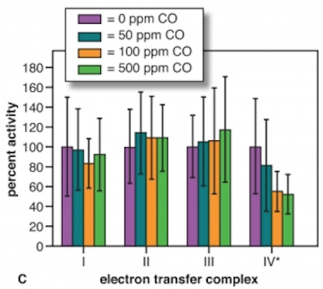
Data Gallery
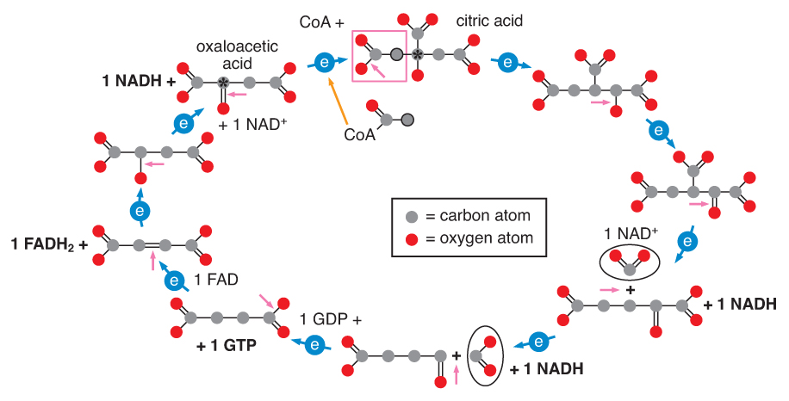
1 2 3
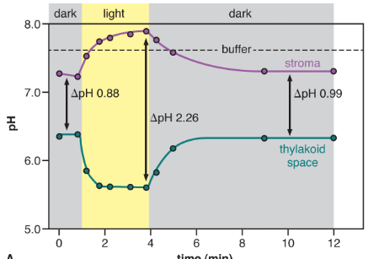

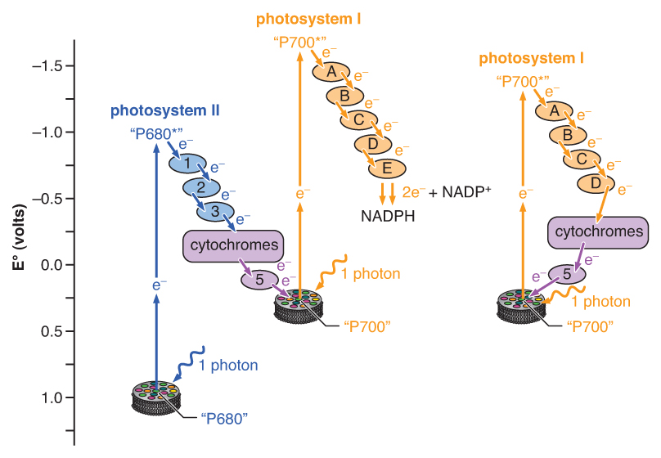
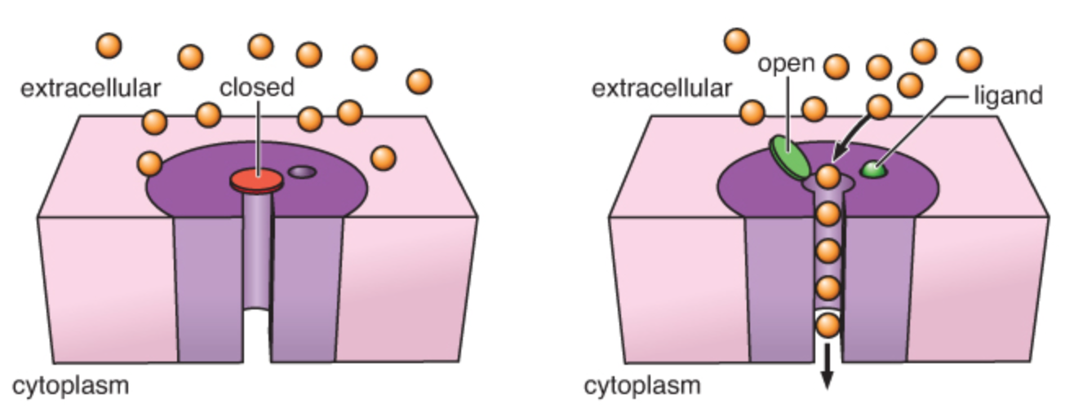
4 5

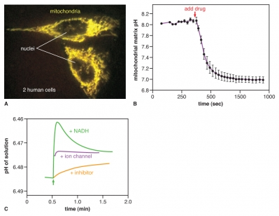
6
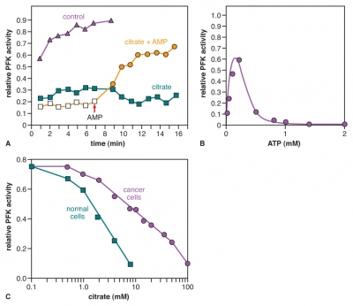
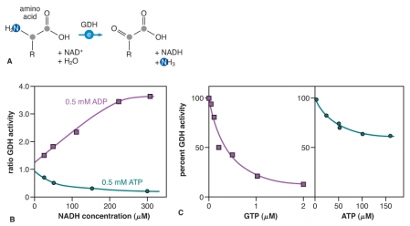

7 8

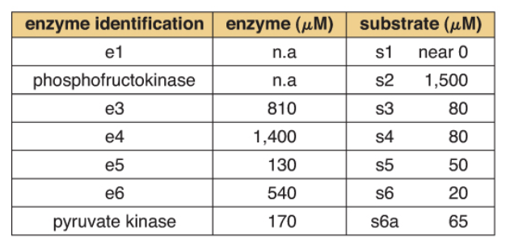

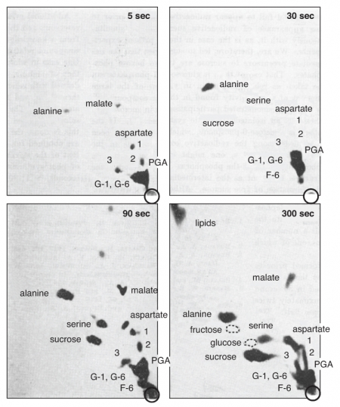
9 10
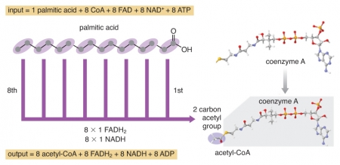
11

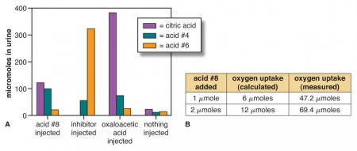

12

13 14
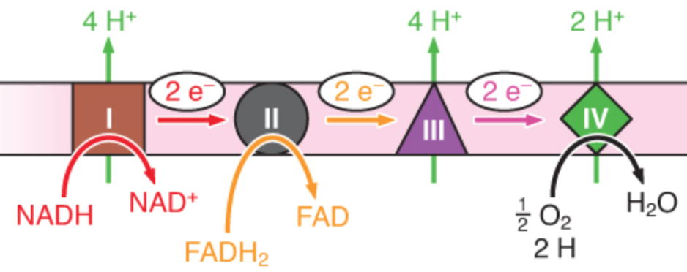
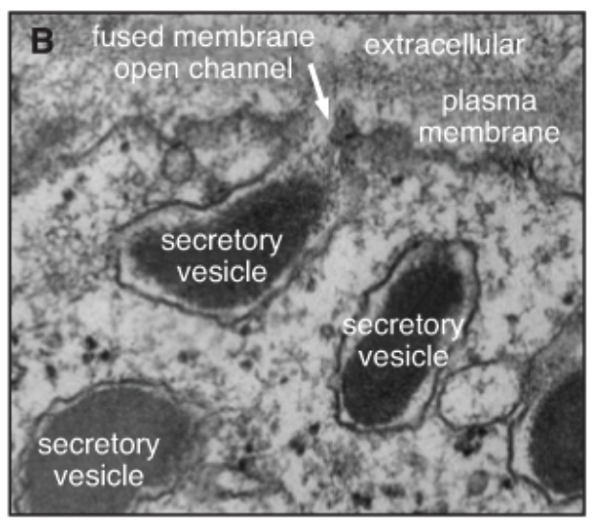

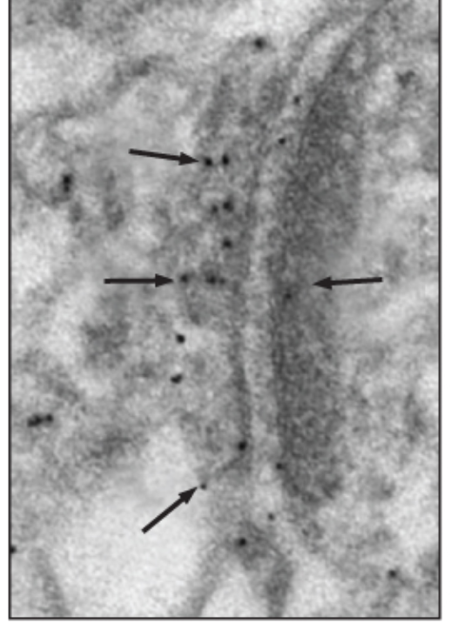

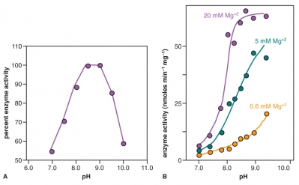
15 17
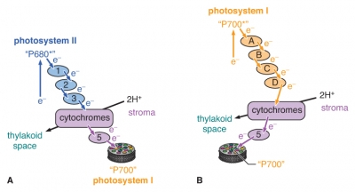
16

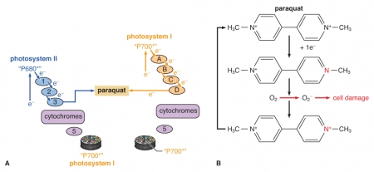
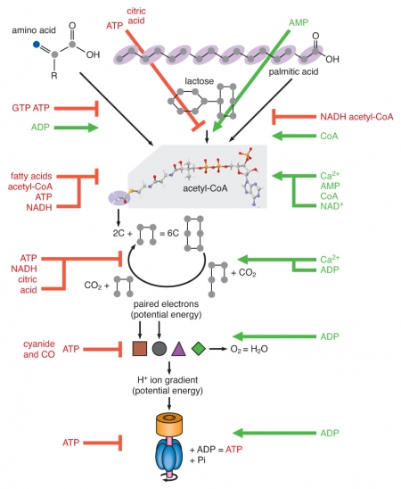
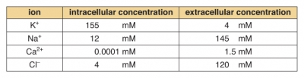
18 19 20

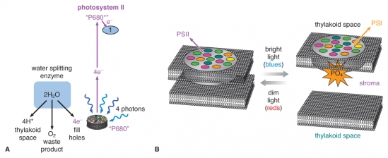

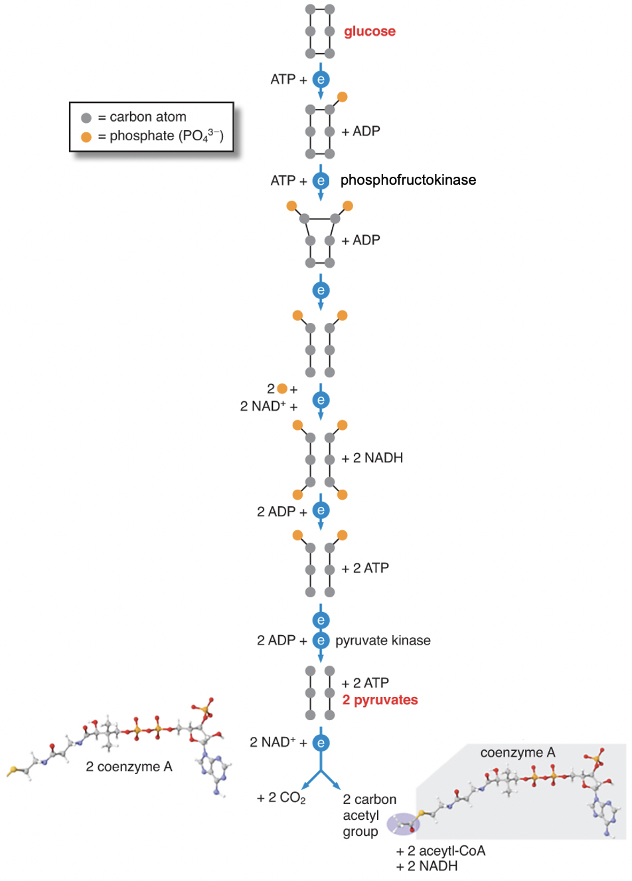
21 22

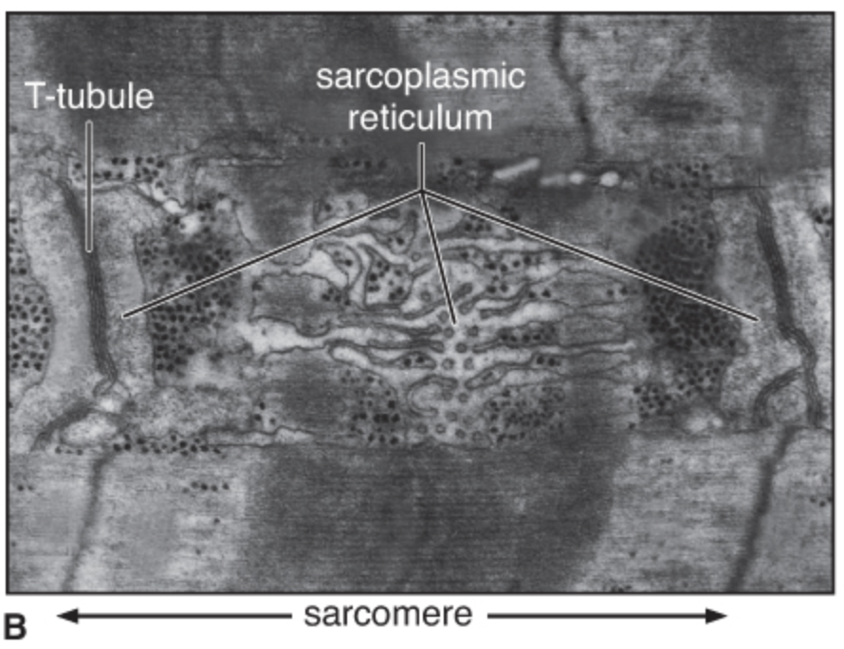

23
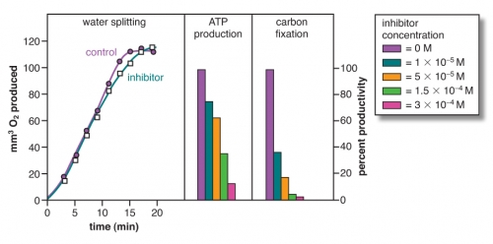

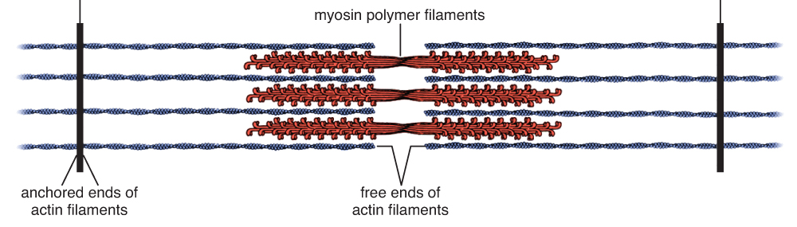
24 25
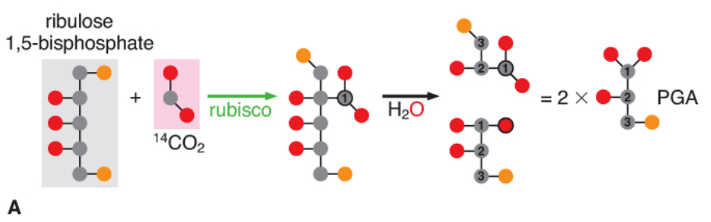
26

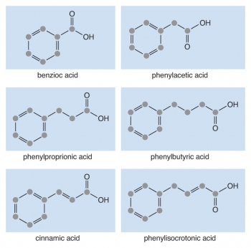
27

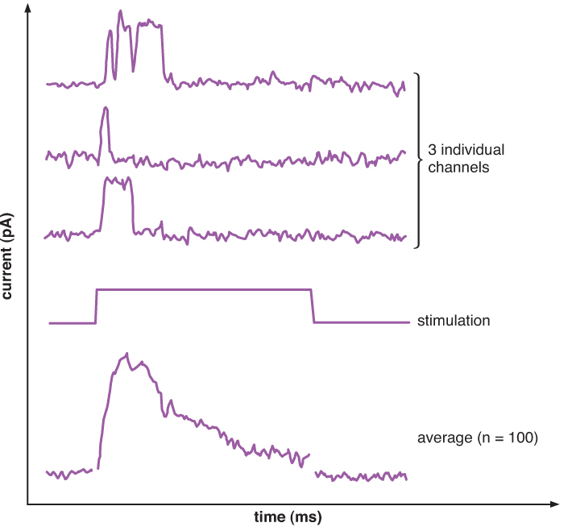
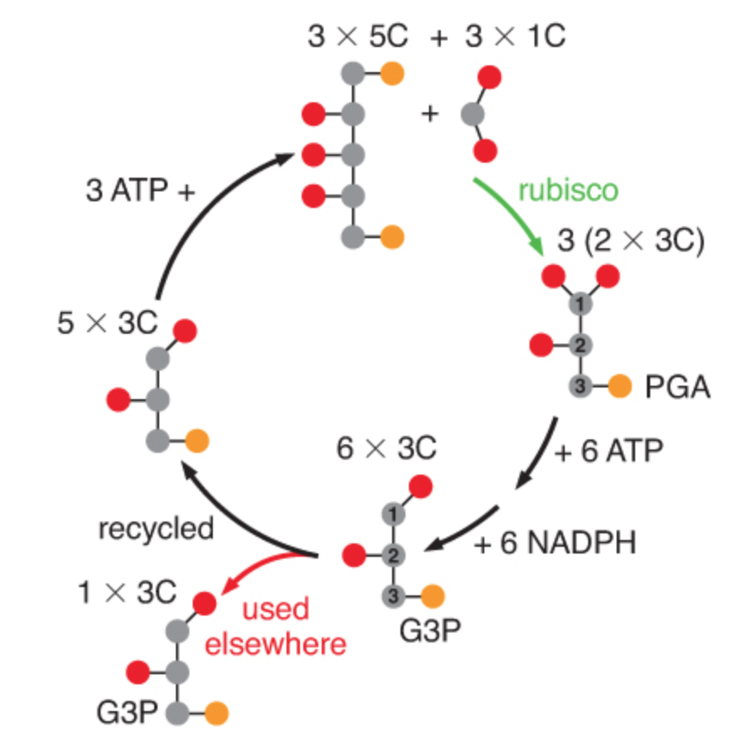
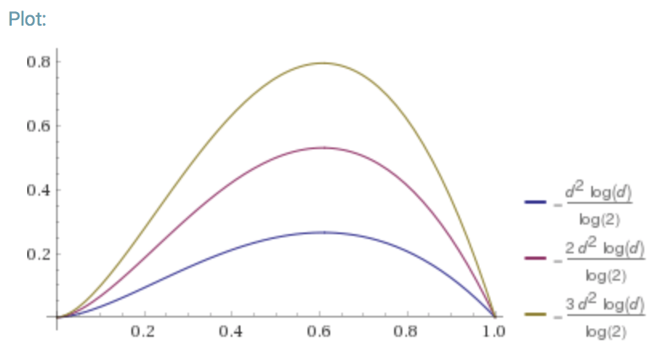
28 29 30

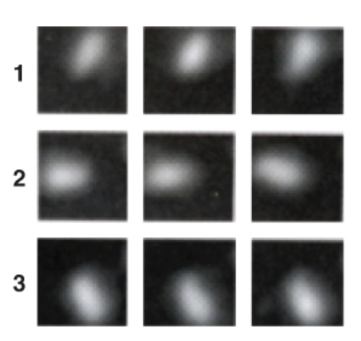

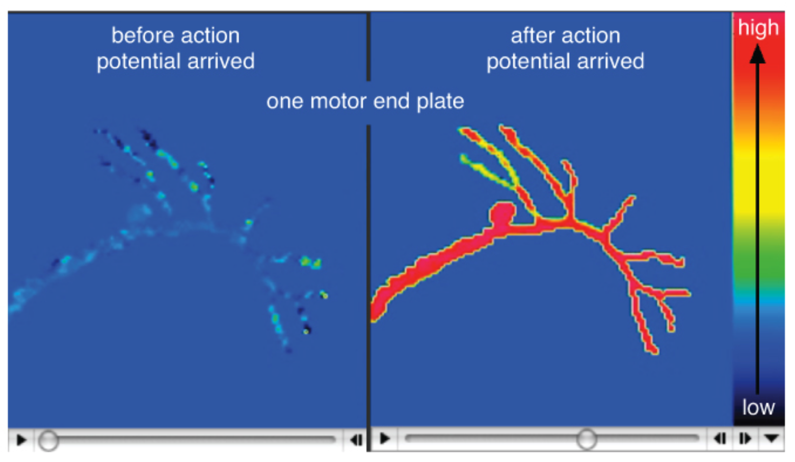
31
32
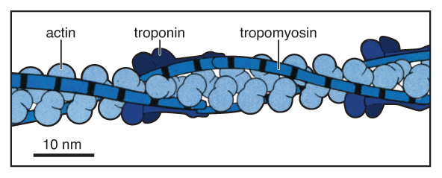
33

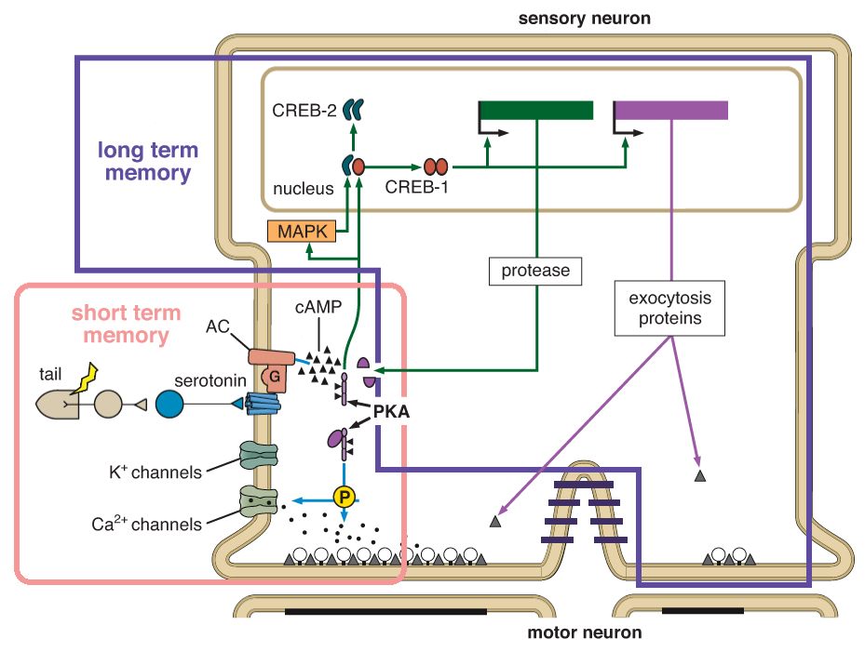
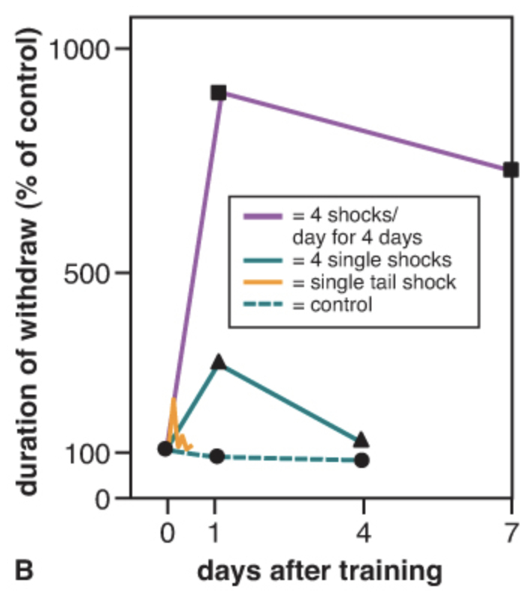

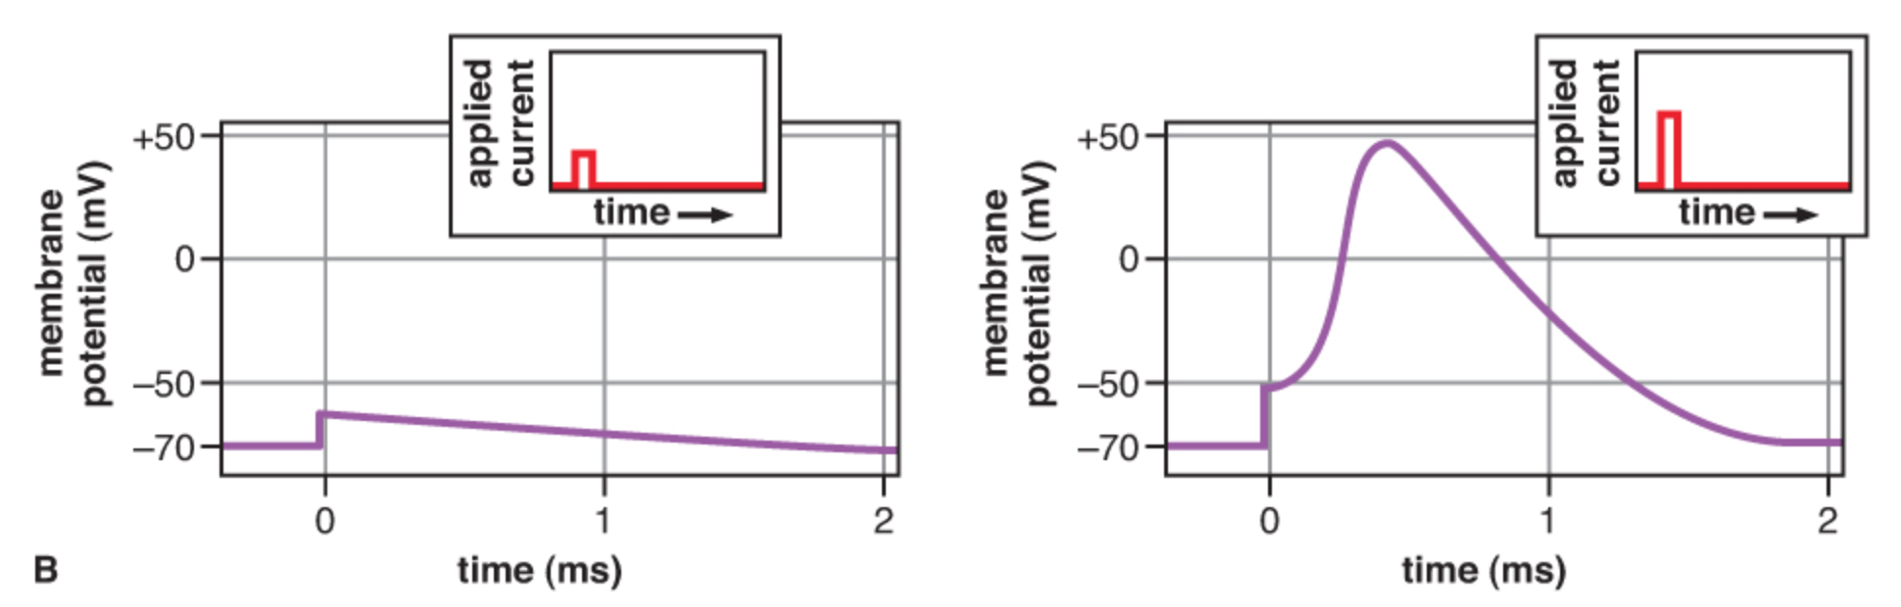
34
35 36

