Biology 113 Closed Book Take-Home Final Exam

There is no time limit on this test, though I have tried to design one that you should be able to complete within 3 hours. There are 7 pages in this final exam, including this cover sheet. There are two supplementary files as well: “RawData_Fall2020.xlsx” and “Sequencing Results Exam3 F2020.docx”. You are not allowed to look at someone else’s test, nor use your notes, old tests, the internet, any books, nor are you allowed to discuss the test with anyone until all exams are turned in by noon EST Tuesday December 8. EXAM IS DUE NO LATER THAN NOON TUESDAY DECEMBER 8th. If you turn in your exam late, then you lose a letter grade for each day you are late unless you communicate with me in advance. The answers to the questions must be typed directly under the questions unless the question specifically says to write the answer in different place. If you do not write your answers in the appropriate location, I may not find them.

I have provided you with a “Data Gallery” in the form of figures and tables. To choose a figure in support of your answer, state Figure #x and do NOT move the image on your test. Do not assume how many of the data images you will use, or not use. Simply choosing the data is not sufficient support for your answer, however. You must explain the significance of the data and how they support your answer. I have given you word limits so be concise.

-3 pts if you do not follow this direction.
Please do not write or type your name on any page other than this cover page.
Staple all your pages together when finished with the exam. Do not print test pages without answers. I only want to see your answers. You can type your answers right under each question.

Name (please type here):

Read the pledge and sign if you can do so with honor:

_______________________________________

On my honor I have neither given nor received unauthorized information regarding this work, I have followed and will continue to observe all regulations regarding it, and I am unaware of any violation of the Honor Code by others.

How long did this exam take you to complete?
Lab Questions
10 pts.
1) This question is holistic. You must perform several steps to reach the final conclusion and answer this question.
Step 1: Open the file “Sequencing Results Exam4 F2020.docx” and perform a clustal omega alignment on these DNA sequences. (https://www.ebi.ac.uk/Tools/msa/clustalo/) Capture a screenshot of your results and paste it here:

Step 2: Notice that the -35 and -10 sites have been underlined in the intended promoter sequence you used for the alignment.
Step 3: Process the raw data in the file called “RawData_Fall2020.xlsx”. These data include RFP values and absorbance values at 600 nm, as indicated. Calculate the average relative fluorescence for the positive control, the negative control and the 3 experimentally cloned promoters labeled X1 – X3.
Step 4: Produce a bar graph with standard error of the mean for error bars (SEM formula is “=STDEV(start:end)/SQRT(n)”. Note that start:end is the data range and n = sample size.
Step 5: Insert a screenshot of your graph here:

Step 5: Evaluate the 3 experimental promoters using all the data provided to you. Limit your evaluations to a maximum of 45 words each.
X1:
X2:
X3:
Step 6: Include in your email to me the Excel file and this Word file so I can grade both.

Class Questions:
15 pts.
2) “Out damn spot!” Macbeth, Act 5, Scene 1.
a) As you know, I recently donated blood to the Red Cross because there is a national need and I am O negative blood type (universal donor). I biked to the donation site and my blood had a pH of 7.1. After doing the paperwork, my blood had pH 7.5 and the oxygen concentration was 30 mmHg oxygen the entire time. Quantify the percentage of my hemoglobin that contained the indicated number of oxygen molecules. (type your numerical answers in the boxes)
 | pH 7.1 | pH 7.5
0 oxygen bound
1 oxygen bound
2 oxygen bound
3 oxygen bound
4 oxygen bound

b) Describe the two emergent properties that influence your answers in the table above. Limit your answer to a maximum of 40 words for each emergent property.
Property 1:
Property 2:

c) What common mechanism is responsible for these emergent properties. Support your answer with one figure. Limit your answer to a maximum of 40 words.

15 pts.
3) There’s a light, over at the Frankenstein place…
a) Use figure 33 to explain how V. fischeri turns on light production. Limit your answer to a maximum of 50 words.

b) Can bacteria communicate with each other about more than just cell density? Support your answer using 2 figures. Limit your answer to a maximum of 40 words for each figure.
Figure 1:
Figure 2:

15 pts.
4) pregnancy
a) Integrate figures 8 and 18 to describe a mother’s immune system during a successful pregnancy. Limit your answer to a maximum of 40 words for each figure.
Figure 8:
Figure 18:

b) Summarize the function of MHC I. Support your summary with two figures. Limit your answer to a maximum of 40 words for each figure.
Figure 1:
Figure 2:

15 pts.
5) You cannot wait on your weight.
a) What tissues produce the encoded proteins that are mutated in ob and db animals? For each answer describe the function of the protein. Limit your answer to a maximum of 40 words for each gene.
ob:
db:

b) Explain to your family, using simple vocabulary, what is likely to happen to their bodies if they over-eat on Thanksgiving. Include the aspects of 1) fat accumulation and 2) changes in appetite as part of your answer. Support your answer with one figure. Limit your answer to a maximum of 50 words.
1)
2)

15 pts.
6) True story – advice given during a press conference with a researcher who discovered the cause of a genetic disease: “Choose your parents carefully.”
a) Look at figures 4 and 16 and explain why the atypical individuals look the way they do. Limit your answer to a maximum of 40 words for each figure.
4:
16:

b) Connect figures 7, 12 and 19 to explain what happens in the cells of typical human females. Limit your answer to a maximum of 40 words for each figure.
7:
12:
19:

15 pts.
7) Don’t let politicians make claims about sex determination that contradict scientific evidence.
a) Connect the genotypes and phenotypes for the atypical individuals in figures 25B, 26 and 29. Limit your answer to a maximum of 40 words for each figure.
25B:
26:
29:

b) Explain to a politician why a law requiring people to use public toilets based on “their sex as determined at birth” is a misguided law. Support your answer using figures 22 and 31. Limit your answer to a maximum of 50 words for each figure.
22:
31:

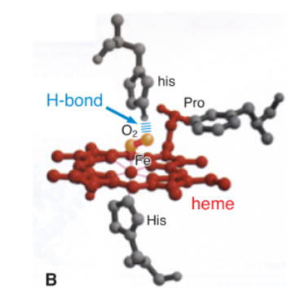
1 Data Gallery

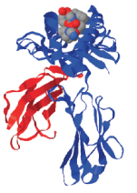
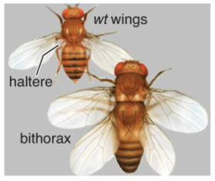
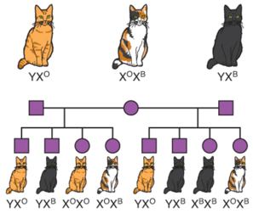
4
2 3 4

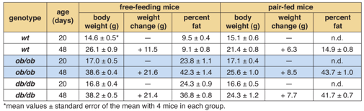
5
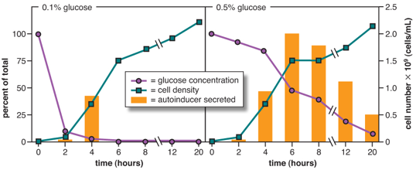
6
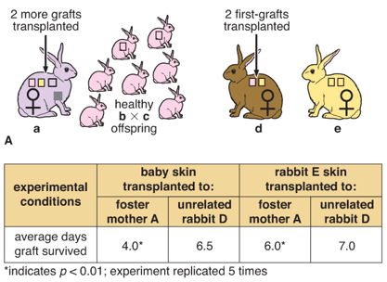
8
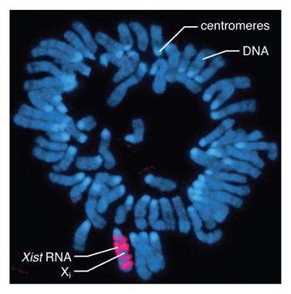
7

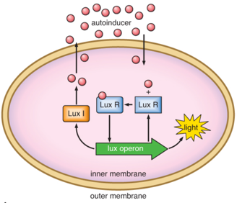

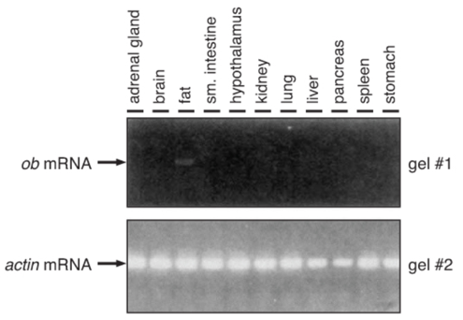
11

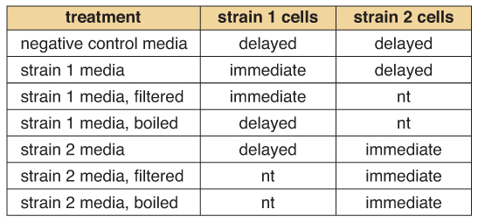
10

9
11

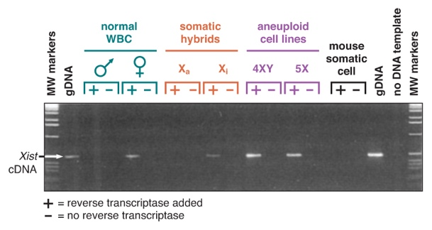
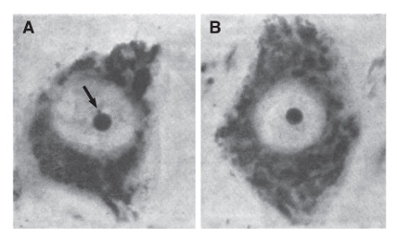
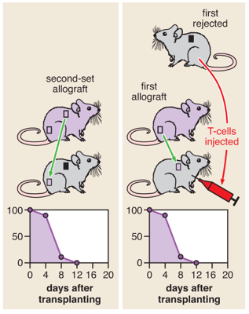
12
13 14

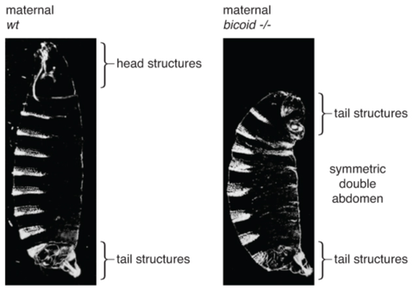
16
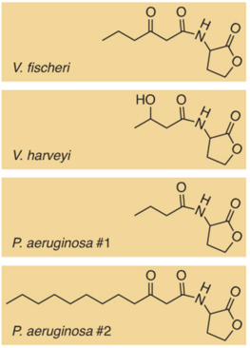
15
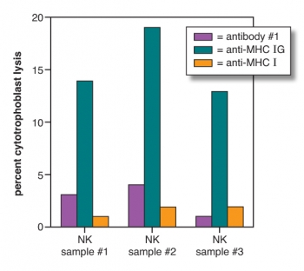
17

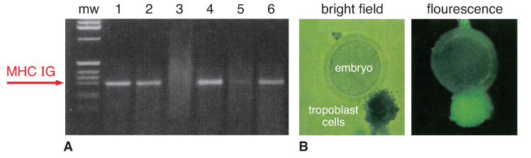
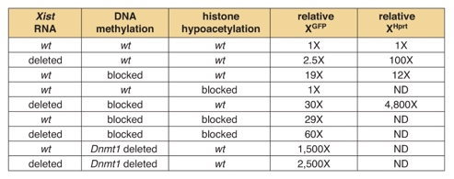
18

19
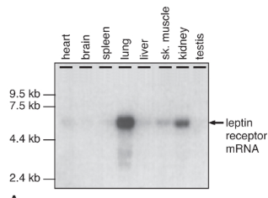

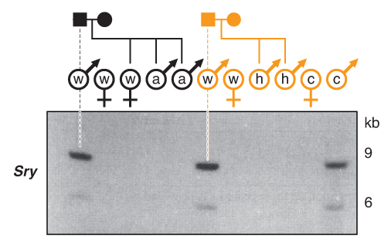
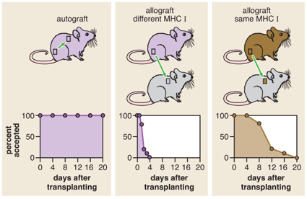
20
21 22

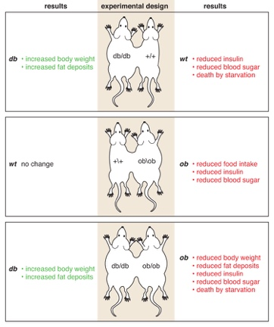
23

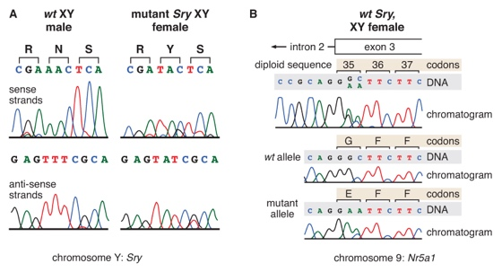
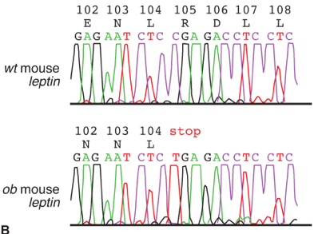
24
25

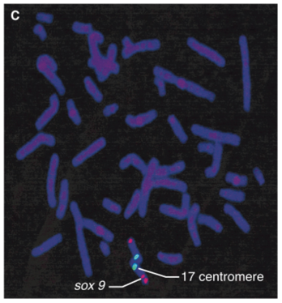
26
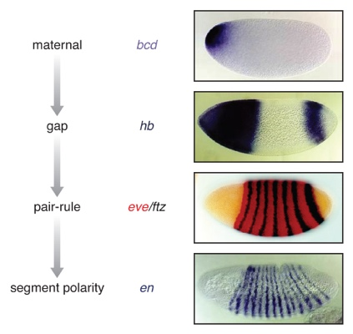
26
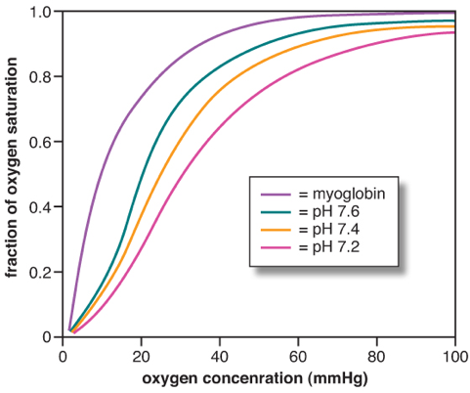
27 28

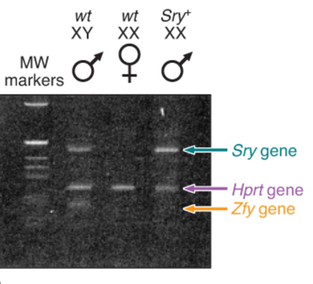
29
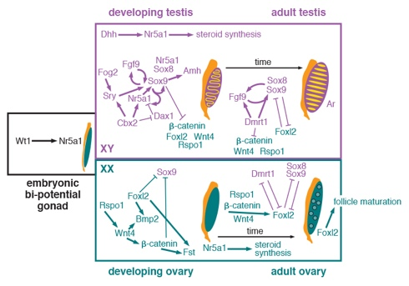
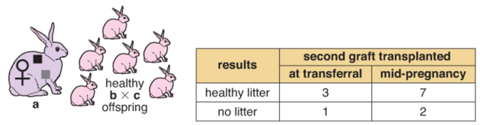
30 31

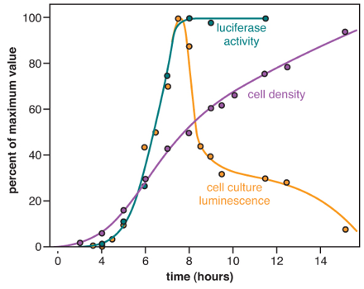

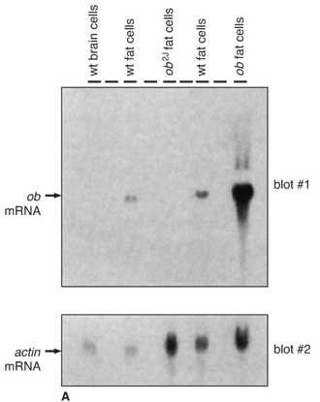
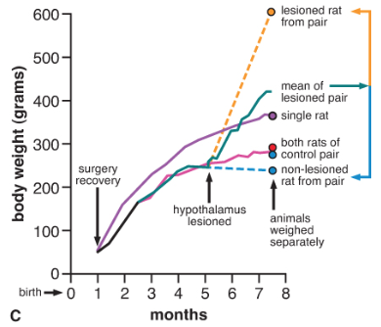
32 33 34

