High School Simulation DNA Microarrays (v1.0)
by A. Malcolm Campbell and Ben Kittinger
Davidson College, Summer 2005
Genisphere Inc.

The purpose for this simulation is to teach high school students the following:

1) Genes are differentially regulated
2) DNA microarrays can measure the activity of many genes all at one time

You can use this simulation to discuss gene regulation qualitatively. However, you could combine this simulation with the free software called MAGIC Tool (www.bio.davidson.edu/GCAT) to bring students to a new, higher level:

1) generate ratios of gene expression the represent fold change in the experimental compared to control cells
2) log transform ratios so you can compare induced and repressed genes on comparable scales
3) Use correlation coefficients to determine which genes are behaving similarly

Kit Contents:
10 glass slides that can be washed and reused once dry
6 dropper bottles, numbered 1 – 6 that represent the genes to be spotted (contain 1% agarose and pH indicators)
1 dropper bottle of Hybridization Buffer

Materials Required (not included):
Oven or water bath set to 65-70ºC to melt spotting solutions
Camera for taking photos to document data
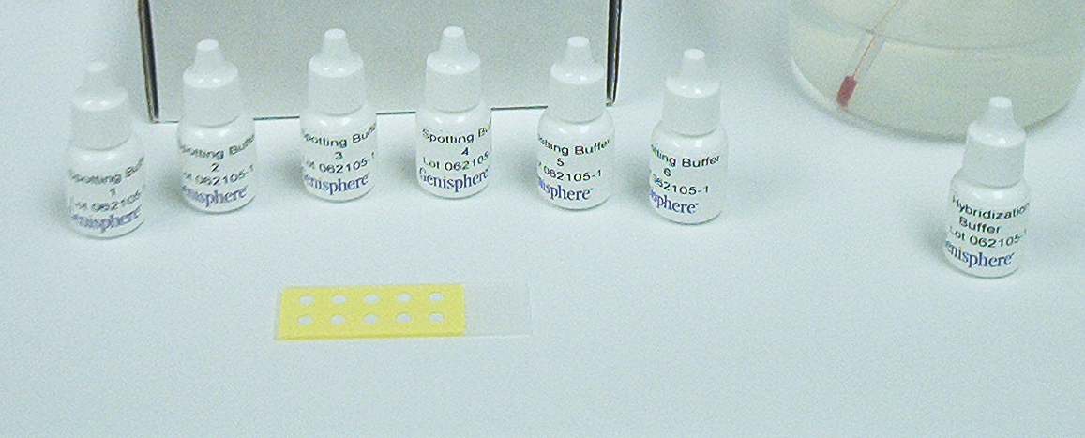

Key to Tubes 1 – 6:
1 = deep red (gene induced in experimental condition)
2 = purple (mixed red and blue; gene equally transcribed in both conditions)
3 = blue (gene repressed in experimental condition)
4 = blank (gene not transcribed under either condition)
5 = light red (gene slightly induced in experimental condition)
6 = light blue (gene slightly repressed in experimental condition)
Procedure for Use:

- Melt contents of microfuge tubes 1 – 6 by placing them into an oven set at 65-70ºC for 20-30 minutes prior to use. Alternatively, partially submerge the 6 dropper bottles (bottle 1/3 of the bottle) in a water bath at 65ºC for 20-30 minutes. Maintain at about 40-45ºC to keep melted. (Note to instructor: Do this before students arrive.) Loosen caps once or twice during the melting process to release excess pressure. Keep lids on to avoid complete evaporation while waiting to spot the arrays.

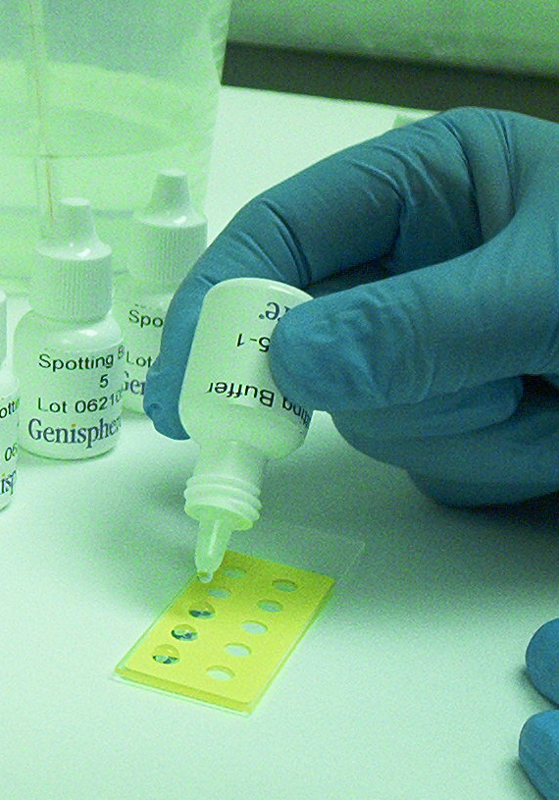
2) Spot out the contents of the tubes by gently spotting one drop from each bottle into a circle. Do not overflow the spotting circle. If the drop build up to a dome, that is fine but not necessary. Tell the students these are the targets DNA sequences for 6 genes. The agarose will harden in one to two minutes. If the spots are hardening too slowly, place the slide on ice or in a 4ºC refrigerator for a few minutes to expidite the process. One a separate piece of paper or in a notebook have the students draw a diagram of the slide indicating the position of each spots on the slide. Alternatively, they can write numbers 1 – 6 on the background so they can track the ID of each gene. In doing this, they have performed the major steps of printing their own DNA macroarray. I recommend using the 6 spots furthest away from the label.

3) Place the slide on a white piece of paper. Apply 2 drops of “Hybridization Solution” to each spot. Cover with a small box or some type of container that can block out the light and allow color to develop (2-5 minutes). The mRNA from the control cells was labeled blue. The mRNA from experimental cells was labeled red. You cannot see the color because the mRNA is very diffuse, but it will base pair with the DNA for each gene spotted onto the macroarray. This is the principle behind real DNA microarrays.

[In our simulation, we simply convert the pH indicators from clear to blue or red by exposing to high pH.]

4) Once the blue color appears dark, remove the slide and place it on something white.

5) Take a photo and have students explain which genes were activated in which cell types. You might be able to do it on cell phones, or just any digital camera will do. Film cameras of course will work too, but you won’t get the data right away.

Notes:

Six sets of genes that can be used to call tubes 1 – 6. The scenarios are: breast cancer, diaxic shift in yeast, gastric cancer, HIV infection, lung cancer, malaria life cycle. Each of these scenarios comes with photos of the real genes and guides to web sites that have REAL data that students can mine. They can compare their simulated data to the real data and see they are in the right ballpark. From here, they can explore other genes that behaved similar to their 6 genes and this can lead to a discussion of why some genes might cluster together. Clustering gene expression sets you up for quantitative DNA microarray data and using MAGIC Tool.

SAFETY CONCERNS:
Basic solutions can be caustic so have students wash their hands after lab. If anyone has any itching sensation, have them wash right away.

The dyes are toxic if swallowed, but basically pretty harmless. (See sections 10 and 11 of MSDS)
http://avogadro.chem.iastate.edu/MSDS/phenolphthalein.htm
http://avogadro.chem.iastate.edu/MSDS/thymolphthalein-0.05pct.htm

