PKAL F21 National Meeting – Chicago
October 6 – 8, 2006

Connections between Mathematics & Biology

Biomathematics Problems
by
Laurie J. Heyer, A. Malcolm Campbell and W. Lance Harden

Most of these problems were taken from Math Minutes, written by Heyer and Campbell for their genomics textbook. The book’s website (http://wps.aw.com/bc_campbell_genomics_2/) provides many free electronic files that facilitate answering some of the questions.
Biomathematics Problem 1
What is a Dot Plot?
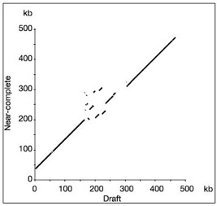
Humans are very good at identifying patterns visually, so one of the first ways that DNA sequences were compared was with a dot plot. The dot plot in Figure 1 compares the finished and draft sequences of human chromosome 7. The vertical axis represents 500,000 bases of the finished sequence, listed from bottom to top, and the horizontal axis represents 500,000 bases of the draft sequence, listed from left to right. Think of the rectangular area enclosed by the two axes as a matrix of 500,000² = 2.5×10¹¹ invisible dots, one for each combination of a base from each axis. A dot is defined by its coordinates, and colored black to indicate similarity between the two sequences. To explore how this process works, we will use a simple example comparing two DNA sequences that are only 15 bases long: Seq1=AGGACTGTGATCTGT and Seq2=CTCTGTGAGTCTTAT.
Figure 1: Dot Plot comparing draft and finished sequences of human chromosome 7
The simplest way to create a dot plot would be to compare one letter at a time, defining similarity as base identity. Using this method, if the 7th base in Seq1 is identical to the 5th base in Seq2, then dot (7,5) is colored black. If they are different bases, the dot (7,5) is left invisible. In the grid below, make a simple dot plot to compare Seq1 and Seq2.

Questions
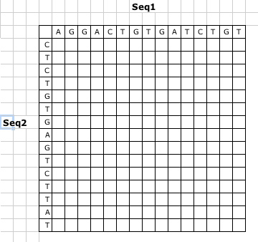
1. What is the problem with the simple dot plot you made in the grid above? What would Figure 1 look like using this approach?
2. Develop a better way of making a dot plot, so that significant regions of similarity are easily visible, as in Figure 1. (Hint: consider using a sliding window.)

3. Suppose that two sequences are identical except that a segment is inverted in one sequence, relative to the other. Explain how such an inversion would be displayed in a dot plot.
4. Suppose that two sequences are identical except that a segment is deleted from the middle of one sequence and not from the other. Explain how such a deletion would be displayed in a dot plot.
5. What would be the value in using a dot plot to compare a sequence to a second sequence, as well as the reverse complement of that second sequence?
6. What would be the value in using the exact same sequence on both the horizontal and vertical axes? Sketch dot plots that illustrate your answer.
7. What would be the value in using a dot plot to compare a sequence to its own reverse complement?

References
A. Malcolm Campbell and Laurie J. Heyer. Discovering Genomics, Proteomics & Bioinformatics 2E. (February, 2008). Cold Spring Harbor Laboratory Press and Benjamin Cummings. <http://awl.com/genomics>

A. Malcolm Campbell and Laurie J. Heyer. Instructor’s Guide to “Discovering Genomics, Proteomics & Bioinformatics”2E. (March, 2006) Benjamin Cummings

Harden, Lance and Laurie J. Heyer. Do-It-Yourself Gene Assembly Gene Synthesis Optimization Program. <http://gcat.davidson.edu/IGEM06/oligo.html>. Accessed 24 August, 2006.

