PKAL F21 National Meeting – Chicago
October 6 – 8, 2006

Connections between Mathematics & Biology

Biomathematics Problems
by
Laurie J. Heyer, A. Malcolm Campbell and W. Lance Harden

Most of these problems were taken from Math Minutes, written by Heyer and Campbell for their genomics textbook. The book’s website (http://wps.aw.com/bc_campbell_genomics_2/) provides many free electronic files that facilitate answering some of the questions.
Biomathematics Problem 2
Can you estimate the number of inversions in a dot plot?
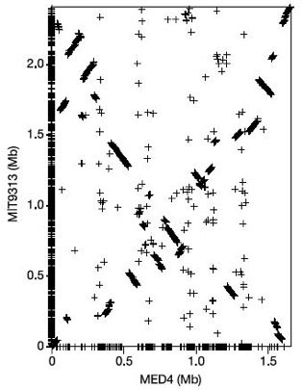
Dot plots like those in Biomathematics Problem 1 and this figure help us visualize large-scale comparisons of genomes. By coloring the dot (or in this case, drawing a +) at the location of aligned chromosomes, we see large segments of the chromosome were rearranged as MED4 and MIT9313 (two cyanobacteria genomes) genomes diverged. If there had been no rearrangements, the dot plot would consist of a diagonal line of plus signs, from the bottom left to the top right.
To help understand the differences between MED4 and MIT9313, and quantify the evolutionary distance between them, we would like to reconstruct the genome rearrangements that might have occurred over time. Visually, reconstruction means moving and/or inverting segments of genes in one genome until total synteny with the other genome is achieved (i.e. until the dot plot is a diagonal line).
Let’s consider a simple example of one chromosome that has 4 genes. To explore this reconstruction process mathematically, we restrict ourselves to rearrangements consisting of chromosomal inversions only. Note that what a biologist calls an inversion, a computer scientist calls a reversal, which is the term we will use in this problem. The derived order of genes (-2, 4, -1, 3) has evolved away from the ancestral order (1, 2, 3, 4). A gene is negative if its orientation in inverted from the ancestral orientation.

Questions
1. Can you determine both ways to use 3 inversions (of one or more genes) to convert the derived order into the ancestral order?
2. Go to the GRIMM site (http://nbcr.sdsc.edu/GRIMM/grimm.cgi) and enter the mouse gene order from the top line of Table1 (below) into the “Source genome” box. You can leave the “Destination genome” box empty, because the program assumes the default target order of positive numbers 1 through 11. Select “multichromosomal or undirected” and “signed” options before hitting the run button. Could you have solved this problem without the website?

Table 1 Gene order on mouse X and human X chromosomes.
Query (mouse) genome 1 -7 6 -10 9 –8 2 -11 -3 5 4

Target(human) genome 1 2 3 4 5 6 7 8 9 10 11

3. At the GRIMM site, select “Human Mouse (123 genes)” from the “choose sample data” drop-down menu. Scroll down to see the results. What operations other than reversals have been performed? Why are these additional operations necessary?
References
A. Malcolm Campbell and Laurie J. Heyer. Discovering Genomics, Proteomics & Bioinformatics 2E. (February, 2008). Cold Spring Harbor Laboratory Press and Benjamin Cummings. <http://awl.com/genomics>

A. Malcolm Campbell and Laurie J. Heyer. Instructor’s Guide to “Discovering Genomics, Proteomics & Bioinformatics”2E. (March, 2006) Benjamin Cummings

Harden, Lance and Laurie J. Heyer. Do-It-Yourself Gene Assembly Gene Synthesis Optimization Program. <http://gcat.davidson.edu/IGEM06/oligo.html>. Accessed 24 August, 2006.

