PKAL F21 National Meeting – Chicago
October 6 – 8, 2006

Connections between Mathematics & Biology

Biomathematics Problems
by
Laurie J. Heyer, A. Malcolm Campbell and W. Lance Harden

Most of these problems were taken from Math Minutes, written by Heyer and Campbell for their genomics textbook. The book’s website (http://wps.aw.com/bc_campbell_genomics_2/) provides many free electronic files that facilitate answering some of the questions.
Biomathematics Problem 7
How do you analyze microarray data?
DNA microarrays allow investigators to measure simultaneously the gene activity of every gene in a genome. The data are two images that allow quantitative measurements of relative gene expression by comparing the amount of gene activity in one condition to the gene activity in a second condition. These data are usually converted to a ratio of gene expression by dividing the experimental gene expression by the control gene expression. In the experiment below, only 12 genes are displayed and the experimental condition was a time course of genome response to the addition of a drug.
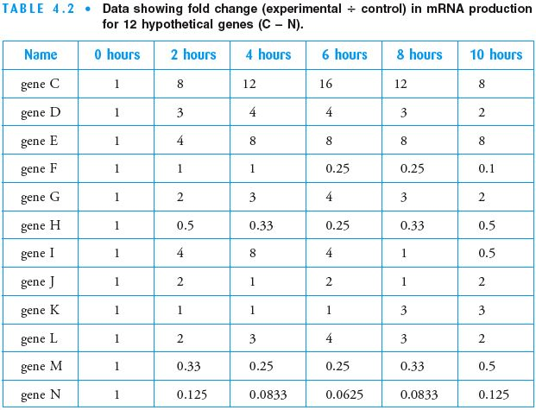

Questions
1. Graph the expression patterns for genes C and N from the table on a single set of axes. Using your graph, can you tell which genes changed the most in their fold expression? If not, transform your data into a format that allows you to visualized magnitude induction and repression on one graph.
2. Using your graph above, can you detect clusters of similar genes? Quantify the degree of similarity within each cluster.
3. Create a dendrogram of these 12 genes that illustrate their similarities and differences of expression pattern.
References
A. Malcolm Campbell and Laurie J. Heyer. Discovering Genomics, Proteomics & Bioinformatics 2E. (February, 2008). Cold Spring Harbor Laboratory Press and Benjamin Cummings. <http://awl.com/genomics>

A. Malcolm Campbell and Laurie J. Heyer. Instructor’s Guide to “Discovering Genomics, Proteomics & Bioinformatics”2E. (March, 2006) Benjamin Cummings

Harden, Lance and Laurie J. Heyer. Do-It-Yourself Gene Assembly Gene Synthesis Optimization Program. <http://gcat.davidson.edu/IGEM06/oligo.html>. Accessed 24 August, 2006.

