PKAL F21 National Meeting – Chicago
October 6 – 8, 2006

Connections between Mathematics & Biology

Biomathematics Problems
by
Laurie J. Heyer, A. Malcolm Campbell and W. Lance Harden

Most of these problems were taken from Math Minutes, written by Heyer and Campbell for their genomics textbook. The book’s website (http://wps.aw.com/bc_campbell_genomics_2/) provides many free electronic files that facilitate answering some of the questions.
Biomathematics Problem 9
What’s the right dose of medication?
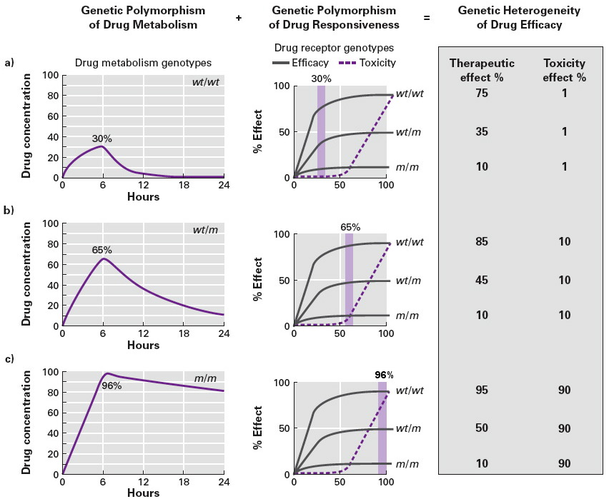
One of the goals of pharmacogenomics is to find appropriate drugs and dosages for individuals of different genotypes. The hypothetical drug described in the figure below has minimal therapeutic effect on patients with m/m receptor genotypes, regardless of dose. However, patients with wt/wt or wt/m receptor genotypes can benefit from the drug, provided the dose is nontoxic. For concentrations of active drug greater than 50%, toxicity increases rapidly, while therapeutic effect increases very slowly. Therefore, activated drug concentration should probably be kept near 50% for all patients. Depending on factors such as disease severity, drug cost, and patient risk tolerance, lower concentrations might be desirable.

Suppose 100 mg of the drug is administered orally to a patient with wt/wt metabolism genotype. The drug is absorbed into the bloodstream at a constant rate of 16 mg per hour, causing an increase in overall concentration over the first several hours. To simplify this analysis, we will assume that the 16 mg enters the bloodstream all at once, at the beginning of the hour. We further assume that metabolizing proteins inactivate the drug at a rate constant of 0.32 after it enters the blood.

Questions
1. Write the difference equations that model drug absorption and inactivation. Verify your equations using the numbers provided above and the wt/wt curve in the Figure.
2. Using the same 16 mg/hr absorption rate, find an inactivation proportionality constant that generates the drug concentration curve for the wt/m metabolism genotype (see the Figure above).
3. Using the inactivation proportionality constant you found in question 2, what is the initial dose you should administer so the peak concentration is roughly 50%? This dosage would be more appropriate for patients with the wt/m metabolism genotype.

References
A. Malcolm Campbell and Laurie J. Heyer. Discovering Genomics, Proteomics & Bioinformatics 2E. (February, 2008). Cold Spring Harbor Laboratory Press and Benjamin Cummings. <http://awl.com/genomics>

A. Malcolm Campbell and Laurie J. Heyer. Instructor’s Guide to “Discovering Genomics, Proteomics & Bioinformatics”2E. (March, 2006) Benjamin Cummings

Harden, Lance and Laurie J. Heyer. Do-It-Yourself Gene Assembly Gene Synthesis Optimization Program. <http://gcat.davidson.edu/IGEM06/oligo.html>. Accessed 24 August, 2006.

