Modified Protocol for Cleaning the Pins

- Soak pins in 50mM KOH for 5 minutes, careful not to let pin holder touch the liquid.
- Rinse pins in dH₂O by wiggling in cup for ~5 seconds twice (in 2 separate containers) to wash away excess salt.
- Sonicate for 30 minutes to 1 hour.
- Soak in 90-95% EtOH for 30 minutes to 1 hour.
- Let pins dry by hanging above EtOH for at least 5 minutes and not too much longer (dust).
10 minutes + 1 hour + 1 hour +10 minutes = 2 hours and 20 minutes
Notes:
•Never let pin tips touch bottom of any container.
•It’s important to let pins dry before running the printer: washes may not be sufficient to get EtOH off.
•30 minutes may be sufficient as a minimum for sonicate/soak, but the longer they do each, the better they perform.
•Always wear powder-free gloves when handling the pin tool.
•Always clean pins before a major run. Once the pin tool has been placed back in its polyethylene holder, it must be cleaned carefully in order to work.

Loading the Microwell Plate
The example of the Johns Hopkins 96 oligo prints has been used throughout this protocol.
Each oligo sample is represent by a number, 1 through 96. It is more logical to look at the 384-microwell plate 90 degrees rotated, because well number A1 is placed bottom left when the microwell plate is loaded into the microarray printer. Volume per microwell depends on how many slides you are printing. 10-25 μl is recommended, but anything below 10 μl will not print because the bottom of the plastic is not covered. Any amount over 25 μl will stick to the sides of the pins and drip onto the chip.
I used 20 μl for each well.
24
23
22
21
20
19
18
17
16
15
14
13
12
11
10
9
8 |  | 96
7 |  | 49
6 | 66 | 90 | 67 | 91 | 68 | 92 | 69 | 93 | 70 |  | 71 |  | 72 | 94 | 73 | 95
5 | 17 | 41 | 18 | 42 | 19 | 43 | 20 | 44 | 21 | 45 | 22 | 46 | 23 | 47 | 24 | 48
4 | 58 | 82 | 59 | 83 | 60 | 84 | 61 | 85 | 62 | 86 | 63 | 87 | 64 | 88 | 65 | 89
3 | 9 | 33 | 10 | 34 | 11 | 35 | 12 | 36 | 13 | 37 | 14 | 38 | 15 | 39 | 16 | 40
2 | 50 | 74 | 51 | 75 | 52 | 76 | 53 | 77 | 54 | 78 | 55 | 79 | 56 | 80 | 57 | 81
1 | 1 | 25 | 2 | 26 | 3 | 27 | 4 | 28 | 5 | 29 | 6 | 30 | 7 | 31 | 8 | 32
 | A | B | C | D | E | F | G | H | I | J | K | L | M | N | O | P
Figure 1. This is how I loaded the microwell plate.
The microwell plate is turned 90 degrees to show how it actually fits into the machine.

70 | 70 | 71 | 71 | 72 | 72 | 73 | 73 |  |  |  |  |  |  |  | 94 | 94 | 95 | 95 | 96 | 96
65 | 65 | 66 | 66 | 67 | 67 | 68 | 68 | 69 | 69 |  | 89 | 89 | 90 | 90 | 91 | 91 | 92 | 92 | 93 | 93
60 | 60 | 61 | 61 | 62 | 62 | 63 | 63 | 64 | 64 |  | 84 | 84 | 85 | 85 | 86 | 86 | 87 | 87 | 88 | 88
55 | 55 | 56 | 56 | 57 | 57 | 58 | 58 | 59 | 59 |  | 79 | 79 | 80 | 80 | 81 | 81 | 82 | 82 | 83 | 83
50 | 50 | 51 | 51 | 52 | 52 | 53 | 53 | 54 | 54 |  | 74 | 74 | 75 | 75 | 76 | 76 | 77 | 77 | 78 | 78
21 | 21 | 22 | 22 | 23 | 23 | 24 | 24 |  |  |  | 45 | 45 | 46 | 46 | 47 | 47 | 48 | 48 | 49 | 49
16 | 16 | 17 | 17 | 18 | 18 | 19 | 19 | 20 | 20 |  | 40 | 40 | 41 | 41 | 42 | 42 | 43 | 43 | 44 | 44
11 | 11 | 12 | 12 | 13 | 13 | 14 | 14 | 15 | 15 |  | 35 | 35 | 36 | 36 | 37 | 37 | 38 | 38 | 39 | 39
6 | 6 | 7 | 7 | 8 | 8 | 9 | 9 | 10 | 10 |  | 30 | 30 | 31 | 31 | 32 | 32 | 33 | 33 | 34 | 34
1 | 1 | 2 | 2 | 3 | 3 | 4 | 4 | 5 | 5 |  | 25 | 25 | 26 | 26 | 27 | 27 | 28 | 28 | 29 | 29
Figure 2. This figure shows how the spots are actually printed on the glass slide when the microwell plate is loaded in Figure 1 configuration (using the following software parameters). This figure represents one metagrid, composed of four grids. I designed the metagrid so that the grids will look asymmetrical after scanning.

Software
Only 4 pins were used to print the 96 oligos. Each spot was printed in duplicates.
Options:
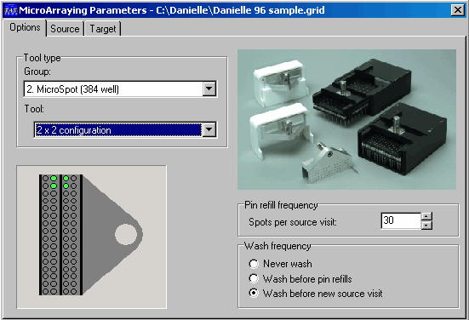

← Four pin positions are highlighted

←This number tells you how many times
each pin will print, including pre-spots.
I used 30, which included 10 pre-spots,
and 20 real spots.

←This option saves DNA by only washing before
different DNA sample is loaded into the pins.
Figure 3. Option tab.

Source:

This number must include the blanks!___

Figure 4. Source tab. “Number of samples” must include the blanks. In other words, empty spots must be counted as samples.
For example, to print in Figure 2 configuration, you must enter “100” not “96” because there were 4 blanks –
in other words, there are 200 spot locations in one metagrid (100 samples including blanks in duplicates).
I made the mistake of entering 96, and wondered why the top right corners of the grids were always missing!
Target:
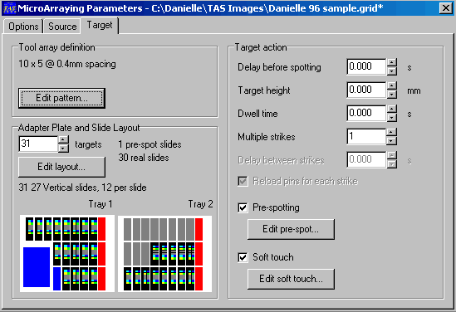
Figure 5. Target tab. Leave the Pre-spotting and soft touch options on. Pre-spotting gets rid of the excess liquid .
Click on “Edit pre-spot” to determine how many pre-spots you will print.
Know how many pre-spot slides are required for pre-spotting to know how many real slides you will be printing.
Then click on the “Edit pattern” button for next.

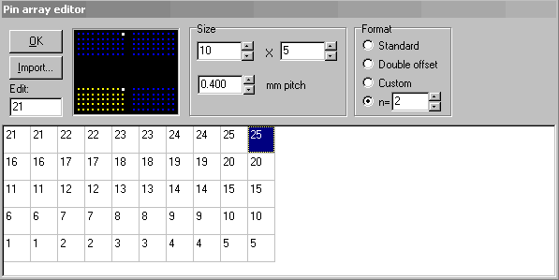
Figure 6. Edit pattern tab. If you click and hold on the yellow spots, you can see the source wells for each spot.
Set n=2 to print in duplicates. Click OK.

Click on “Edit Layout” from the Target window for next.
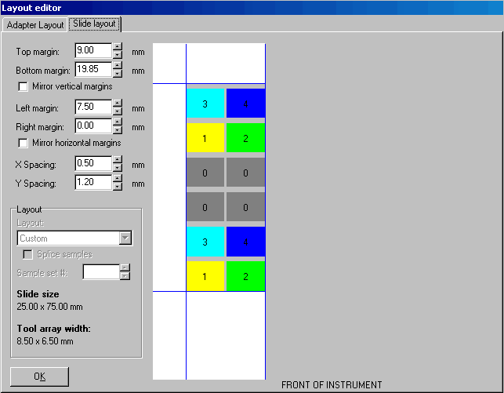
Figure 7. Slide layout tab.
The slide layout shows the physical dimensions of the slide. I have found out that the margins that matter the most are
the bottom margin and the left margin. The top and right margins did not matter as much because I was using
such a small area for spots. X spacing refers to the physical distance between each spot in the X direction, and Y in the Y direction.

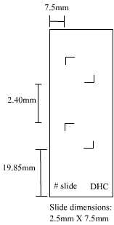
Figure 8. Slide dimensions. Here is a physical dimension of one of the printed slides.
The bottom margin was 19.85mm and the left margin was 7.5mm
(the top and right margins did not turn out to be the numbers I entered).

Before printing, check the humidity inside the printer. If the humidifier is not turned on, now is the time to turn it on. Make sure you have the flask (that is turned upside down next to the printer) filled with dH₂O. To turn on the humidifier, click on “Window” → “Run Preferences” → “Climate” tab and press “Start”.

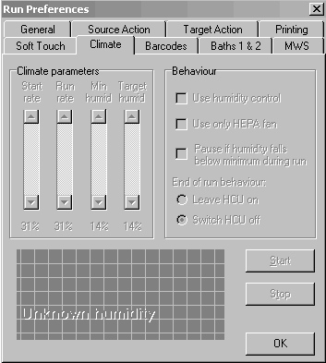
Figure 9. Window→Run Preference→Climate to turn on the humidifier.

Also, check on the “Biobank” status – make sure the water reservoir is full with fresh dH₂O.

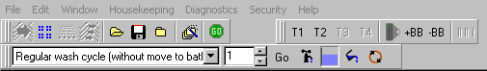
Figure 10. Water level can be checked by looking at the blue rectangle next to the faucet icon. If you click on the faucet icon,
the reservoir will start to drain (make sure you have a flask to hold the water when it comes out) if you want to fill the tank with fresh water.

You can go to “File” and then choose “Go” or click on the green “Go” icon in Figure 10.
You can also load and unload trays and the pin tool by clicking on “Housekeeping” tab.
Good luck!

