Jackie Ryan
CGH Protocols
February 20, 2006

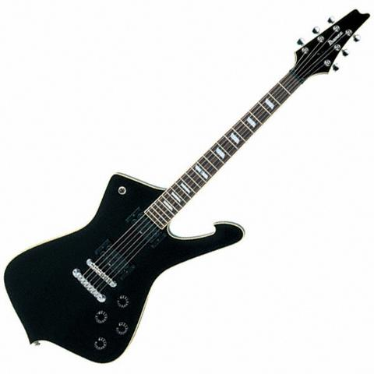 Note: To perform the following procedure you will need to check to see if the lab contains:
- Zymolase (E1003)
- Zymo YD digestion buffer (D2002-1)
- Zymo ZR Genomic DNA kit Whole Blood (D3004)
- Zymo DNA Clean and Concentration kit (D4013)
Genomic DNA isolation and tagging can be performed batch style (Steps 1-27); we prepared enough DNA for hybridizing many slides.

Genomic DNA Isolation (Day 1-approximately 1.5 hours in addition to the 12-16 hours required to grow yeast overnight)
Steps 1-3 are adapted from Zymo YeaStar Genomic DNA kit (catalogue # D2202). Kit need not be purchased, because necessary reagents can be obtained separately.

- Each standard prep isolation yields approximately 5-15 µg of genomic DNA. Therefore, grow one swab of yeast in 3 mL of liquid media overnight at 28°C for each isolation necessary. Once the yeast have grown up, tap/swirl the tube(s) of yeast in liquid media to mix. If performing multiple isolations of DNA from the same strain of yeast, combine all vials of yeast in liquid media to attain a standard concentration of cells.
Yeast doubles approximately every 90 minutes. Our yeast came from the freezer, and we did not have sufficient growth after an overnight incubation. We recommend adding “clumps” of yeast from a Petri dish or planning to incubate the yeast longer than overnight.
We suggest the following, if wanting to grow yeast batch style: incubate 3 ml of yeast per strain, inoculate the needed volume of media with this concentrated yeast, and incubate again. Jackie predicted that we needed between 9-10.5 ml of turbid yeast sample to have enough DNA for one strain to go on 2-3 slides. It is important to remember that each slide will contain a strain tagged red and one tagged green.

- Spin 1.5 mL of fresh yeast cells down briefly in a 1.5 mL microcentrifuge tube at 5,000 rpm for 2 minutes. Remove supernatant completely. Repeat this procedure two additional times so that there is a total of 4.5 mL spun-down liquid yeast culture in one 1.5 mL microcentrifuge tube and no supernatant remains.
If you are doing a large DNA isolation, there is no centrifuge that will accommodate Falcon tubes (50 ml conical tubes) and spin at 5,000 RPM. The maximum speed of the Labofuge found in the prep room (across the hall) was less than 5,000 RPM, but this was satisfactory.

- Add 120 µL of YD Digestion Buffer (Zymo catalogue# D2002-1) and 5 µL of R-Zymolyase (Zymo catalogue# E1003) to the yeast cells. Resuspend the pellet by vortexing and incubate at 37°C for 12-16 hours.

Steps 4-11 are adapted from the Zymo ZR Genomic DNA Kit Whole Blood protocol (catalogue #D3004)
- Ensure that the Zymobeads are fully resuspended by vortexing for a few seconds. Add 750 µL of Genomic Lysis Buffer and 30 µL of Zymobeads to ~125 µL of digested yeast cells from step 3. Mix by inversion several times. Let stand at room temperature for 2 minutes. Centrifuge at 5,000 rpm for 1 minute. Discard supernatant.
In order to pipet the zymobeads it is helpful to cut off the end of the pipet tip. This will prevent the tip from becoming clogged.

- Add 750 µL of Genomic Lysis Buffer to the pellet by vortexing or break up the pellet using a pipette tip. It is very important to completely resuspend and break up the pellet. Otherwise, impurity may be trapped in the aggregate and contaminate the recovered DNA. Centrifuge at 5,000 rpm for 1 minute. Discard supernatant.
- Add 1.5 mL of g-DNA Wash Buffer to the Zymobeads/DNA complex. Resuspend pellet as in step 5. Centrifuge at 5,000 rpm for 1 minute. Discard supernatant.
- Add 1.5 mL of g-DNA Wash Buffer to the Zymobeads/DNA complex. Resuspend the pellet as in step 5. Discard the supernatant. Recentrifuge briefly and remove any residual wash buffer.0
- Add 105 µL of dH₂0, vortex or break up pellet by pipetting, and incubate at 65°C for 5 minutes. (I use a water bath)
- Vortex briefly. Centrifuge at 14,000 rpm for 1 minute.
- Collect the supernatant and quantify the solution using a Nanodrop or other device. The supernatant now contains purified genomic DNA and now can be used immediately or stored at –20°C for future use.
Concentration of Genomic DNA (Day 1-optional; approximately 1 hour)
Protocol adapted from How to “Clean” DNA in the Davidson College Molecular Biology lab manual Spring 2000:
- Concentrate DNA, if necessary, using steps 12-16.
Try to avoid splitting a single strain into multiple 1.5 ml tubes. You may be able to find a centrifuge to accommodate a larger volume tube that spins at 14,000 rpm.

- Add 1/10 volume of 3M sodium acetate to DNA solution and mix (e.g.: 40 µL of sodium acetate for 400 µL DNA).
- Add 2 volumes of 4°C 100% EtOH and vortex for 10 seconds (e.g. add 800 µL of EtOH for 400 µL of DNA). Put the tube in the -70°C freezer for 30 minutes or in a -20°C freezer overnight.
- Spin in a microfuge tube for 10 minutes at 14,000 rpm. Pour out the EtOH but save the pellet!
- Wash the pellet with 500 µL of +4°C 70% EtOH, gently roll the tube, then dump the EtOH but keep the pellet, and speedvac the pellet. Speedvac until the moisture level does not recede, but do not over-dry the pellet. SAVE the pellet!
- Resuspend the DNA in appropriate volume of water.
- Quantify the concentration and quality of isolated DNA using Nanodrop or other device.
- Store Eluded DNA at -20°C or +4°C. This is a possible stopping point.

N.B. This procedure can lead to supersaturated DNA solution if too small a volume of water is added at step 16. Make sure DNA solution is clear and OD₂₆₀ readings are <1.5 before proceeding with concentrated DNA.

