Printing Microbial DNA Microarrays

Choi, D. H. and Campbell, A. M. Spring 2004. Davidson College, NC.
Independent Research.

Abstract

In collaboration with Dr. Brad Goodner, Hiram College, OH, plasmids of nine different microbial species with inserts have been printed on 41 slides. Based on a pilot study by Dan B. Pierce, printing plasmids instead of the traditional PCR products have been suggested to be effective for microarray expriments. The plasmid microarray slides will be used for hybridization with probes by Dr. Goodner’s students.

Introduction

The idea of microbial species identification using DNA microarrays has been explored in depth recently. The genome of Bacillus anthracis, the causative agent of anthrax, has been studied through microarray analysis to show chromosomal similarities among the closely related species. Also, when the SARS epidemic scared the world during the spring and summer of 2003, a group of scientists developed an efficient method for identifying viruses using microarrays to meet the medical needs.
In our pilot study, Dr. Goodner, Hiram College, has provided us with 9 different microbial species with rDNA segments as inserts, which we printed on 41 glass slides for future use. Students in Dr. Goodner’s class will design probes that may be of ecological interest. For example, probes may be designed so that presence or absense of a microbial species present on the slides may be detected in local environment by obtaining local water or dirt samples.

Material and Methods

Plasmids Preparation
The plasmids used were pCR®2.1-TOPO® with 3908 nucleotides (Figure 1). The plasmids were purified using Qiagen Hispeed Plasmid Maxi kit and the DNA concentrations were obtained by OD measurements. The names and final concentrations of the species can be found in Table 1. Based on Dan B. Pierce’s experimental results, the final concentration of 240 ng/μl seem to work the best to print on the slides in terms of signal acquisition. Even though final concentration of 480 ng/μl showed the trend of higher signal level, we decided on 240 ng/μl because of the concern about smearing due to too much DNA. The purified plasmids were cleaned and precipitated using the protocol in the Molecular Biology Lab Manual.

Printing the Slides
Only one pin was used to print all 41 slides, since one grid contained only 20 spots (the spots were printed in duplicates, including the control plasmid). The layout of the slide is shown in Figure 2. Also, the physical measurements of a printed slide is shown in Figure 3. The slide labels were printed using LABPAL™ label printer. The microwell plate configuration is shown in Figure 4. Before the printing, the pin was cleaned thoroughly following a standard protocol. Using the TAS software and MicroGrid II Compact (Biorobotics, Inc) provided by Davidson College biology department, the 9 samples were printed in duplicates in an asymmetrical configuration for easier orientation identification in the images (Figure 2). On EPO-25C epoxy slides from CEL Associates, Inc., forty one slides were printed in total, and each slide contained two metagrids (Figure 3). The spotted arrays were exposed to UV light for 3 minutes for cross-linking.

Results and Discussion

The 41 microbial DNA microarrays have been printed successfully. It would be interesting to see how the two species with lower concentrations, Enteric Group 17 and Serratia plymuthica, turn out during the hybridization and why the two species did not give as high yields as other species.

Table 1. The two species, Enteric Group 17 and Serratia plymuthica, did not proliferate as well compared to the other species during incubation, and could not be made more concentrated than the results. Also note that the final concentration is twice as concentrated than when actually printed on the slides due to the addition of spotting solution. The control plasmid MHP is one of Dan Pierce’s purified plasmids, completely unrelated to any of the other nine species.
Number | Name | Final Concentration (ng/μl)
1 | Enteric Group 17 | 120
2 | Serratia plymuthica | 120
3 | Staphylococcus gallinarum | 480
4 | Entrobacter cloacae | 480
5 | Actinomyces sp. | 480
6 | Bacillus pantothenticus | 480
7 | Pseudomonas aureofaciens | 480
8 | Listeria murrayi | 480
9 | Aeromonas hydrophilia | 480
C | Control species (MHP plasmid) | 385
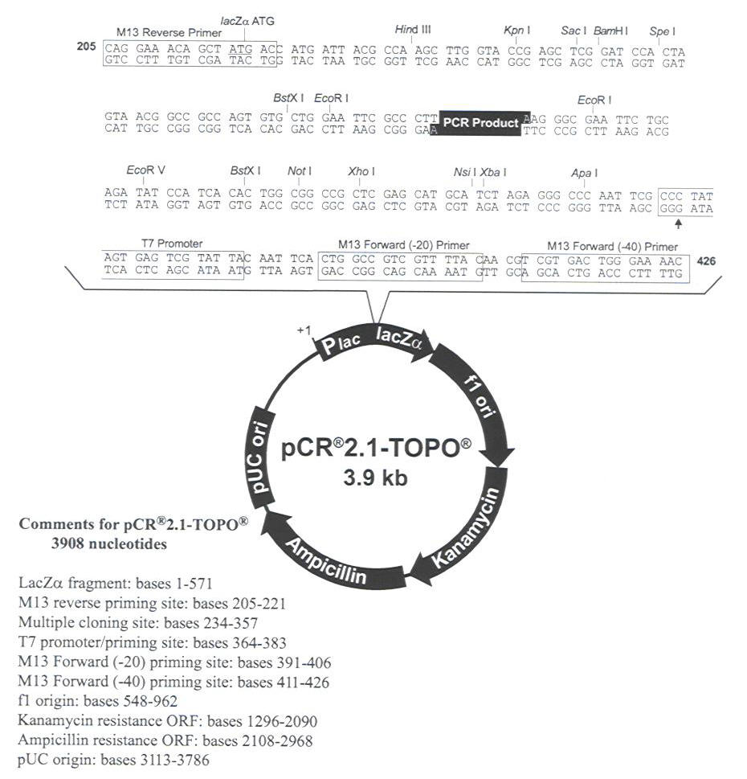
Figure 1. The design of plasmids with inserts.

6 | 6 | 7 | 7 | 8 | 8 | 9 | 9
1 | 1 | 2 | 2 | 3 | 3 | 4 | 4 | 5 | 5
C | C
Figure 2. One grid contained only 20 spots. Each slide contained 2 grids.
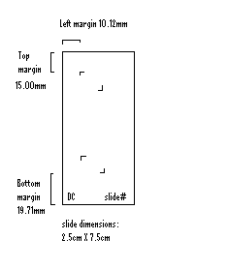
Figure 3. Physical dimensions of a printed slide. This figure is not drawn to scale.

4
3 | 4 |  | 5 |  | 6 |  | 7 |  | 8 |  | 9
2
1 | C |  |  |  |  |  |  |  |  |  | 1 |  | 2 |  | 3
 | A | B | C | D | E | F | G | H | I | J | K | L | M | N | O | P
Figure 4. Microwell plate loading configuration.

References and Notes

Pierce BD, Campbell AM. 2003. Exploring the use of plasmids in DNA microarray technology.
Read TD, Peterson SN, et al. The genome sequence of Bacillus anthracis Ames and comparison to closely related bacteria. Nature 2003 May 1;423(6935):81-6.
Wang D, Urisman A, Liu YT, Springer M, Ksiazek TG, Erdman DD, Mardis ER, Hickenbotham M, Magrini V, Eldred J, Latreille JP, Wilson RK, Ganem D, DeRisi JL. Viral discovery and sequence recovery using DNA microarrays. PLoS Biol. 2003 Nov;1(2):E2. Epub 2003 Nov 17.
Qiagen. December 2001. HiSpeed™ Plasmid Purification Handbook. For HiSpeed Plasmid Maxi Kit.
Dr. A. Malcolm Campbell. Spring 2000. Molecular Biology Lab Manual. Davidson College.
Adapted from Oldham, E. E. 2003. Exploring the use of controls in DNA microarrays: a case study in quality control. Soaked pins in 50mM KOH for 5 minutes, careful not to let pin holder touch the liquid. Rinsed pins in dH₂O by wiggling in cup for ~5 seconds twice (in 2 separate containers) to wash away excess salt. Sonicated for 30 minutes to 1 hour. Soaked in 90-95% EtOH for 30 minutes to 1 hour. Dried the pins by hanging above EtOH for at least 5 minutes.
http://www.cel-1.com

