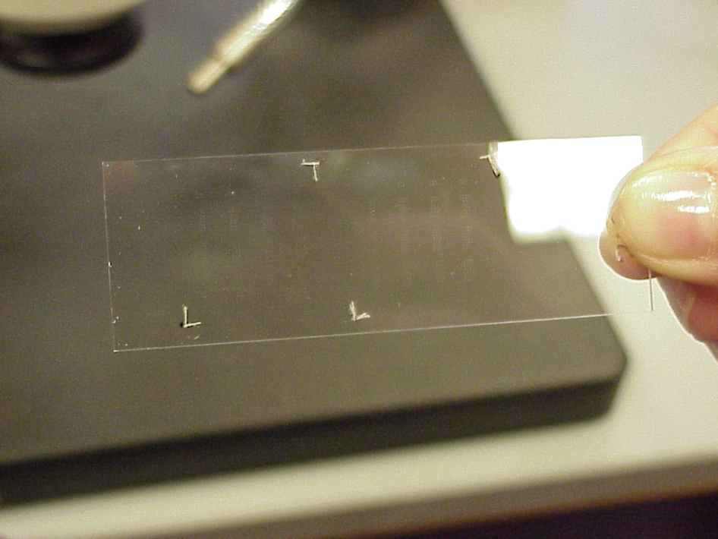

Figure 5. Photograph of a printed microarray.

- Printing.
Approximately 300 CSA-100 Amine Silanated Slides (CEL Associates, Pearland TX) were printed using a BioRobotics MicroGrid II Compact microarray printer. Each microwell contained 10 µL of DNA solution and 10 µL of 2X spotting solution for an optimal well volume of 20 µL. Pin misfires were random; during printing runs, any number of spots on either metagrid could fail to print. Because considerable variation can be seen between slides of different printing batches, (3, 4, 5, 24), all experiments except the directly-coupled dendrimer experiment (p. 37) were performed on one set of 48 slides from the same printing batch with no misfired spots.
A rigorous pin cleaning protocol was performed before every printing run. Non-powdered gloves were worn at all times when handling the pin tool. Check company website regularly for software upgrades (45).

- Soak pins in 50 mM KOH for 5 minutes. Be careful not to let the KOH touch the pin holder as it degrades the aluminum.
- 3 dunks in dH₂O to wash away excess salt
- Sonicate in pure water for 1 hour
- soak in 95% EtOH for at least one hour, or until ready to print.
*** Before printing, hang pins above yogurt cup to dry EtOH before placing in machine.
Each 10K Microspot Pin holds ~50 nL and delivers approximately 0.5 to 1.0 nL per spot. Using an average of 0.75 nL per spot and the conversion factor of 1 µg of 500 bp DNA = 1.82 x 10¹² molecules per spot (46), average molecules per spot were calculated as a function of spot concentration. For example, the most concentrated spots have DNA concentrations of 1600 ng/µL, or 0.0016 µg/nL; this value multiplied by 0.75 nL, then by 1.82 x 10¹² molecules per spot gives an average of 2.18 x 10⁹ molecules per spot. These values were calculated for all spot concentrations and are shown in Table 12.
Concentration (ng/µL) | Average Molecules per Spot
1600 | 2.18 E 9
800 | 1.09 E 9
400 | 5.45 E 8
200 | 2.73 E 8
100 | 1.37 E 8
50 | 6.83 E 7
25 | 3.41 E 7
12.5 | 1.71 E 7
6.25 | 8.53 E 6
3.125 | 4.27 E 6
1.5625 | 2.13 E 6
0.78125 | 1.07 E 6
0.390625 | 5.33 E 5
Table 12. Average number of molecules per spot at each concentration across the 4096-fold range printed for each gene.

F. Post-Printing Processing.
Bovine serum albumin, or BSA, is used in some protocols to block non-specific DNA binding (47). We found BSA treatments were time-consuming and made a negligible difference in results. Baking slides at high temperatures for long periods of time was also recommended for immobilizing the DNA on the glass surface (48); we found that UV-crosslinking was effective and faster. All slides were UV-crosslinked for 3 minutes to covalently bind the DNA onto the glass. Slides were next washed with the following optimized procedure:
- 0.1% SDS for 2 min. at room temperature
- Fresh 0.1% SDS for 2 min. at room temperature
- dH2O for 2 min. at room temperature
- Immersed in a boiling water bath for 2.5 min. to denature double stranded DNA
- 95% EtOH soak for 1 min. at room temperature
- Spun at 1600 rpm for 2 min.

G. SYBR Green.
SYBR Green II (Molecular Probes) is a non-specific, DNA-binding dye that detects the presence of DNA on a given medium. Test slides consisting of 4 positive control spots (SHY at 250 ng/µL) and 4 negative control fly spots (Hedgehog at 250 ng/µL) were printed. To confirm that DNA was effectively bound on the printed microarrays, the following protocol was followed:
- Dilute SYBR Green II stain 10,000 fold in TBE buffer
- Cover metagrid with diluted stain
- Incubate at room temperature for 2-3 min. without a coverslip
- Wash the microarray 3-4 times with TBE buffer
- Spin at 1000 rpm for 2 min.
- Scan on channel Alexa fluor 488.

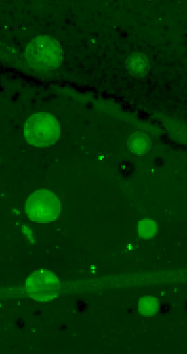
Figure 6. Test slide 12 incubated with SYBR Green II. No BSA block. SHY (left column), and Hedgehog (right column).

As seen in Figure 6, consistent and detectable green signal indicates printing process effectiveness and the presence of DNA on the glass slide. The disparity in spot size between the positive and negative control columns is an artifact of printing.

- HYBRIDIZATION OPTIMIZATION.
Signal intensity must be optimized for detection, reliability and consistency while
reducing noise. Improper cross-hybridization, or false-positive and false-negative signal, must be eliminated wherever possible. An ideal labeling method would provide such signal while remaining economically feasible.
- First Pass Hybridization: Fluorescing Oligos.
Optimally designed oligonucleotide probes for the SHY and RAD genes were synthesized with a single attached Cy3 fluorophore (Proligo, HPLC purification, 10 OD). Only Cy3 was tested in this initial experiment because before more money was invested in synthesizing these expensive oligos, signal reliability using these reagents must be proven. The same test slides from Figure 6 were used.
The DIG Easy Hyb protocol (Roche) suggested hybridizing 0.1-2.0 pmol/mL to each metagrid. To test hybridization temperature, probe concentration, and the effectiveness of BSA blocking to reduce background noise, the following first-pass hybridization experiment was performed. The experimental design is summarized in Table 13.
Slide Name | Top Metagrid Probe Concentration (pmol/mL) | Bottom Metagrid Probe Concentration (pmol/mL) | Hybridization Temperature (°C) | BSA Block
PCNC 1 | 0.1 | 0 | 22 | Yes
PCNC 2 | 10 | 1.0 | 22 | Yes
PCNC 3 | 0.1 | 0 | 37 | Yes
PCNC 4 | 10 | 1.0 | 37 | Yes
PCNC 9 | 0.1 | 0 | 22 | No
PCNC 10 | 10 | 1.0 | 22 | No
PCNC 11 | 0.1 | 0 | 37 | No
PCNC 12 | 10 | 1.0 | 37 | No
Table 13. First-pass hybridization experiments. Ideally, signal intensity would correlate to probe concentration.

20 µL of SHY probe solution at the appropriate concentrations were hybridized per coverslip (2.2 x 2.2 cm, Fisherbrand, Fisher Scientific). Slides were placed in 50 mL tubes with a Kimwipe soaked in dH₂O to maintain humidity. The tubes were wrapped in aluminum foil to reduce photobleaching and tape was wrapped around one end of the tube to keep the slide level within the chamber (Figure 7). Slides were incubated overnight.
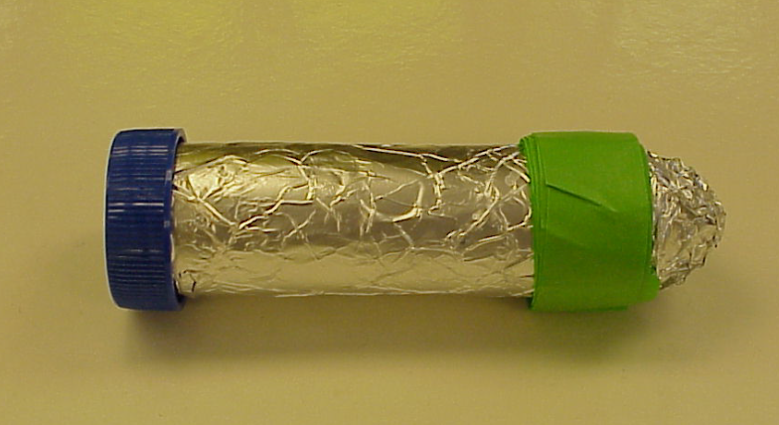
Figure 7. Photograph of a microarray hybridization chamber.
Following hybridization, slides were washed according to these steps:
- Coplin jar of 1X SSC/0.2% SDS at 37 °C for 10 minutes
- Transfer to new Coplin jar of 0.1X SSC/0.2% SDS for 10 minutes at room
temperature
- 0.1X SSC for 10 minutes at room temperature
- Spin at 1600 rpm for 2 minutes
- Keep in the dark until ready to scan
6. Spray with pressurized CO₂
7. Scan.

All slides looked similar, indicating probe concentration, hybridization temperature and BSA blocking made a negligible difference in signal intensity under the described hybridization conditions. As seen in Figure 8, equal signal intensity for both the positive and negative controls was observed. This labeling method was unable to distinguish between the positive and negative control spots. Because only a single unit of fluorescence was present per probe molecule, signal was too low and this labeling method was rejected.

+ —
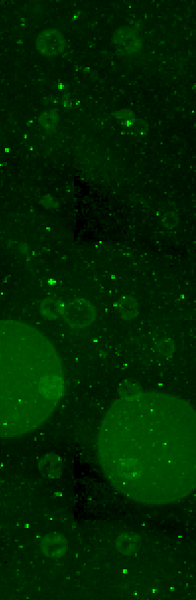
Figure 8. Representative slide showing signal only slightly above background. Positive control (left column), negative control (right column).

- Second Pass Hybridization: 3DNA.
3DNA (Genisphere) is a microarray probe labeling method that entails binding
dendrimers, or large masses of repeated DNA capture sequences attached to fluorophores, to complementary target sequences. Each dendrimer molecule has an average of 250 “arms,” or complementary capture sequences, and 200 or more fluorescent labels (49). A cartoon of a 3DNA dendrimer is shown in Figure 9.
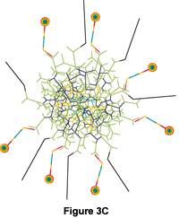
Figure 9. Cartoon of a 3DNA dendrimer (49).
Oligonucleotide probes 61 base pairs in length (30 bind to the target on the slide and 31 bind to the fluorescently labeled dendrimer) are hybridized to the microarray. The 31mer capture sequences kink away from the 30mer oligonucleotide probe sequence, allowing fluorescing dendrimers to bind to the raised 31mer strands and thus allow hybridization to be detected. A schematic of the 3DNA labeling method is shown in Figure 10. The nucleotide sequences for the capture sequences are shown in Table 14.
Figure 10. A schematic of the 3DNA labeling method. 61mer oligonucleotide probes are hybridized to the microarray. 30 of these 61 base pairs bind to the 500mer target, and 31 bind to the dendrimer. Dendrimers fluoresce either red (Cy5) or green (Cy3).

Cy3 | 5' - ggC CgA CTC ACT gCg CgT CTT CTg TCC CgC C -3'
Cy5 | 5' - CCT gTT gCT CTA TTT CCC gTg CCg CTC Cgg T -3'
Table 14. Capture sequence nucleotides. They are synthesized on the 5’ end of the oligonucleotide probes.

In an effort to maximize the light units per molecule utilized in the labeling method, a 3DNA protocol was tested.
Dendrimers may be used with either a two-step or a one-step protocol. The two-step method entails first hybridizing oligonucleotide probes, with capture sequences attached to the 5’ end, alone overnight. Excess probe is washed away, dendrimer dyes are hybridized, any excess is removed and slides are scanned. The one-step method describes combining the oligonucleotide probe solution with the dye solution first to allow them to bind to each other, hybridizing the probe-dendrimer complexes overnight, washing away any excess and scanning. For preliminary tests, 61mer Cy3 oligos were synthesized for SHY and RAD; the 1st Cy3 capture sequence was attached to the 5’ end of each of the optimized 30mer probe sequences (Proligo, PAGE purified, 1 OD).
The protocol must be optimized for buffer content (vial #6 or vial #7), presence or absence of calf thymus DNA, and one-step versus two-step method. SHY was hybridized to the top metagrid and RAD was hybridized to the bottom metagrid of each test slide. The experimental set-up is summarized in Table 15.
Slide Number | Buffer | Calf Thymus DNA (1.0 ng/µL) | Method
276 | 6 | yes | one-step
277 | 7 | yes | one-step
278 | 6 | no | one-step
279 | 7 | no | one-step
280 | 6 | yes | two-step
281 | 7 | yes | two-step
282 | 6 | no | two-step
283 | 7 | no | two-step
Table 15. Experimental set-up for 3DNA optimization. These experiments were performed twice.

Hybridization Buffer 6 required a higher hybridization temperature than Buffer 7. The

hybridization buffers were made up of the following components:

Buffer 6: Buffer 7:
0.25 M NaPO₄ 40% Formamide
4.5% SDS 4X SSC
1mM EDTA 1% SDS
1X SSC 2X Denhardt’s Solution
2X Denhardt’s Solution.

Figure 10 shows two representative test slides from the 3DNA optimization experiment. Though the genes were hybridized on separate metagrids, each metagrid showed signal for both gene’s spots. This was seen because the probe solution volume was too high; the liquid seeped out from under the coverslips and mixed during hybridization. This observation prompted us to reduce the probe solution volume from 30 µL to 10 µL to avoid cross-reaction between metagrids.

A.
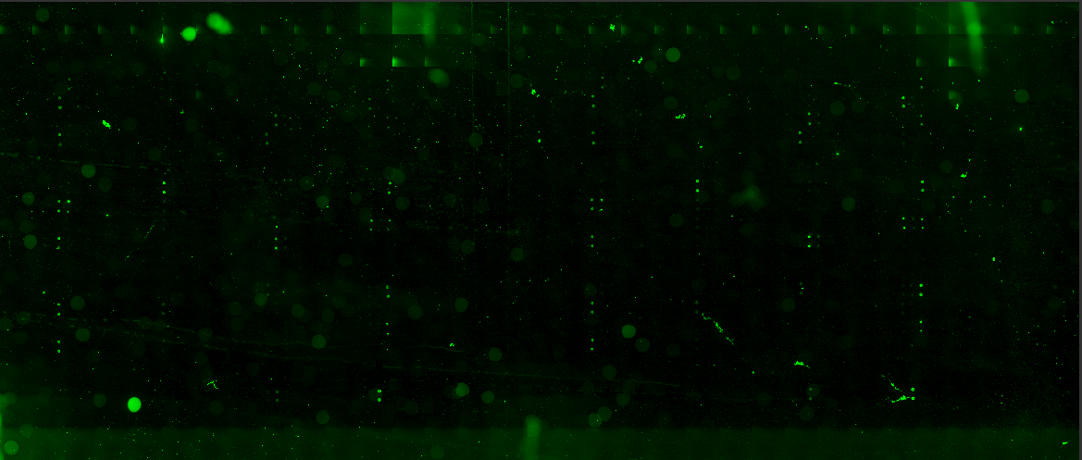
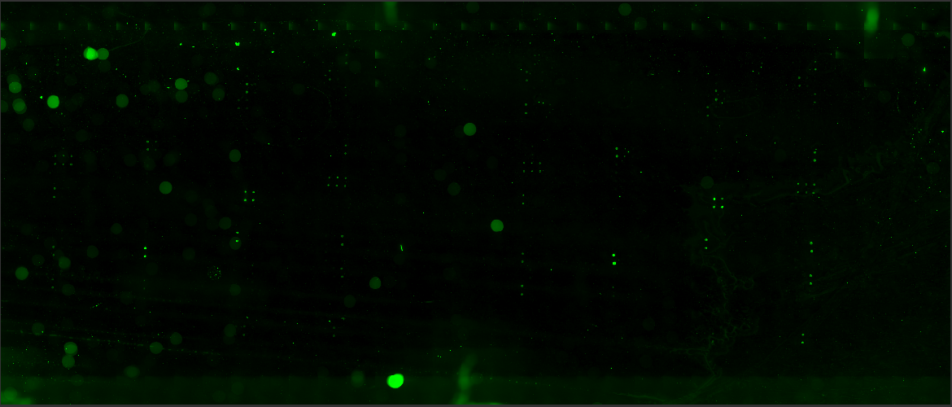
MDH B.

MDH MDH
MDH

\
MDH MDH
MDH

Figure 11. A. Two-step method, calf thymus DNA, buffer 6, higher hybridization temperature. B. One-step method, no calf thymus DNA, Buffer 7, lower hybridization temperature. Slides show both RAD and SHY spots because optimal hybridization volume had not yet been determined.

Using buffer 7 at a lower hybridization temperature than buffer 6 yielded some false-positive signal. These MDH spots are labeled in Figure 11 and are seen on both metagrids. Even at the higher hybridization temperature, these spots were seen in the one-step method (data not shown). Slides incubated with calf thymus DNA were cleaner than those without. The two-step method at a higher hybridization temperature with buffer 6 and calf thymus DNA blocking gave cleaner, brighter, more accurate signal. The one-step method and buffer 7 were rejected.
C. The Optimized 3DNA Protocol.
All metagrids were probed with 10 µL of hybridization solution under square coverslips. Coverslips were dipped in 0.2% SDS and dH₂O and dried with Kimwipes. All microarrays were hybridized in 50 mL tubes wrapped in aluminum foil. A Kimwipe soaked in dH₂O in each tube maintained humidity during hybridization. The tubes were wrapped in tape on one end to keep the chamber level (Figure 7). The temperature on the oven differed from a thermometer placed inside the oven. True temperatures are indicated per the thermometer inside; temperatures given in quotation marks indicate the digital oven thermometer reading. The optimized two-step protocol is as follows:
- Resuspend oligonucleotide probes in dH₂O for a final concentration of 1.0 ng/µL.
- Vortex 25 µL of Buffer 6, 4 µL oligo, 1 µL calf thymus DNA (1 ng/µL) and heat at 80°C for 10 min.
Incubated prepared slides at 37°C overnight, 12-18 hours (“42°C”)
- Wash slides in a Coplin jar with 2X SSC/ 0.2% SDS for 15 min. at 37°C
- 2X SSC for 10 min. at room temperature
- 0.2X SSC for 10 min. at room temperature
- 95% EtOH for 1 min without air drying
- Spin at 1600 rpm for 2 min.
- Vortex 2.5 µL Cy3 dendrimer, 2.5 µL Cy5 dendrimer (or dH₂O if only one fluorophore used) and 25 µL buffer 6; heat at 80°C for 10 min.
Incubate hybridized slides at 54°C for 2 hours (“62°C”)
- Using Coplin jars wrapped in aluminum foil, wash slides in 2X SSC/ 0.2% SDS for 15 min. at 54°C
- 2X SSC for 10 min. at room temperature
- 0.2X SSC for 10 min. at room temperature
- 95% EtOH for 1 min without air drying
- Spin at 1600 rpm for 2 min
- Keep slides in dark until ready to scan.

This protocol was applied to all subsequent experiments. A variable number of oligonucleotide probes were mixed for a final volume of 4 µL. Fluorophores could be hybridized singly or together. The protocol for the directly coupled dendrimers experiment (page 37) added 1 µL of 20X SSC to 2.5 µL of each oligo reagent and Buffer 6 to a final volume of 31µL, and incubated at 46°C (“55°C”) overnight.
Slides were scanned with an ArrayWoRx e scanner (ArrayWoRx 2.0 software, Applied Precision, Inc.). Tiff files were analyzed using ScanAlyze v. 2.50 (Michael Eisen, Stanford). All ratios reported are Cy5/Cy3. While preliminary ratios were calculated with mean, median and no background, negligible differences between these methods were observed and per the author’s recommendation (50), all subsequent ratios were calculated using median background correction.
Two filters were applied to raw ratio data. The first, a quality control parameter included in the software, filtered out weak spots and spots from only a few bright pixels, leaving only uniformly bright spots. Specifically, using the lower end of the recommended threshold value (50), any spots with CH1GTB2 or CH2GTB2 lower than 0.55 were discarded; the fraction of pixels within the spot exceeding 1.5 times the background must be 0.55 or greater. The second filter exploited the duplicity of all printed spots by discarding any pair of spots whose ratios were not within 15% of each other.

