Pierce, B. D. and Campbell, A. M. Exploring the use of plasmids in DNA microarray technology. Fall 2002 & Spring 2003. Independent Research Paper.

Abstract
Using microarrays for high-throughput DNA detection is one of the fastest growing fields in biology today. However, the field is so new that most users do not know how to incorporate standards and controls into their experiments. Furthermore, consistent production of target DNA has been problematic and a documented source of variability. My research centered on three questions: Can target DNA be cloned into plasmids and used for spotting on microarrays? Do plasmids work as well as PCR products? If you probe with known ratios, does the method detect those same ratios? The data indicate that plasmid DNA is indeed useable as a target in microarray experiments and is comparable to PCR product at producing a 1:1 Cy5:Cy3 dye ratio. However, DNA microarrays appear to under-represent the ratios of probes used under well-controlled conditions. These findings open the way for improved DNA microarray experimental design and quality assurance of results.

Introduction

The use of microarrays for high-throughput DNA detection is one of the fastest growing fields in biology today. However, field-wide guidelines have yet to be introduced for investigators to follow when designing experiments and determining results. Due to this lack of standards and the general novelty of the field, there also may be new research possibilities that have not been explored. The research presented in this paper is both an attempt at rectifying this lack of standards and an investigation into a method that has not previously been considered – the use of cloned PCR product as the spotting material on DNA microarray chips.
The traditional method of DNA amplification for use as the spotting material on these chips has been Polymerase Chain Reaction (PCR). Amplification of the spotting material is necessary to produce enough DNA for probe binding (Schulze, et al., 2001). Previous studies differ in their reports of the optimum concentration of spotting material; exclusive studies have optimized the concentration of the spotting material anywhere from 50 ng/µL (Farbrother et al., 2002) to 500 ng/µL (Cheung et al., 1999). Clearly no set norm has been established. A method that has not been reported previously is that of spotting target genes cloned in a plasmid. Although the insertion of a large number of diverse genes into plasmids may be initially tedious, once cloned into a plasmid there is no doubt as to the exact nature of the spotting material (Figure 1). Once the genes have been inserted into the particular plasmid, production of target genes becomes cheaper, easier, and faster. After cloning, plasmid replication and purification becomes a more cost effective process than amplification with PCR.
The aim of this study is to specifically answer three questions: 1) Can target DNA be cloned into plasmids and used for spotting on microarrays? 2) Do plasmids work as well as PCR products? 3) If you probe with known ratios, does the method detect those same ratios? The research presented here is designed to first test the effectiveness of spotting and probing plasmid DNA and then to assess the quality of the resulting signal. Spotting both PCR product alone and PCR product plus plasmid (PPP) of the same gene on a slide and probing with the same oligonucleotide sequence first determines whether plasmids are feasible as a spotting material. After this pilot study, we look at known ratios of probes compared with the experimental red to green ratios observed after scanning. The results of these experiments may be used to address the specific problem of the lack of data validation that is prevalent in microarray data interpretation.

A B
MW idh2 upc FLY dbr SHY mhp MW idh1 rad rim cat mdh dbr upc

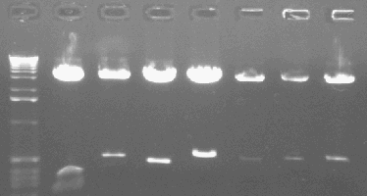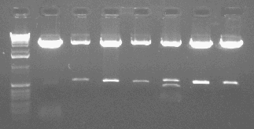
plasmid
500 bp insert
500 bp insert
plasmid

C D
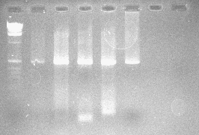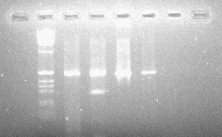
Photos Courtesy E. Oldham

Figure 1. Photographs taken of gel electrophoresis with EtBr and viewed under UV light.
A & B. All 12 genes cloned into plasmids and cut with EcoRI. Full-length idh2 was unable to be cloned into the plasmid, and was therefore used as a control for the remainder of the experiments. The genes mdh, idh1, and rim all had an internal EcoRI site, which accounts for the multiple bands. C & D. A subset of the genes amplified with PCR. The streaking is due to excess DNA in the lanes, a common result when using PCR. As shown here, there are also smaller fragments of different size and unknown sequence that showed up

Methods

PCR Preparation:

Five-hundred base pair fragments of 11 genes were obtained (E. Oldham). Ten of the genes used were from the organism S. cerevisiae (idh2, upc, SHY, mhp, idh1, rad, rim, cat, mdh, & dbr) and one gene was from D. melongaster (hh, labeled FLY in these experiments). Several searches showed that these fragments had no sequence similarity. The fragments were PCR amplified using a PTC-100TM from MJ Research, Inc (see Oldham, 2003 for primers and reaction conditions).

Plasmid Preparation:

Each PCR product was cloned into plasmid pCR 2.1-TOPO (PCR product plus plasmid = PPP). Competent bacterial cells (JM109) containing the plasmid were grown and the plasmids were isolated using the QIAprep® Spin Miniprep Kit from Qiagen® and eluted with dH₂O. Digesting the resulting plasmid with EcoRI and using gel electrophoresis to examine the product resulted in insert verification (Figure 1). Plasmid concentrations were quantified and the desired concentration of the plasmid to be printed was obtained.

Printing Procedure:

Cleaning the Pins:
The pins to be used for printing were soaked in 50mM KOH for 5 minutes. Pins were then rinsed in two separate dH₂O containers for about 5 seconds to wash away salt. The pins were then sonicated for 30 min. to 1 hour in dH₂O. Finally, the pins were soaked in 90% EtOH for 30 min. to 1 hour and left to dry (above EtOH) for 5 min. before printing.
Microarrayer Printing:
Plasmid solutions were mixed in a 1:1 ratio with ArrayIt® Micro Spotting Plus solution (our experiments used a 10 µL : 10 µL ratio). The mixture was then spotted with a MicroGrid II Compact arrayer from Biorobotics® on CSA Silanated Slides (CEL Associates, phone number: 800-537-9339). After printing, the slides were crosslinked by UV light using a DNA Transfer Lamp from Fotodyne® for 3 minutes.

Hybridization

Prior to hybridization, the slides were washed using the following protocol: wash the slides in 0.1% SDS for 2 min. (at RT); repeat; wash the slides in dH₂O (at RT) for 2 min.; boil the slides in H₂O for 2.5 min.; place the slides in 95% EtOH (at RT) for 1 min. and spin in a centrifuge (1000 rpm for 1-2 min.) immediately. The slides were then ready for hybridization followed by scanning.
Probe Construction:
Probes of 61 bp were made that had complementary sequences unique to their respective gene fragment and a 5’ capture sequence for dyes Cy5 (red) and Cy3 (green) to bind. Cy5 and Cy3 labeled oligonucleotides sequences from Genset Oligos were used to bind to the spotted DNA. The OD₂₆₀ of the probes were taken to determine their concentration with a spectrophotometer (Table 1). Separate samples of these probes were then diluted to stock solutions of 15, 150, and 300 ng/µL.

________________________________________________________________________
Table 1. Comparison between the labeled probe concentrations and the actual probe concentrations.
________________________________________________________________________

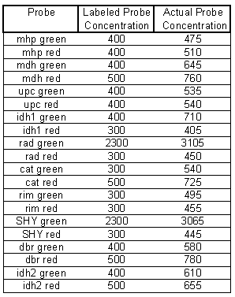

Each oligonucleotide probe is shown on the left-hand column and the company-labeled probe concentrations were reported as such. Actual concentrations of probes were obtained by determining the OD₂₆₀ with a spectrophotometer.

The probe sequences are as follows:
GREEN probes:
rad: 5’- GGC CGA CTC ACT GCG CGT CTT CTG TCC CGC C GAT
GATCTCAGAG AACGGAACAA TCAAATA - 3’
SHY: 5’- GGC CGA CTC ACT GCG CGT CTT CTG TCC CGC C GCTGTA
AACGGAACGC AAGCTGTTGA TAAT 3’
cat: 5’- GGC CGA CTC ACT GCG CGT CTT CTG TCC CGC C ACTACGTTT
GTCAGCAGTT GAATAAACTA G -3’
dbr: 5’- GGC CGA CTC ACT GCG CGT CTT CTG TCC CGC C AGGG
TGCTGTCATG GTCAGCTAAA CCAAAT -3’
idh2: 5’- GGC CGA CTC ACT GCG CGT CTT CTG TCC CGC C GACTTGGCTG
GTACTGCTAC TACTTCATCA -3’
mdh3: 5’- GGC CGA CTC ACT GCG CGT CTT CTG TCC CGC C TTGGGGGTCA
TTCAGGGGAA ACCATTATCC -3’
upc: 5’- GGC CGA CTC ACT GCG CGT CTT CTG TCC CGC C ACTGGAGCAA
TACGTTTCAT CTCACCGCCT -3’
idh1: 5’- GGC CGA CTC ACT GCG CGT CTT CTG TCC CGC C GAACATGAAT
CCGTCCCTGG TGTAGTGGAA -3’
mhp: 5’- GGC CGA CTC ACT GCG CGT CTT CTG TCC CGC C AGTGATAC
CAACGGTACG AACGCAGATG AT -3’
rim: 5’- GGC CGA CTC ACT GCG CGT CTT CTG TCC CGC C ACTTAA
CGATTTTTAT CACGAAGGTG TTGC -3’
RED probes:
cat: 5’- CCT GTT GCT CTA TTT CCC GTG CCG CTC CGG T ACTACGTTT
GTCAGCAGTT GAATAAACTA G -3’
dbr: 5’- CCT GTT GCT CTA TTT CCC GTG CCG CTC CGG T AGGG
TGCTGTCATG GTCAGCTAAA CCAAAT -3’
idh2: 5’- CCT GTT GCT CTA TTT CCC GTG CCG CTC CGG T GACTTGGCTG
GTACTGCTAC TACTTCATCA -3’
mdh: 5’- CCT GTT GCT CTA TTT CCC GTG CCG CTC CGG T TTGGGGGTCA
TTCAGGGGAA ACCATTATCC -3’
upc: 5’- CCT GTT GCT CTA TTT CCC GTG CCG CTC CGG T ACTGGAGCAA
TACGTTTCAT CTCACCGCCT -3’
rad: 5’- CCT GTT GCT CTA TTT CCC GTG CCG CTC CGG T GAT GATCTCAGAG
AACGGAACAA TCAAATA -3’
SHY: 5’- CCT GTT GCT CTA TTT CCC GTG CCG CTC CGG T GCTGTA
AACGGAACGC AAGCTGTTGA TAAT -3’
idh1: 5’- CCT GTT GCT CTA TTT CCC GTG CCG CTC CGG T GAACATGAAT
CCGTCCCTGG TGTAGTGGAA -3’
mhp: 5’- CCT GTT GCT CTA TTT CCC GTG CCG CTC CGG T AGTGATAC
CAACGGTACG AACGCAGATG AT -3’
rim: 5’- CCT GTT GCT CTA TTT CCC GTG CCG CTC CGG T ACTTAA
CGATTTTTAT CACGAAGGTG TTGC -3’

Hybridization Solution Construction:
The protocol from the 3DNATM GenisphereTM company was followed using 1 ng calf thymus DNA in Hybridization Buffer #6 filled up to 30 µL. A total of 10 µL of the probes, calf thymus DNA, and Buffer #6 solution was pipetted on an array under a Fisherbrand® 22mm X 22mm cover slip, so 0.33 ng of calf thymus DNA was placed on the slide and the following amounts of probes were used. Different probe ratios and concentrations were made in the following manner:
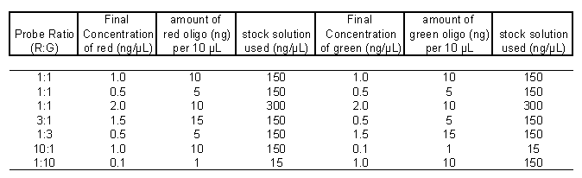
After the probes were on the slide under the cover slip, they were allowed to hybridize at 42˚ overnight unless otherwise noted. After probe hybridization, the slides were washed using the following protocol: 2X SSC, 0.2% SDS, at the hybridization temperature; 2X SSC at RT; 0.2X SSC at RT; place the slides in 95% EtOH (at RT) for 1 min. and spin in a centrifuge (1000 rpm for 1-2 min.) immediately.
The probes were detected with the dendramers supplied in the 3DNATM Submicro Expression Array Kit from GenisphereTM. Again, the protocol from this company was used regarding relative concentration of Hybridization Buffer #6 and the fluorescent dyes. After Fisherbrand® 22mm X 22mm cover slips were added to the slides, the dendramers were allowed to bind at 57˚ for 2 hours. Following this step, the slides were washed using the previous post-hybridization washing protocol and stored in the dark until scanned.

Scanning and Data Analysis

Slides were scanned using an arrayWoRx® escanner from Applied Precision®. All scanned data were analyzed with ScanAlyze® software version 2.5 courtesy Michael Eisen. All graphs and tables were made using Microsoft Excel®.

Results

Determining the Feasibility of Plasmid DNA as a Target

To determine the effectiveness of using plasmid DNA, a gene was chosen as a sample material. The UPC gene was obtained both as a pool of PCR products and as these PCR products inserted into plasmids (PPP). Spots of DNA were set up as in Figure 2. This spot configuration was present four times on each slide.

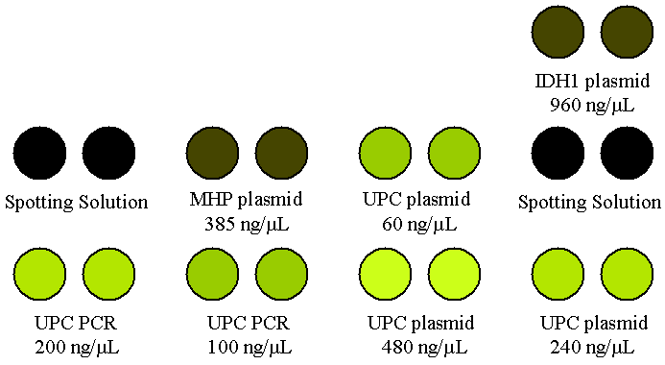

Figure 2. The set-up of the experiment to test the feasibility of Plasmid DNA. Plasmid or PCR DNA was spotted in duplicate in the concentrations shown.

The spots were probed with UPC red and green probes at 1.0 ng/µL. Although the concentration of plasmid that was spotted was higher than that of the spotted PCR product, the 500 bp gene fragment was in a 3.9 kb plasmid. Due to the larger amount of DNA that is present when PCR product is cloned into a plasmid when compared with PCR product alone, the PCR product itself only has a concentration of 27.3 ng/µL when the total concentration of a PPP is 240 ng/µL. Two types of controls were used: two unrelated genes (MHP and IDH1) in plasmids identical to those containing the UPC gene and spotting solution alone.
The results of three slides show that we can indeed use plasmid DNA as a spotting material (Figure 3). UPC plasmid at its highest concentration (480 ng/µL) had a higher average intensity among the pooled spots than the UPC PCR product at its highest concentration (200 ng/µL). A direct relationship between the level of fluorescence intensity and the concentration of the spotting material was also observed. A very low concentration of UPC plasmid (60 ng/µL) was still higher than the negative control plasmids, and spotting material by itself showed relatively no signal intensity. These data provided the pilot study necessary for future examination of plasmids as a starting material.

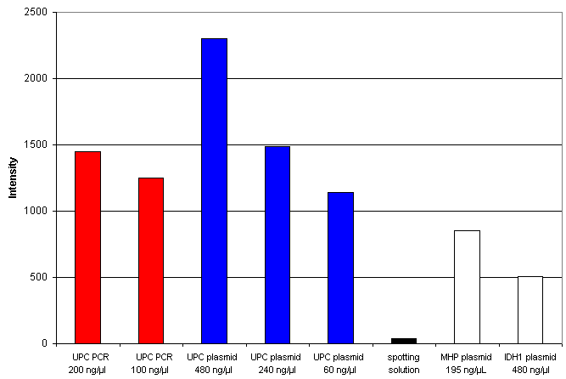

Figure 3. Graphical representation of the amount of fluorescence intensity for each type of spotted material.
Intensity is given in arbitrary units set up through the program Scanalyze®. UPC plasmid appears to have higher intensities than UPC PCR product. The raw intensity values of both negative controls were below the intensities of PCR product and PPP.

Examining the “Non-Self” Binding for Red and Green Probes of Individual Genes at a 1:1 Ratio

After an initial indication that plasmid DNA could be used as a possible spotting material, a DNA chip was made with all ten yeast genes in plasmid and a fly gene in plasmid as a control (Figure 4). Three different concentrations of PCR product plus plasmid (PPP) were used and each spot was printed in duplicate. The remaining spots on the DNA chip (indicated as a box with a slash through it) were used with spotting solution only as a negative control. Due to the inability of inserting idh2 PCR product into the plasmid, the spots with this DNA were not probed. The FLY (hh) gene from Drosophila was not probed for either, and these two PPP were therefore used as a control.

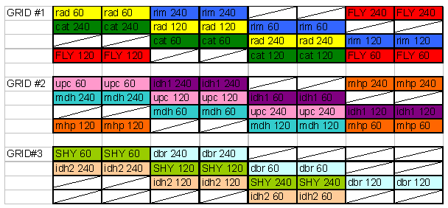
Figure 4. The set-up of the experiment to test all eleven spotted plasmid DNA.
Three concentrations of spots (240, 120, and 60 ng/µL) were printed in duplicate along diagonals to maximize the spacing of the PPP spots for one gene. Boxes with lines through them indicate spotting solution alone as the printed material.

An experiment determining the amount of cross-reactivity in the system was performed with the microarray chips. Equal amounts of red and green probes for one gene at a time were added to the slides and the resulting intensities were recorded (Table 2). The signal intensity for the spotted gene whose probe was added was used as a standard on which to measure the other spotted gene intensities (Table 2). This value of self-to-self binding was determined to be the maximum (100%) binding intensity. A percentage of the “self-to-self” was then determined for each spot in relation to the probe in question. An arbitrary value of 25% “cross-reactivity” was assumed to be a high level in the system.

_______________________________________________________________________
Table 2. Percentages of spotted material non-self binding when individual probes were added.
_______________________________________________________________________

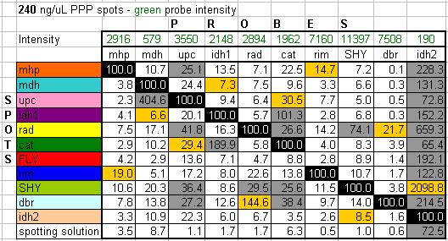

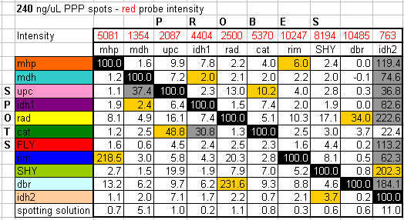

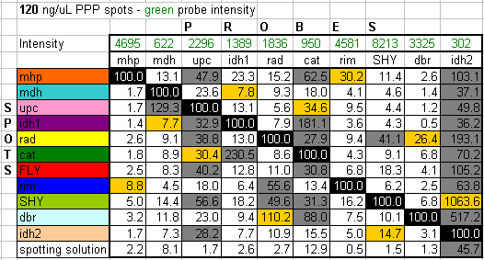

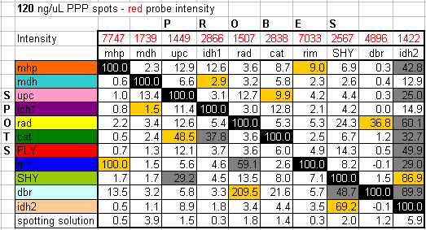

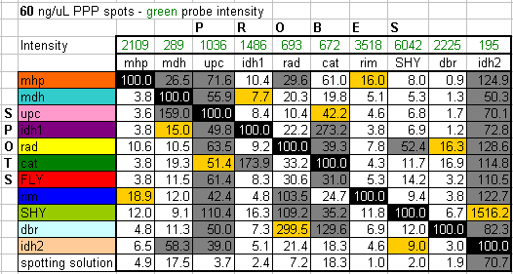

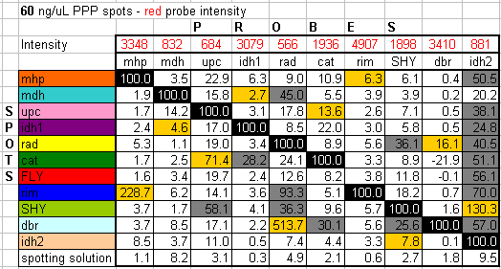

Probes listed above the table were hybridized with the spots listed on the left column. The PPP spots were at the concentrations indicated and all were hybridized at 37˚. Intensities of self-to-self binding are given on the top row. The top-left to bottom-right diagonal of 100% boxes indicate the self-to-self binding of that particular probe to its complementary spot. All other boxes down a column are a percentage of the self-to-self binding using the probe in that column. Gray boxes indicate non-self binding over 25%. Orange boxes indicate partner probes on a slide. Each slide had two cover slips, so the non-self binding observed here was probably due to the leakage of probes under a cover slip on one half of the slide to the other set of spots under a different cover slip. If leakage did occur, this data is not useable.

To try and reduce the high amount of cross-reactivity in the two genes (UPC and CAT) whose probes bound to the most number of “non-self” binding spots, an optimization of hybridization temperature was performed (Table 3). As the hybridization temperature increased, the level of non-self binding decreased. In addition, as was the case in all experiments, the intensity of self-to-self binding decreased as spotting material concentration decreased (Table 4). As a result, the percentage of non-self binding at lower spotting concentrations increased. A pool of all of the spots at different concentrations yields R/G ratios that are close to 1 (0.979, 0.954, and 0.948 for spots at 60, 120, and 240 ng/µL, respectively).

________________________________________________________________________
Table 3. Percentage of non-self binding while increasing the temperature for UPC and CAT probe hybridization.
________________________________________________________________________

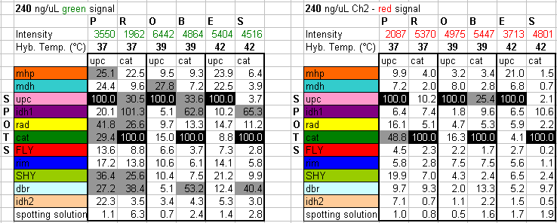

All data taken in this experiment were taken from spots at 240 ng/µL. The hybridization temperature was increased as shown. Data for green labeled probes appear on the left and data for red labeled probes are on the right. Probes listed above the table were hybridized with the spots on the left column. Intensities of self-to-self binding are given on the top row, in a similar manner to the previous table. Gray boxes indicate non-self binding of over 25%.
________________________________________________________________________
Table 4. Signal differences across spotting material concentrations.
________________________________________________________________________

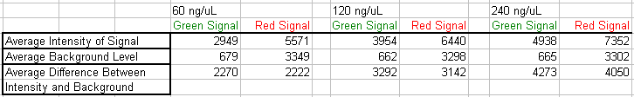

All sixteen slides were pooled, yielding 1408 spots per column. As the concentration increases, the intensity of the signals for both fluorescent dyes increase, while the background remains constant. Using the difference between intensity and background, we can determine R/G ratios. The R/G ratios at each concentration are close to 1.

Examining the R/G Ratio for Probes at a 1:1 Ratio

An experiment was performed where all nine probes were added in equal ratios (both red and green probes were added at 1.0 ng/µL). After hybridization at 42˚, two slides were scanned and the red and green fluorescent intensities were recorded. A typical scan is shown (Figure 5). Visually we can tell that some spots are more red than others and some are more green. These differences are quantified by a R/G ratio. A red/green (R/G; Cy5/Cy3) value was determined for each spotted gene in its plasmid. The R/G values at all three concentrations were comparable and were therefore pooled. The average R/G value of the 48 spots for each gene was graphed (Figure 6). The error bars represent the 95% confidence interval for the data, which appear around the predicted R/G ratio of 1. This graph shows some inherent error in the system, as the R/G ratios aren’t at a perfect 1:1 ratio. This does, however, provide us with a basis to perform further experiments.

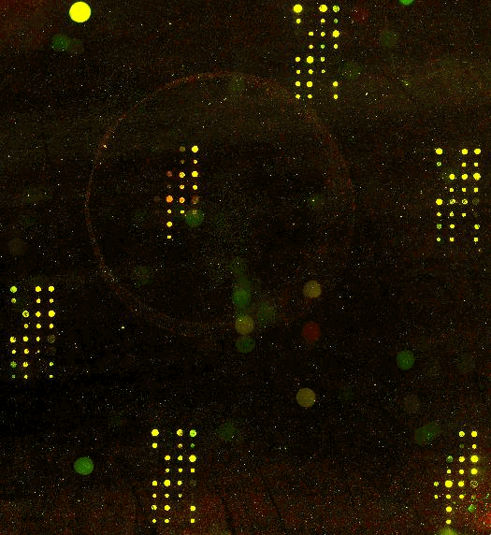
GRID #3
GRID #3
GRID #1
GRID #2
GRID #2
GRID #1
SHY 60
upc 60
rad 60

Figure 5. Picture of a slide using nine probes at a 1:1 ratio. A typical result is shown. We see the grids from Figure 4. turned on their sides, and the black spaces in the grids indicate where only spotting solution was spotted. Empirically we can tell that some spots show more red and some are show more green. These differences are quantified by a R/G ratio.

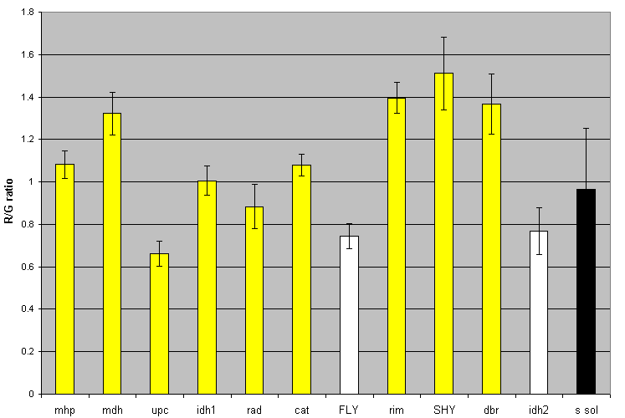
Figure 6. Analysis of the R/G Ratio for Probes at a 1:1 Ratio.
The pooled R/G ratios of each gene are shown. The two types of negative controls, genes in plasmids for which there were no probes and spotting solution alone, are colored white and black, respectively. For each bar, N=48 spots. The error bars represent a 95% confidence interval for the data.

Examining the R/G Ratio for Probes at Different Concentrations

After the ratios of probes at 1.0 ng/µL were examined, an experiment was performed where the concentration of the probes were changed. Again, all nine probes were added in equal ratios, though this time both probes were at concentrations that differed from the 1.0 ng/µL used previously. Probes in equal ratios at 0.5 ng/µL and then at 2.0 ng/µL were used. After scanning, the spot intensities for all three concentrations were pooled and graphed alongside the previous experiment (Figure 7). Although the 1:1 ratio was maintained, there was some variation in the reproducibility of the results. Data analysis shows that when the concentration was decreased, there was a decrease in signal intensity without a decrease in the background levels (Table 5). Signal intensity is cut significantly. When the concentration of the probes was raised to 2.0 ng/µL for the trial, the intensity of the signal was not improved upon. A fresh set of dyes was used in the experiments with 2.0 ng/µL probes, which seems to be responsible for the decrease in intensity. Because of the apparent loss of signal with an increase in probe concentration, we conclude that there is no reason to use a probe concentration different from the 1.0 ng/µL that is recommended in the manufacturer instructions.
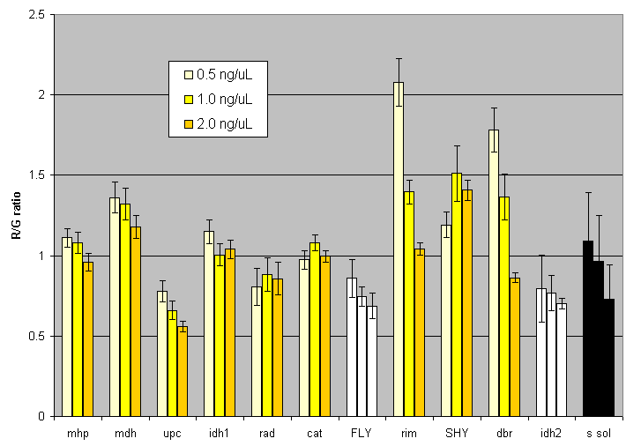
Figure 7. Analysis of the R/G Ratio for Probes at a 1:1 Ratio.
The pooled R/G ratios of each gene are shown. The two types of negative controls, genes in plasmids for which there were no probes and spotting solution alone, are colored white and black, respectively. For the 0.5 and 2.0 ng/µL bars, N=24 spots. For the 1.0 ng/µL bars, N=48 spots. The error bars represent a 95% confidence interval for the data.

________________________________________________________________________
Table 5. Signal differences across spotting material concentrations.
________________________________________________________________________

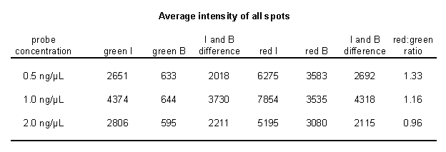
Equal concentrations of red and green probes at three different concentrations used and the signal intensities (I) and background (B) were recorded for each spot. Green intensities (green I) and background levels (green B) for the pooled spots are shown. Red levels are shown in a similar manner. A total of 384 spots were pooled for probes at 1.0 ng/µL and 192 spots were pooled with probes at 0.5 ng/µL and 2.0 ng/µL.

Examining the R/G Ratio for Probes at 3:1 and 10:1 Ratios

After determining the R/G ratios with the use of 1:1 probe ratios, 3:1 and 10:1 ratios were used. Probes of ratios of 3:1 and 10:1 (see Methods) were added to the slide, followed by hybridization at 42˚. After two slides at each concentration were hybridized at 42˚, the slides were scanned and the data pooled (Figure 8). The height of the bars in the graph was predicted to be indicative of the probe concentration that was used. For example, the 3:1 red to green bar was predicted to have a R/G value of 3.0, while the 1:3 red to green bar was predicted to have a R/G value of 0.333. Similarly, the 10:1 red to green bar was predicted to have a R/G value of 10 and the 1:10 red to green bar was predicted to have a R/G value of 0.10. The height of the bars follow the predicted pattern but seem to under represent the exact nature of the probe concentration.

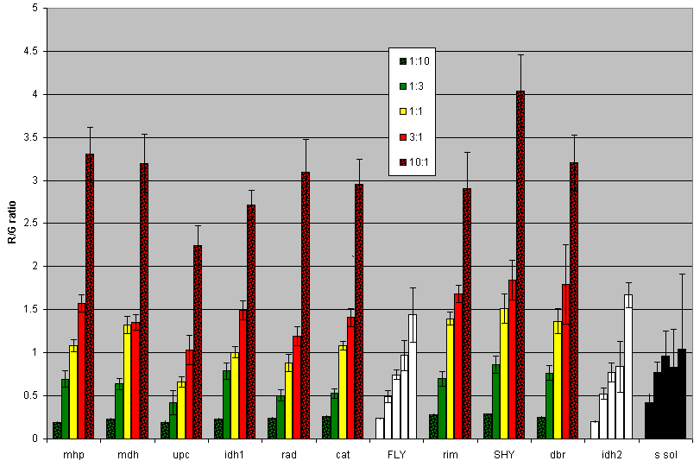

Figure 8. Analysis of the R/G Ratio for Probes at 3:1 and 10:1 Ratios.
The pooled R/G ratios of each gene are shown. Five probe concentrations were used: Probes in an equal ratio (represented by the yellow bar), green in ten times the concentration of red and vice versa, and green in three times the concentration of red and vice versa. The two types of negative controls, genes in plasmids for which there were no probes and spotting solution alone, are colored white and black, respectively. For all bars with spotted plasmid, N=48 spots. The error bars represent a 95% confidence interval for the data.

Discussion

Can target DNA be cloned into plasmids and used for spotting on microarrays?

The unequivocal answer to this question is that yes, DNA cloned into plasmids is an effective spotting material on microarrays. The pilot study in Figure 3 provided the preliminary indication that plasmids work, and subsequent experiments (Figures 4-8) corroborate this conclusion.

Do plasmids work as well as PCR products?

Though it was a pilot study, the results shown in Figure 3 would indicate that plasmids work as well as PCR product. The fluorescent intensities of the PCR product at a concentration of 200 ng/µL are comparable to those of PPP concentrations at 240 ng/µL. When the actual pieces of PCR product where probe binding can occur are considered for both types of spots, over 7 times the amount of target is available for the PCR product alone at these concentrations. This would indicate that probing PCR products in a plasmid are more effective than probing PCR products alone. A possible hypothesis for this observation is that PPPs provide a more effective binding site for probes. This may be due to the plasmid DNA that flanks the cloned product’s ability to adhere to the microarray slide. When PCR product is spotted alone it is the only material that is available to adhere to the slide. If the 3.9 kb of the plasmid itself adheres, it may allow the inserted gene to more easily accept a probe. Also, as Figure 1 indicates, the target material presented in the cloned PCR product is pure target and is free from contamination that appears during PCR amplification.

If you probe with known ratios, does the method detect those same ratios?

Probing with known 1:1 ratios showed that the plasmid method produced an advantage when compared to previous research that used the more common approach of probing PCR product alone (Oldham, 2003). Figure 6 indicates that the R/G fluorescent intensity values hover around the expected value of 1. Although the values are not exactly 1, the results are comparable to results using PCR product (Oldham, 2003).
In determining the answers to the three questions postulated, several other findings were made. Two experiments performed were essentially optimization procedures, and these helped modify or validate the existing protocol. The experiments shown in Table 3 show that 42º is an ideal hybridization temperature. Similarly, the experiments represented in Figure 7 indicate that the previously reported probe concentration of 1.0 ng/µL is the optimal amount to use. In addition, the probe concentrations were re-quantified and precise stock concentrations were made, which led to results that were closer to expected values.
The most striking finding of this research is the conclusions that may be drawn from the use of red and green probes at a variety of concentration ratios. Clearly the expected R/G fluorescence ratios are not found, even though there is a consistent decrease and increase in the R/G ratios across all spotted genes (Figure 8). An examination of Figures 6 and 8 leads us to this conclusion. From these graphs we see that the gene with the highest R/G ratio with probes at a 1:1 ratio is SHY (at just over 1.5). SHY also has the highest R/G ratio value at every other probe concentration (10:1, 3:1, 1:3, and 1:10). Similarly, the gene with the lowest R/G ratio at a 1:1 probe concentration is UPC. This PPP also has the lowest R/G ratio at all other probe concentrations. This validates the experimental conditions and indicates that there are inherent properties of some of the spotted genes that cause ratio differences.
One interpretation of Figure 8 could be that the resulting R/G ratio is a condensed form of the experimental probe conditions. This has been noted in several DNA microarray papers (Rocket, 2003, Soukas, et al., 2000 and Townsend, et al., 2002). At this point, it is important to recognize the scope of microarray technology. It is not a heavily-controlled-for, foolproof method of looking at induction and repression. At this point, it is important to look at microarrays as a preliminary guess, and then use better, well-established tools to determine the actual biology. Microarray data is useful when sweeping conclusions about induction or repression are made. At the same time, using microarray data to quantify exact fold induction or repression is inappropriate at this stage of the field’s development.
In broad terms, spotting plasmid DNA alongside PCR product DNA for genome-wide experiments could be a positive control that, when probed for, would ideally show a 1:1 R/G ratio. By adding known probe concentrations in addition to the experimental conditions, investigators would be alerted to problems in the system if the plasmid did not produce this expected 1:1 ratio. Attempts at concrete interpretations from DNA microarray experiments continue to be debatable at best, and a need for rigorous controls remains crucial to the advancement of this field. The use of specific genes in plasmids as these controls may provide an opportunity for researchers to standardize their experiments, and subsequently lead to a practical solution to this problem.

References

Cheung, V.G., M. Morley, F. Aguilar, A. Massimi, R. Kucherlapati, and G. Childs. 1999. Making and reading microarrays. Nat. Genet. 21: 15-19.

Farbrother, P., S. Muller, A. A. Noegel, and L. Eichinger. 2002. Comparison of Probe Preparation Methods for DNA Microarrays. Biotechniques. 33:884-888.

Oldham, E. E. 2003. Exploring the use of controls in DNA microarrays: a case study in quality control.

Rocket, J. C. April 2003. To confirm or not to confirm (microarray data) – that is the question. DDT. 8:8. 343.

Schulze, A. and J. Downward. 2001. Navigating gene expression using microarrays – a technology review. Nat. Cell Biol. 3:E190-E195.

Soukas, A., P. Cohen, N.D. Socci, and J.M. Friedman. Leptin-specific patterns of gene expression in white adipose tissue. Genes Dev. 2000 Apr 15. 14(8):963-80.

Townsend, J. P. and D. L. Hartl. 2002. Bayesian analysis of gene expression levels: statistical quantification of relative mRNA level across multiple strains or treatments. Genome Biol. 3(12).

