Week 3: Testing Phenotype of Cloned DNA

Learning Objectives for Promoter Discovery

Skills
- Properly manipulate bacterial cultures to maintain clonality of cells.
- Isolate and quantify plasmid DNA from E. coli.
- Use Nanodrop data to evaluate the quality of your isolated plasmid DNA.
- Quantify RFP levels in populations of E. coli cells.

Cognitive
- Integrate fluorescence and absorbance data to determine promoter strength.
- Review the information contained within promoters.
- Analyze experimental data and reach logical conclusions.
- Describe the big idea of information based on lab experiences.
- Interpret Synergy data for fluorescence and optical density.
- Design experiment to confirm cloned DNA was successful.

Pre-Lab

Before you come to lab
1) Watch 6 videos for week 3
www.bio.davidson.edu/people/macampbell/113/2iterationsGGAstudentF2022.html

2) Predict what you will see from your colonies on the positive control plate (J04450: http://parts.igem.org/Part:BBa_J04450), the negative control plate (J119137 + water; http://parts.igem.org/Part:BBa_J119137), and your experimental plate (J119137 and your promoter).

3) Answer each of these four questions in two sentences or less.

A) How can you be sure that E. coli cells in a colony contain a plasmid?

B) What phenotypes would indicate the plasmid contains your promoter?

C) How does RNA polymerase know which way to transcribe when it binds to a promoter?

D) How can we use RFP or GFP to measure the strength of transcription from a promoter?

Information: Start Overnight Cultures of Transformed E. coli

In Lab:

1) Yesterday, one person from your group started growing [in LB + amp (100 µg/mL) media] multiple overnight cultures of transformed JM109 E. coli so that your lab group can determine the phenotype of each strain of cells (different genotypes). The positive control (P) is J04450 (RFP), with a strong promoter and strong RBS.

2) First, we will start the PCR using the protocol online.
gcat.davidson.edu/GcatWiki/index.php?title=PCR_for_Bio113

3) Second, we will preserve an aliquot of each strain of E. coli that originated from a distinct colony on your plate.
gcat.davidson.edu/GcatWiki/index.php?title=Freeze_glycerol_stocks_of_E._coli

4) The third task is determining whether your promoter worked or not. We will use the Synergy machine to measure cell density via spectrophotometry and RFP fluorescence via its fluorometer.
gcat.davidson.edu/GcatWiki/index.php?title=Synergy_Machine_Protocol_for_Bio113

5) Once you have your Synergy data, each person should generate his or her own graph showing the relative fluorescence for each sample. Working in your lab groups, generate column graphs of your v1 promoters. But each person should work independently so you will know how to generate these graphs on the exam. Be sure to take into account the data from the LB amp tube that lacked any cells. What should you do with these data?

If you do not know about the shortcut in Excel to perform the same calculation multiple times, be sure and ask. It has to do with getting a black + sign and dragging the corner.

To make your analysis go smoothly, follow this sequence of manipulations:
- subtract background from all data
- generate ratios for each triplicate independently
- average the triplicate averages
- calculate standard error of the mean (SEM) which is done by dividing the standard deviation by the square root of the sample size. In the formula bar of Excel, type this command: =(STDEV(E8:E10)/SQRT(3)) where E8:E10 indicates where the 3 independent ratios are located. In your experiment, what was the sample size?
- graph the averaged ratios
- produce error bars using the SEM you just calculated. Do NOT use the standard error bars produced by Microsoft.
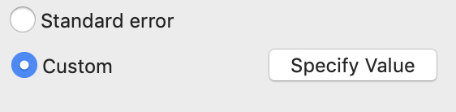
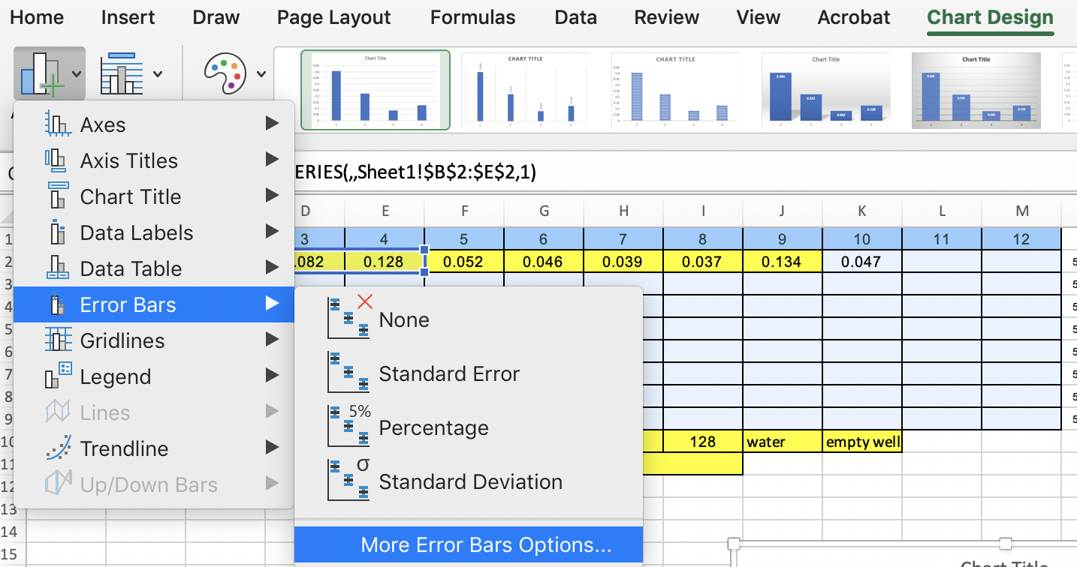
To generate custom error bars, select your graph by clicking on it once. From the “Chart Design” menu, choose “Error Bars” and “More Error Bars Options…” A new dialog box will appear on the right side of the graph. In that box, choose “Custom” and click on the “Specify Value” button. You can now click and drag through the SEM values you calculated. Do this for the positive and the negative directions to make two-sided error bars.

Show your graphs to the instructor before you leave today.

