Week 11: Determine v1 & v2 Genotypes

Learning Objectives for Promoter Discovery

Skills
- Align multiple DNA sequences to look for mutations

Cognitive
Use chromatograms to evaluate the quality of DNA sequencing and specific base calling

Pre-Lab

1) Watch 1 video from list for week 11 lab
<https://www.bio.davidson.edu/people/macampbell/113/2iterationsGGAstudent_S2024.html>

2) Download the sequencing data and find the 4 .seq files for your promoter (one v1 and three v2). If you want to download a free tool to look at chromatograms, try this one (https://jorgensen.biology.utah.edu/wayned/ape/).

3) Download the Kalign submission template file.

4) Answer each of these four questions in two sentences or less.

A) What would you expect to see on a chromatogram for a good sequencing reaction? Do you have any reactions that failed?

B) What would you see on a chromatogram if you added two primers to the reaction, or if your primer bound to more than one location?

C) How many strands of DNA are sequenced in a single reaction? Explain why.

D) Where on the chromatogram is the data less reliable? Hypothesize why some data are unreliable even on a good sequencing reaction.

Information: Comparing DNA Sequences

In Lab

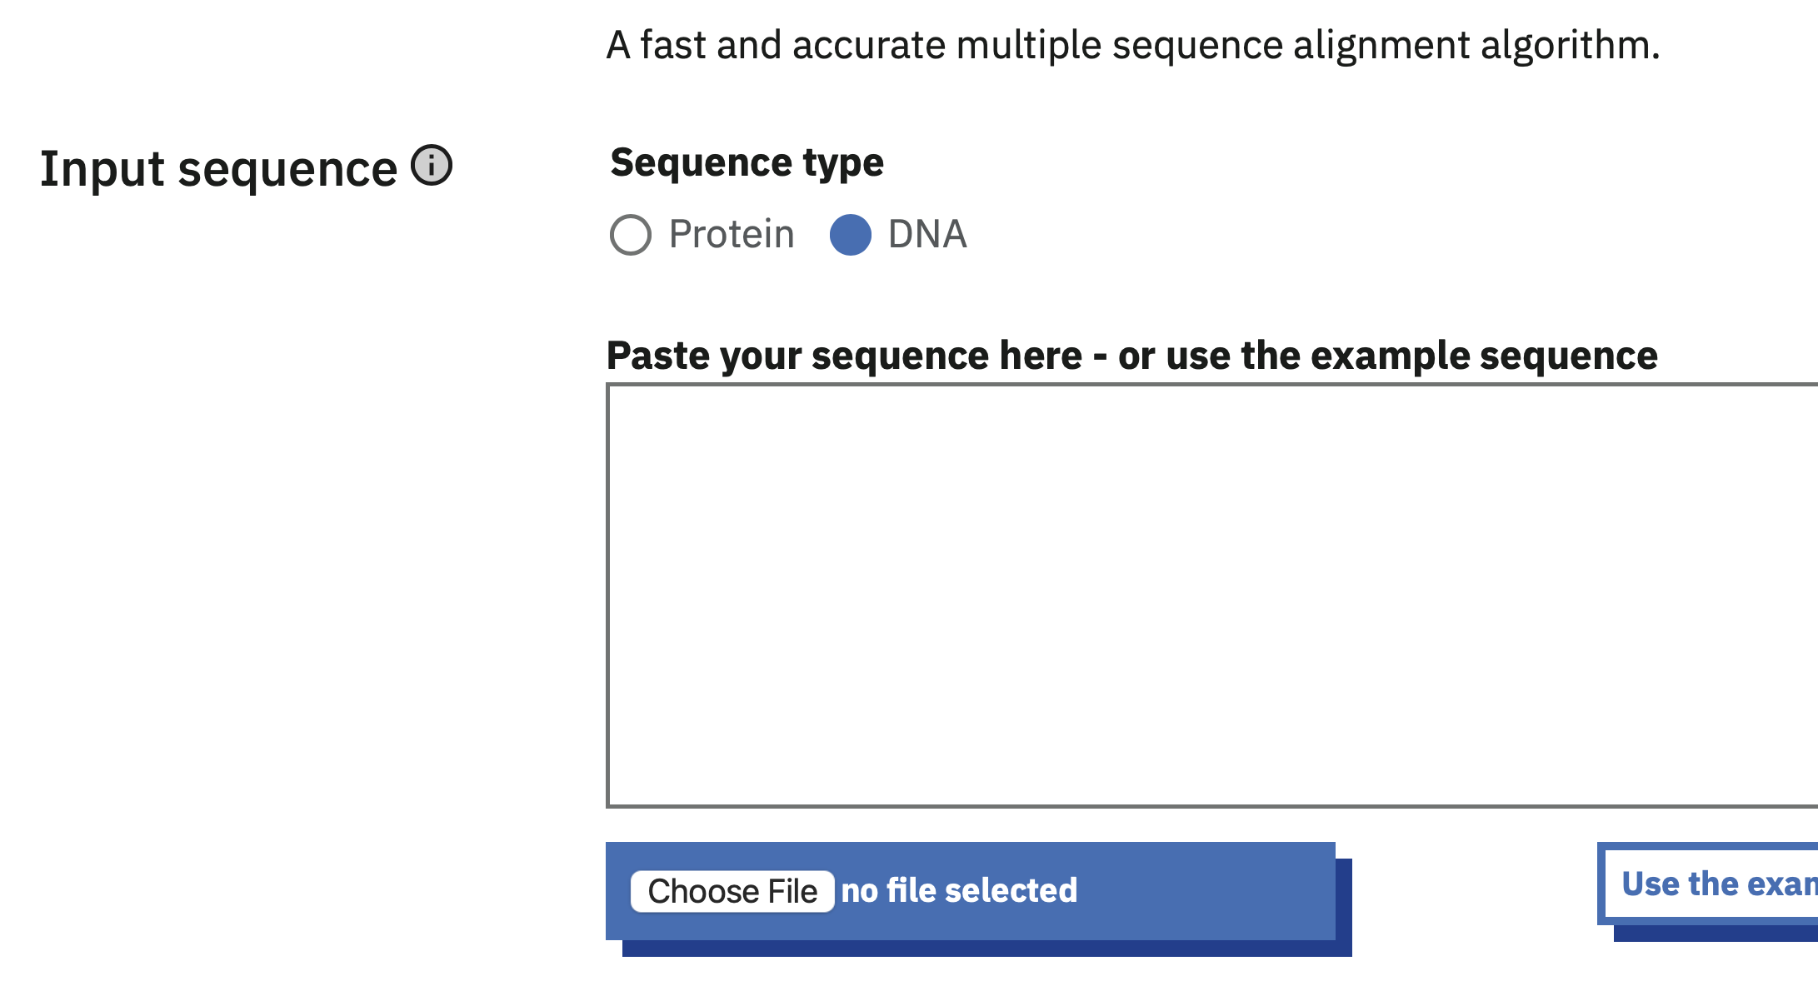
1) Use Kalign (https://www.ebi.ac.uk/jdispatcher/msa/kalign) to compare your expected DNA control element sequence with your actual sequences that you had synthesized. You may trim off any Ns at the beginning and the end of your sequence. How well do the two sequences match? You have to submit your sequences using “fasta format” (see image below for example). You should align all six sequences (4 sequencing results plus the two intended promoter sequences) in a single alignment. After you see those results, you might want to perform alignments with different subset combinations of sequences.

Use the submission template to help you produce FASTA-formatted sequences for alignment.

2) Generate figures that summarizing your sequencing results. Keep in mind your goal is to confirm whether you successfully cloned the v1 and v2 promoters.

3) Discuss how the sequencing results influence your interpretations of your phenotype results. Did you determine the phenotype for your intended genotype???

