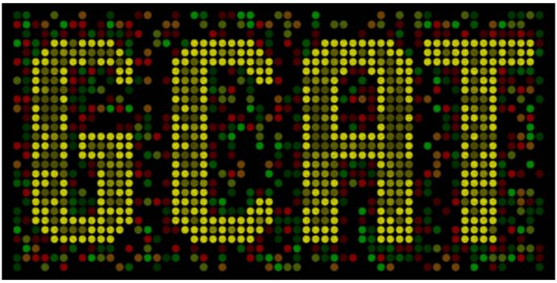

The Genome Consortium for Active Teaching
brings genomics into your undergraduate curriculum
APPLICATION RECEIPT DUE DATE: 5 pm eastern time, JANUARY 15, 2011.

GCAT is please to announce a new synthetic biology faculty workshop for the summer of 2010 hosted by Davidson College. This workshop is funded by Davidson's HHMI grant. You can learn more about synthetic biology at this web site: <www.bio.davidson.edu/projects/GCAT/Synthetic/What_Is_SynBio.html>.

The goal of this workshop is to prepare 15 pairs of faculty to spend the 2011-12 academic year getting ready for undergraduate-lead research in synthetic biology during the summer of 2012. We will train participants how to do the wet lab methods and how to think differently to prepare for synthetic biology. By the end of the workshop, we want each team to have mapped out possible research projects and implementation plans.

Participants will NOT have to pay anything to attend with the possible exception of some travel expenses (still working on this aspect of the budget: what happens with the economy and fuel prices?).

The dates are:
Arrive in Davidson Wed. June 15
Workshop all day Thursday and Friday June 16 - 17
Workshop until noon on Saturday June 18 and departure after that.

- Instructors will be Drs. Jeff Poet and Laurie Heyer (both mathematicians) as well as Todd Eckdahl and Malcolm Campbell (biologists).
- 15 teams of two faculty members from 15 different schools
- Each team would be composed of a biologist and a non-biologist (chemist, mathematician, computer scientist, perhaps biochemist if in different department, etc.)
- Teams would apply no later than January 15 and be notified of their selection before February 1, 2011.
- GCAT will pay for room and board on campus in dorms with single rooms and shared bathrooms.
- Food at Commons which is really good cafeteria food.
- Lab supplies all provided free of charge. Computers will be available but participants are encouraged to bring laptops if they can.

We hope that all 15 schools will have their students present their research in the summer of 2012 at research venues to be discussed at the workshop. A tentative schedule is attached.

For Faculty Teaching Undergraduates
June 16 - 18, 2010 at Missouri Western State University, MO
Application Deadline DECEMBER 15, 2011.

Name #1_____________________ _ Rank and Dept._________________________________

Name #2_________________ _____ Rank and Dept._________________________________

Institution(s) #1____________________________________#2 if different______________________

Mailing Address #1__________________________________________________________________

Contact Phone #1 _______________ Contact Email #1______________________________________

Contact Phone #2 _______________ Contact Email #2______________________________________

Current courses taught Person #1________________________________________________________

Current courses taught Person #2________________________________________________________

Field of expertise #1 _______________________________#2 ________________________________

How do you plan on using synthetic biology in your teaching and/or research? (used second page if needed)

__________________________________________________________________________________

Will you be able to conduct undergraduate-based research in the summer of 2012?________________

If yes, please explain: (used second page if needed)
#1________________________________________________________________________________

#2________________________________________________________________________________

Do you have prior experience with synthetic biology and/ or undergraduate research? _____________
If yes, please explain: (used second page if needed)
#1________________________________________________________________________________

#2________________________________________________________________________________

Demographics. Please fill out this table to help us understand the undergraduates served at your institution.
Group | Percentage of institutional undergraduate population
African Americans
Hispanics
Native Americans
Native Hawaiians/Alaskans
Optional: your ethnicity | #1 #2

Last Question: Why are you applying for this workshop? Help us understand why you want to attend. Keep your answer to less than one page please.

EMAIL APPLICATIONS TO: Jeff Poet: poet@missouriwestern.edu

APPLICATION RECEIPT DUE DATE: 5 pm eastern time, DECEMBER 15, 2010.
Neither HHMI nor GCAT uses quotas for any workshop. We encourage all faculty to apply but we will emphasize the potential impact for faculty who teach at MSIs, or those faculty members who are themselves members of underrepresented groups.
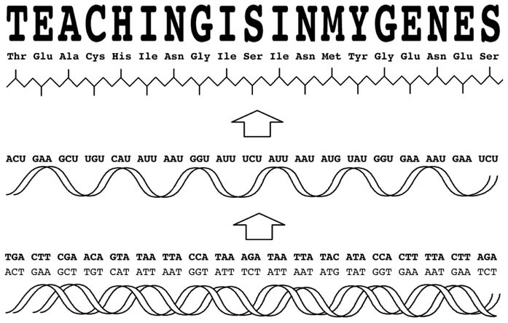
Synthetic Biology Workshop June 2011
Tentative Schedule
Day 1 – June 16, 2011
7:00 – 8:15 Breakfast
8:30 Overview
What is synthetic biology?
How is synthetic biology suited for multidisciplinary research with undergraduates?
What are the goals of the workshop?
9:30 Introduction of BioBrick assembly scheme, Registry
Give assignment to participants
10:30 Break
11:00 Synthetic biology project examples
Presentations on medicine, energy, the environment, technology
12:00 Lunch
1:00 Explore the iGEM Wiki
Work as pairs of participants, describing past iGEM projects in area of interest
2:00 Report iGEM project examples explored above (What makes the above project “synthetic biology”?)
3:00 Break
3:30 Wet lab work
Discuss methods for obtaining Registry parts or building new parts
Start PCR for building a new part
Use Oligo assembly web site
Pipet and boil oligos for assembly of new part

Evening Synthetic Biology research presentation based on MWSU and DC students

Day 2 – June 17, 2011
7:00 – 8:15 Breakfast
8:30 Reflections on previous day, feedback on workshop so far and goals for Day 2
9:15 Birds of a Feather discussions – what issues do you see at this point?
10:00 Discussion of ethical issues related to synthetic biology
10:30 Break
11:00 Participant pairs work on their plans for synthetic biology at their institution
Brainstorm area of focus, understand overlapping interests, project ideas
12:00 Lunch – Bioethicist will join us for lunch.
1:00 Discuss lab methods and practices,
Wiki, GCAT-alog, sharing protocols online
2:00 Lab work
Load PCR products on gel
Ligate oligo assembly
Transform parts from mini-Registry and oligo assembly
Take gel pictures
3:20 Break
3:40 Work in pairs on topics for project presentation/discussion/ AMC, LH, TE, JP consulting
5:15 Announce topic of choice to whole group (from which we create two groups for Day 3 report)
Evening Presentation by NSF Program Officers

Day 3 – June 18, 2011
7:00 – 8:15 Breakfast at Commons
8:30 Observe colonies and discuss results
8:50 Group Photo and assessment data collection
9:15 Divide into two groups based on participant project topics
Allow 20 minutes for each pair for presentation/discussion/feedback
10:30 Short Break
12:00 Participants leave with optional box lunch

Short-Term Outcomes of GCAT Synthetic Biology Workshop
1) Everyone will learn as much as possible. We will all have fun, and the participants will begin a new phase in their teacher-scholar career.
2) Participants will learn some vocabulary and a new perspective that makes synthetic biology distinct from genetics and molecular biology.
3) Interdisciplinary teams will explore an area of common interest and investigate feasible projects for undergraduate research and possible course development.
4) Participants will develop a strategy to recruit and support undergraduates for research in synthetic biology.
5) Faculty from different departments will collaborate to find common ground, mutual understandings from different perspectives, and a shared vision of how to start a new research adventure.

Long-Term Outcomes of GCAT Synthetic Biology Workshop
1) Participants will apply what they learn to develop an undergraduate research program in synthetic biology.
2) Participants will assemble multidisciplinary teams consisting of at least two faculty and two or more students from at least two different majors.
3) Faculty from outside biology will utilize the methods they learned to help design, construct, and test DNA-based devices as part of a synthetic biology research project.
4) Biology faculty will learn the language and tools of the trade from their partner’s discipline to a level of proficiency that they can help design, construct, and test a model of the device as part of a synthetic biology research project.

